Homework
Year 4
Thursday 08th May
Please complete and return work completed in your homework book or on purple mash on Tuesday. Please ensure that you mark the homework
Dear Parents,
Please see below for homework this week.
Reading
Please remember to read with your child daily and support them with understanding through comprehension of the text and not just decoding. Please sign and date the reading record. If you have any comments you wish to write about your child’s reading please do so.
ENGLISH:
Complete the reading comprehension based on our new History topic the Mayans.
SPELLINGS:
Words with ‘ough’ to make a long /o/ oo / or / or sound
though
although
dough
through
breakthrough
thought
bought
brought
fought
ought

MATHS:
We have spent last week looking at finding complements to 1. We have been using base facts to support us.
Please see the example below to help 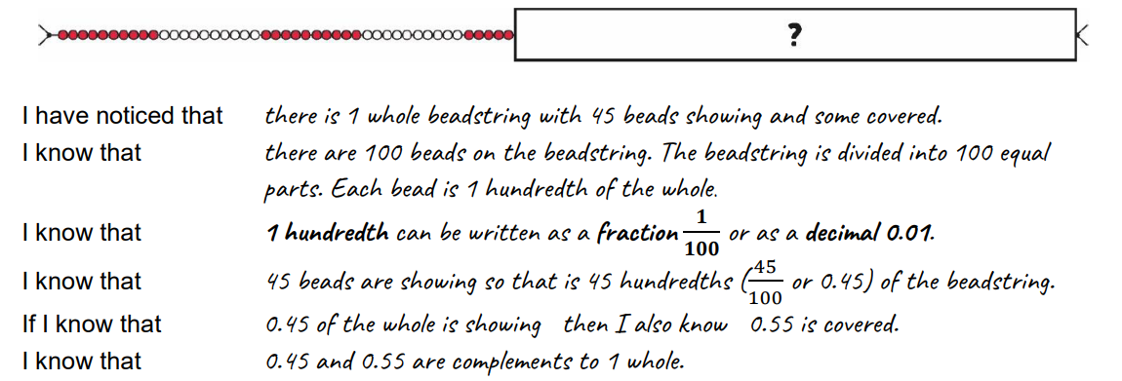
Base facts here would be: 45 + 55 = 100 therefore 0.45+0.55=1.0
Reminders
- Reading Records to be in every day.
- PE Kits should be in school every day.
- Please bring in an art apron to leave in the locker
PE will be on a Monday and Wednesday.
Thank you for your continued support.
Miss Entwisle

