Homework
Year 4
Thursday 05th September
Please complete and return work completed in your homework book or on purple mash on Tuesday. Please ensure that you mark the homework
Dear Parents,
Please see below for homework this week.
Reading
Please remember to read with your child daily and support them with understanding through comprehension of the text and not just decoding. Please sign and date the reading record. If you have any comments you wish to write about your child’s reading please do so.
RE:
This week, we have started our new RE topic; People. This topic focuses on family roots. Please create a family tree. Please try to get creative as possible with this as it will be going on display for our first topic. Talk through your family roots as far back as you can, as we will be referring to them through the lessons. Please see ideas below.
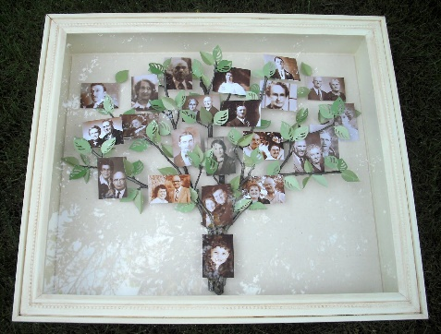
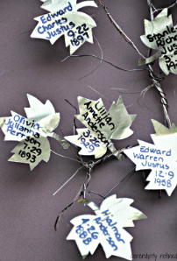
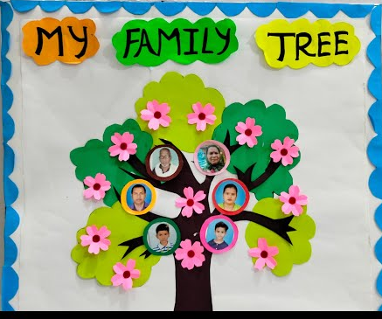

Subject of the Week: This week the focus is PSHE.
TASK 1: Online Safety Poster
Use your artistic talents to create an eye-catching poster about online safety for our classroom. Remember, it's important to stay safe and SMART when using the internet. You should include: what it means to stay safe online and how you stay safe online. Please make sure that this is colourful and vibrant as it will be going on display.
TASK 2:
British values are an essential part of our school community. They include respect, tolerance, democracy, rule of law, and individual liberty. Create a British Values Poster or leaflet. On your poster, show information about what the values are, how you show them in school and in the community, and why we have them. These values are important because they promote a harmonious society where everyone is valued and included. This needs to be full, colourful with neat handwriting. You can make your own leaflet or there is a template below. Please bring this in on Tuesday.
Make sure to put your best effort into each task and have fun with them. I have given everyone 2 pieces of paper for your posters. If you need more, please just ask. Looking forward to seeing all your fantastic work!

Reminders
- Reading Records to be in every day. They will be changed Monday and Wednesday.
- PE Kits should be in school every day.
Thank you for your continued support.
Miss Entwisle

