Homework
Year 4
Thursday 22nd January
Please complete and return work completed in your homework book or on purple mash on Tuesday. Please ensure that you mark the homework.
Dear Parents,
Please see below for homework this week. If you require a new homework book, please let me know.
Reading
Please remember to read with your child daily and support them with understanding through comprehension of the text and not just decoding. Please sign and date the reading record. If you have any comments you wish to write about your child’s reading please do so.
English :
Complete the reading comprehension and answer the questions at the bottom of the page in your homework books.
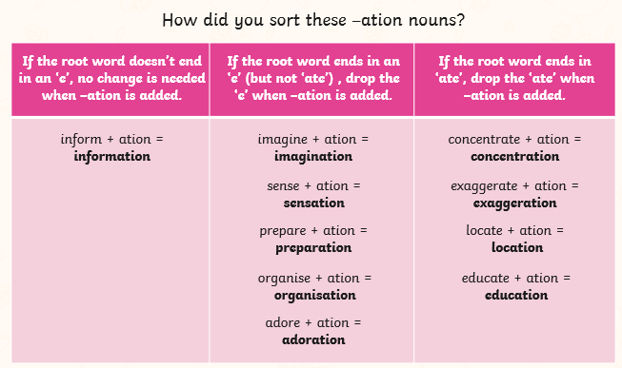
Spellings:
information
adoration
sensation
preparation
education
location
exaggeration
concentration
imagination
organisation

Maths:
TTRS – 5 minutes each day.

Reminders
- Reading Records to be in every day. I will change them as the children come to the end of the book but only when the parent has signed to state this.
- PE Kits should be in school every day. PE will be on Tuesday and Thursday.
Thank you for your continued support.
Miss Entwisle

