Racial Justice Sunday 1st February 2026
Saints – around the world
The Catholic Church is called universal because it belongs to people all over the world. Saints come from many different countries, cultures and backgrounds, showing us that anyone can follow Jesus and live a holy life.
The Bible reminds us, “Whoever loves God must also love his brother and sister” (1 John 4:21), and the saints lived this out by caring for others and being faith filled and brave. Even though they were all different, they shared a love for God and for people, reminding us that we are one family and that everyone is called to live with faith, courage, and love.
Homework Task
- On the small template your teacher gave you, write this sentence in your home language:
“Whoever loves God must also love his brother and sister.”
Then decorate your work neatly and creatively.
- Read the information about Saint Euphrasia Eluvathingal (1877–1952).
After reading, write a short paragraph (blurb) about:
- Who Saint Euphrasia was
- How she showed love and kindness
- How you can be like Saint Euphrasia today
- Use the writing template your teacher has given you.

YEAR FOUR:
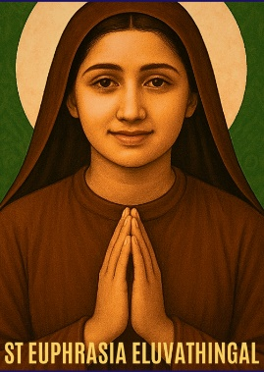
St Euphrasia Eluvathingal (1877–1952)
Country: India
How she lived out her faith:
St Euphrasia lived a life of prayer, service, and sacrifice as a Carmelite nun. She spent long hours praying for others and helping people who were suffering. Her faith was shown through humility, obedience, and deep trust in God.





