Homework
Year 4
Thursday 4th December
Please complete and return work completed in your homework book or on purple mash on Tuesday. Please ensure that you mark the homework.
Dear Parents,
Please see below for homework this week.
Reading
Please remember to read with your child daily and support them with understanding through comprehension of the text and not just decoding. Please sign and date the reading record. If you have any comments you wish to write about your child’s reading please do so.
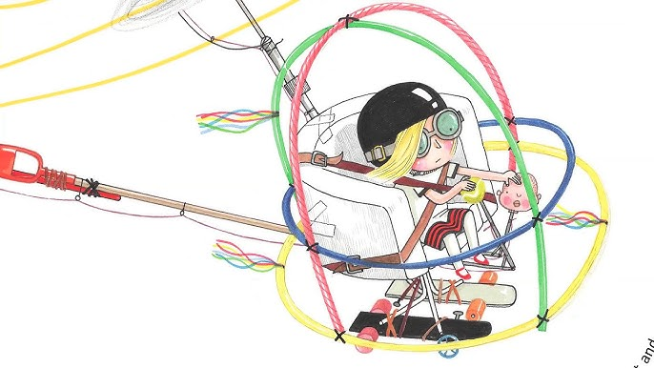
English:
Create your own imaginative design of a flying machine. You might be inspired by flying creatures or pure fancy but you need to label the various parts of your contraption such as armchair for a comfortable flight/ skateboard wheels for a smooth landing/ eagle feathers for lift off etc.
We will be using this in our English next week.
Spellings:
invention
injection
action
question
mention
attraction translation devotion
position
solution
Words with a /shuhn/ sound, spelt with ‘tion’ (if root word ends in ‘te’ or ‘t' / or has no definite root)

Maths:
Please complete TTRS!
Complete the multiplication work sheet.

Reminders
- Reading Records to be in every day. I will change them as the children come to the end of the book but only when the parent has signed to state this.
- PE Kits should be in school every day. PE will be on Wednesday and Friday next week.

I have put a lot of unclaimed PE uniform that I have put in the lost uniform box in the office.
Thank you for your continued support.
Miss Entwisle

