Dear Parents,

Next week is Design and Technology week and Year 3 are… cooking!

We will be rustling up lots of tasty treats throughout the week and the school will provide the majority of ingredients however, on the Friday it’s over to you!

Seasonal Tart

Please can you send your child to school with the following:

- 100g grated cheese
- Pack or ready rolled puff pastry

Then please choose 1 or 2 toppings from the list below:

- handful of sweetcorn
- half an onion (sliced)
- 4/5 mushrooms (sliced)
- handful of spinach leaves

Each child will need a baking tray that will fit the unravelled puff pastry on.

The children will bring the tart home to be cooked – I will send the information home next Friday.

If you have any problems at all then please get in touch

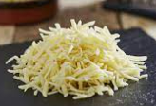
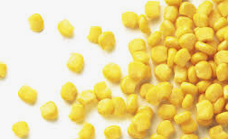
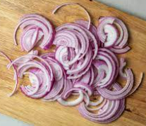
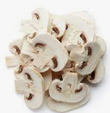
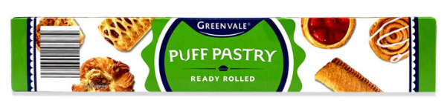
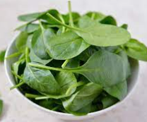
Mrs Ramsay

