Y3 English Homework week 13 (4.12.25)

Challenge 1:
Can you match the past and present verbs below? Think about how the spellings have changed for each.

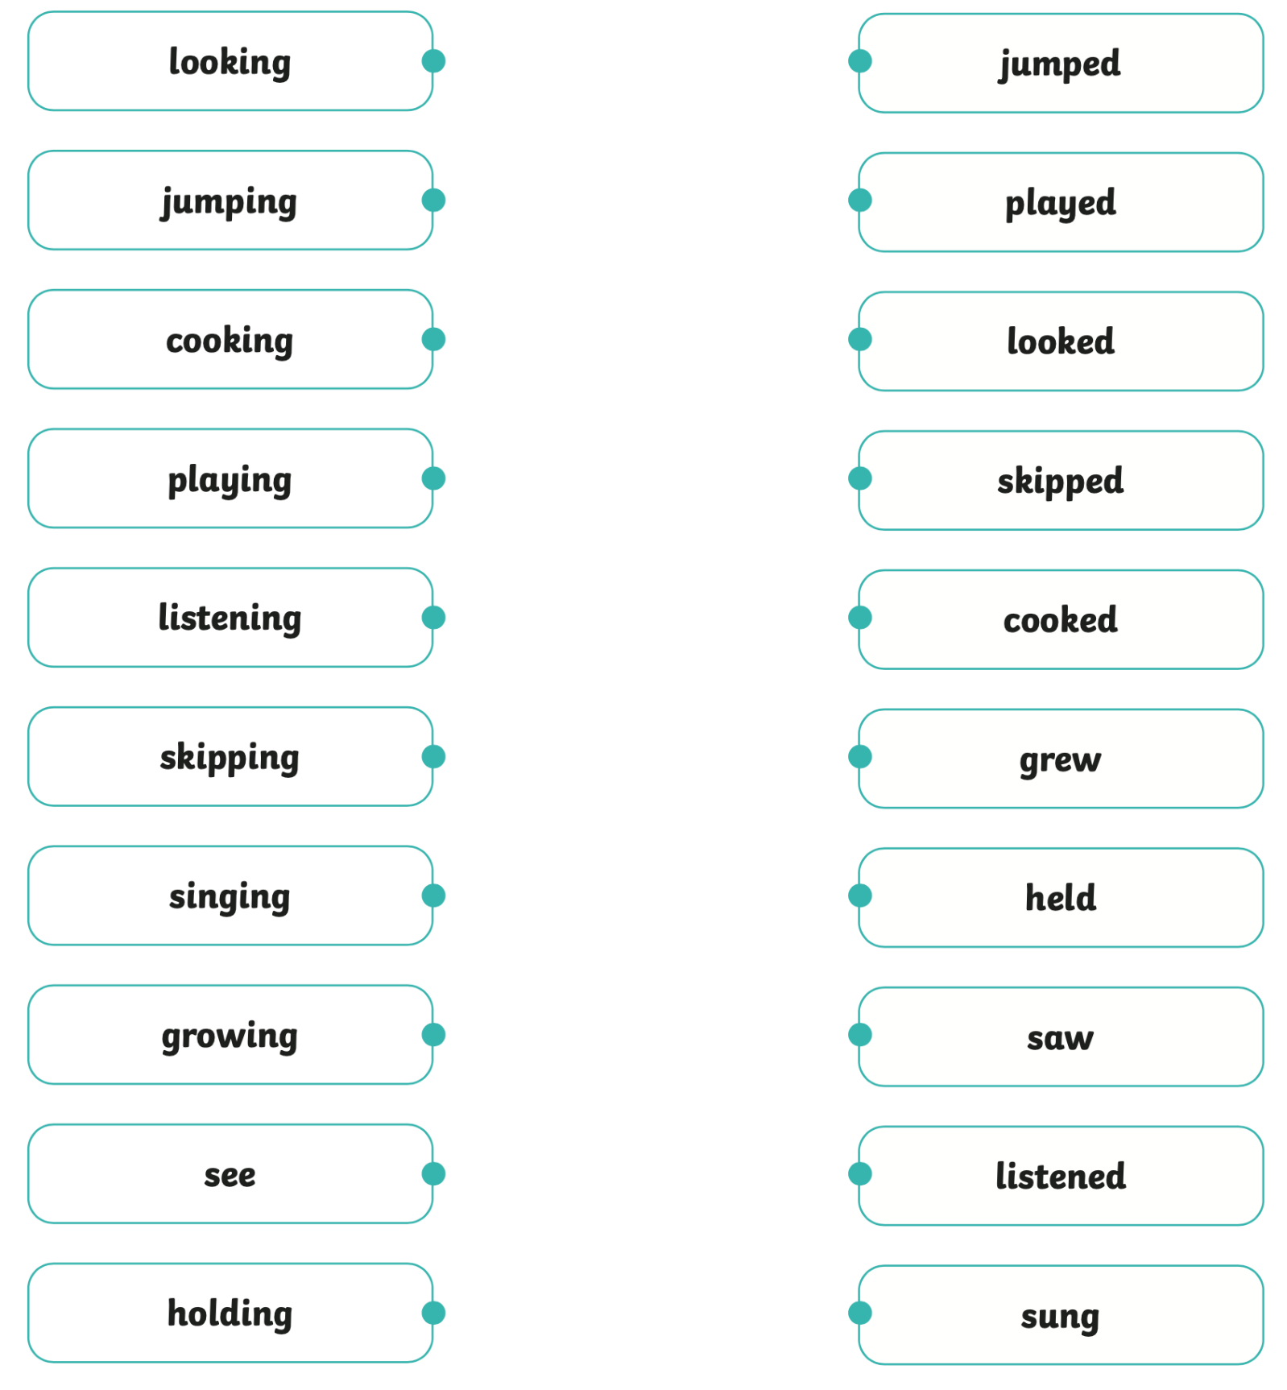

Challenge 1: Answers

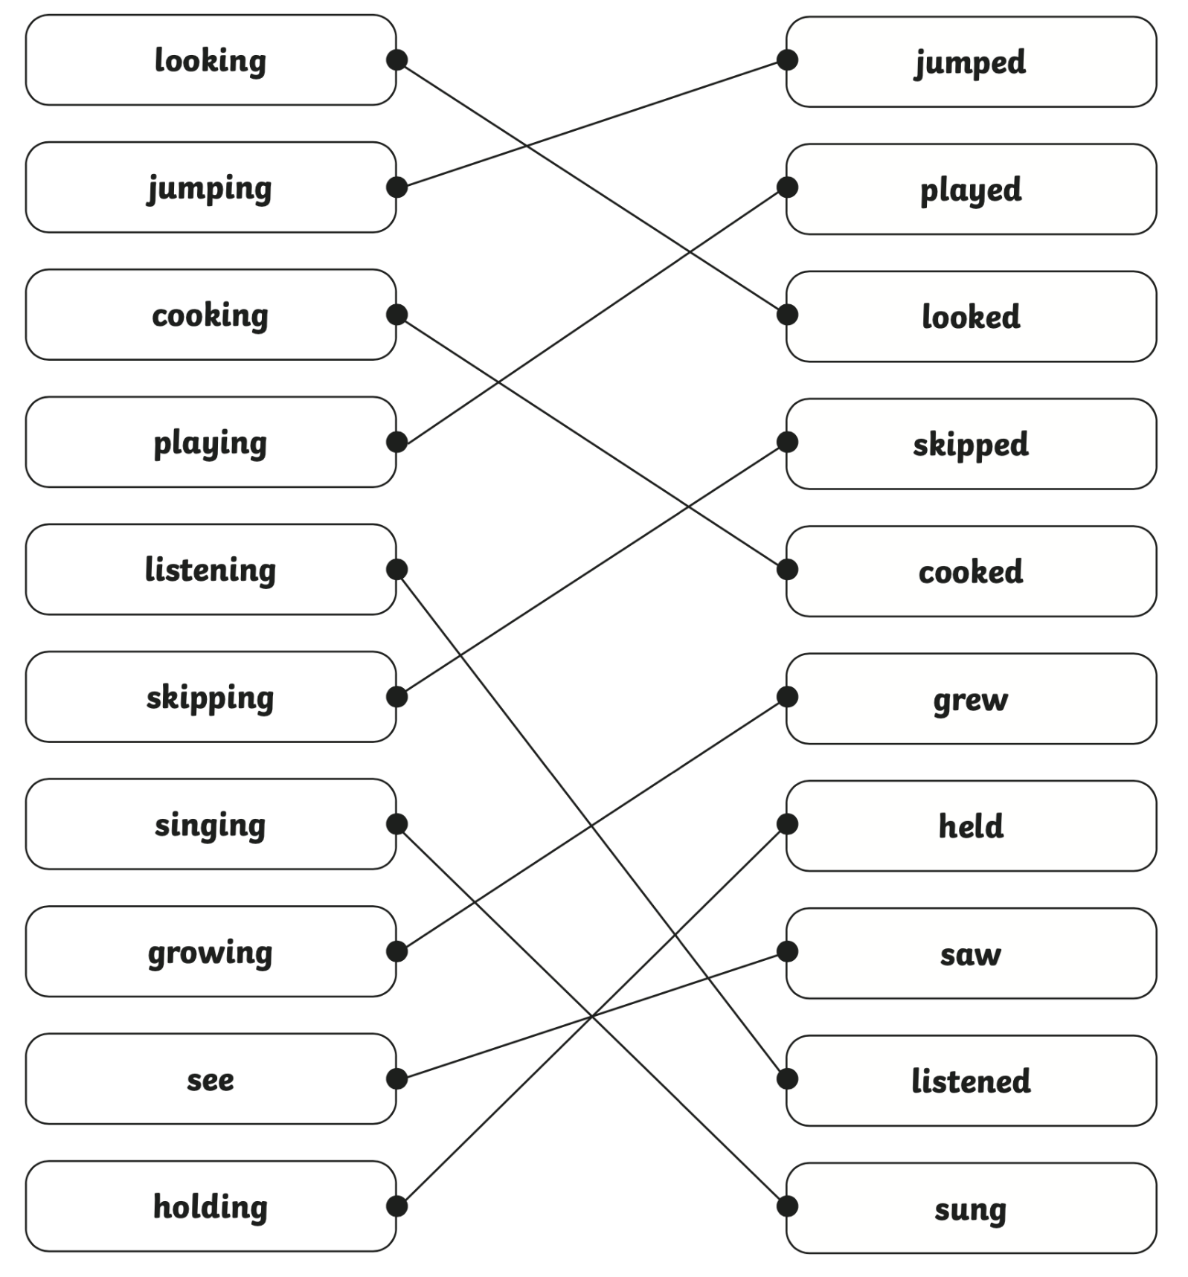

Y3 English Homework week 13 (4.12.25)

Challenge 2:
Change these sentences to the past tense.

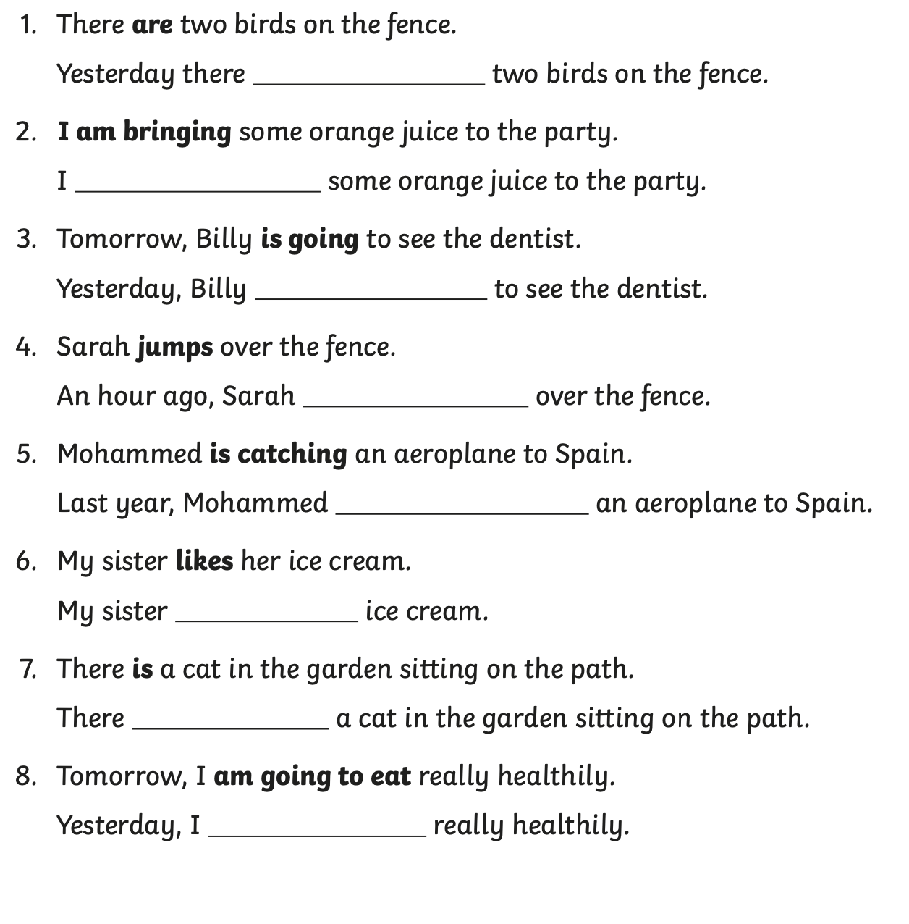

Challenge 2: Answers



