Y3 Maths Homework week 13 (4.12.25)

Challenge 1: Can you find the missing numbers to make a total of 100?
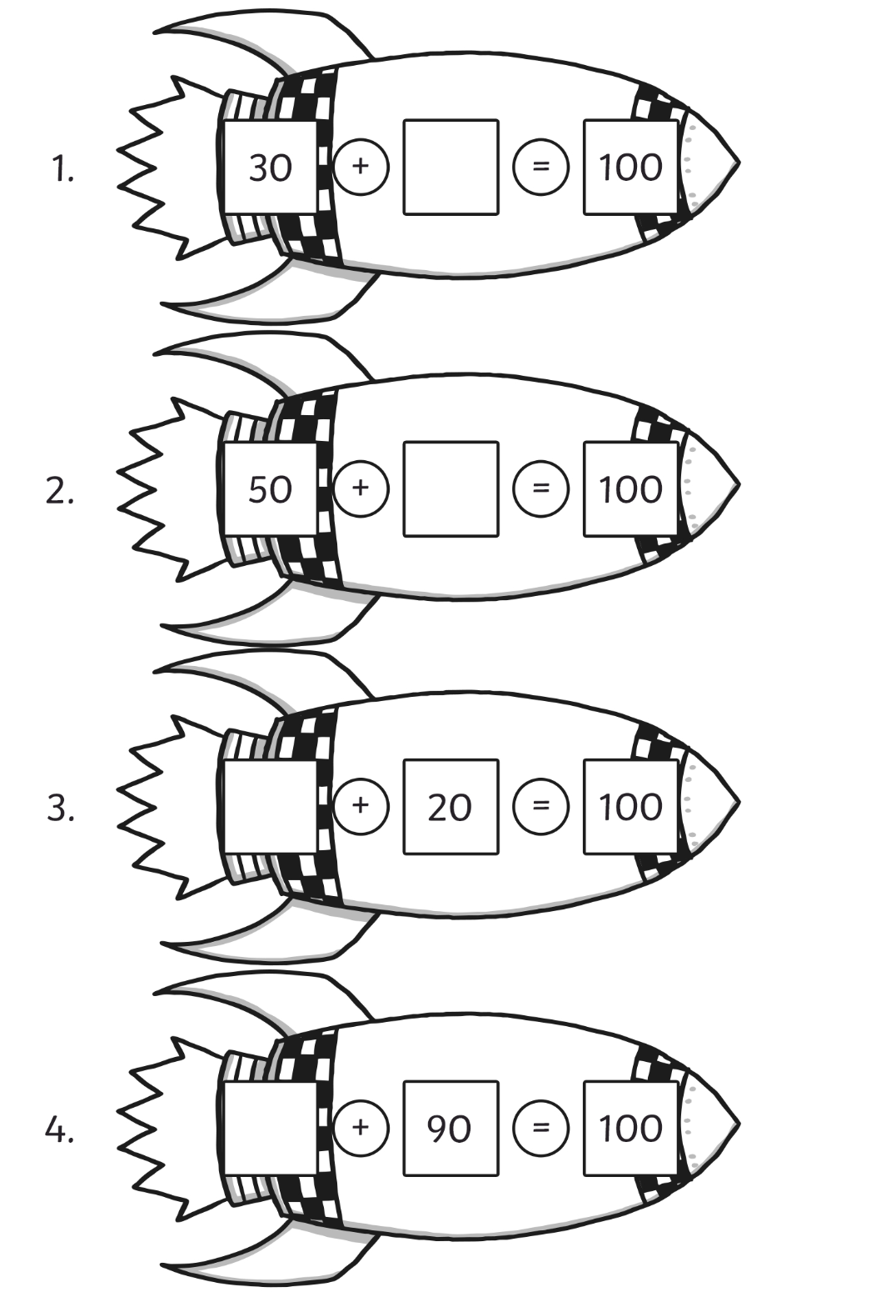
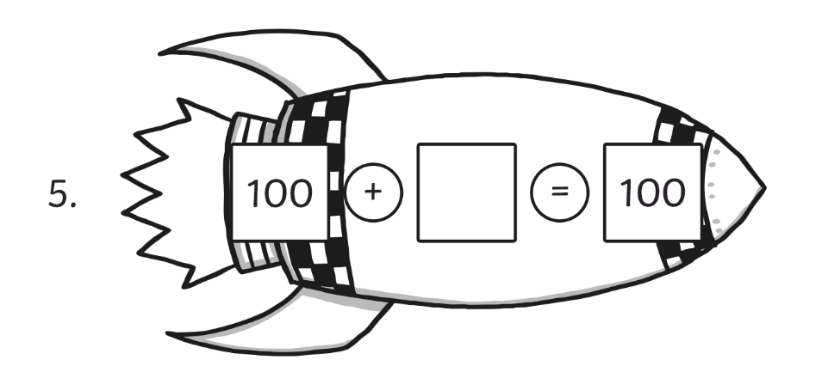

Now mark your homework using the answer sheet on the Year 3 class page on the school website please.

Y3 Maths Homework week 13 (4.12.25)

Challenge 2: Can you find the missing numbers to make a total of 100?

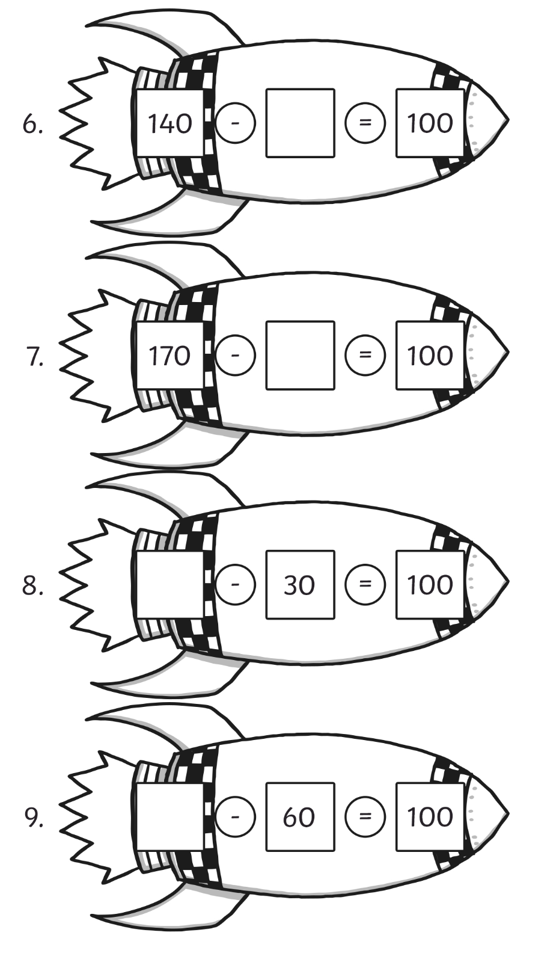
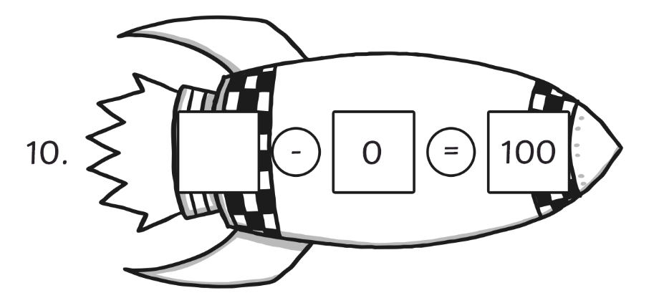
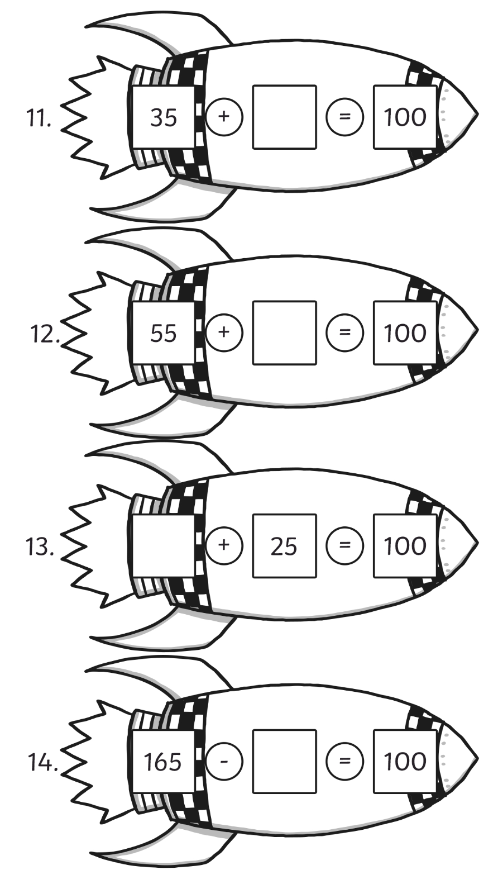
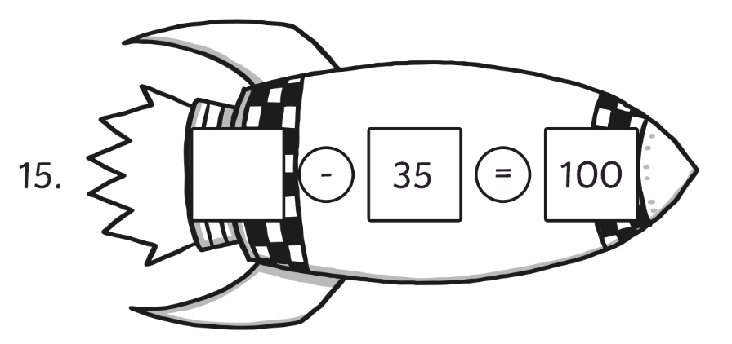

Now mark your homework using the answer sheet on the Year 3 class page on the school website please.
Y3 Maths Homework week 13 (4.12.25)

Missing numbers making a total of 100: ANSWERS:



