Homework
Year 3
Thursday 18th September 2025
Please just stick your completed question sheets into your Homework book.
Dear Parents: Please see below for Homework this week:
Homework Tasks:
1). Reading: Please remember to read daily with your child (about 20 minutes) and support them with understanding through comprehension of the text and not just decoding. Please sign and date the reading record. If you have any comments you wish to write about your child’s reading, please do so. Then send the signed Reading Record and book into school each day so that the Reading Record book can be checked and the book changed.
2). Spellings: Spellings are tested on Tuesdays and the new spelling pattern/rule introduced for that week. We are revising our vowel digraphs and this week we are looking at the ‘long e’ sound.
The spellings are published on the Class Dojo to give you plenty of time to practise them and a list of the spellings are stuck into your Homework Book every week as well.
3). English: Our English task this week is on the revision of Articles.
Articles are the words ‘a’, ‘an’ and ‘the’. They go before a noun. Use ‘a’ when the noun starts with a consonant sound (e.g. I need a holiday.) and use ‘an’ when the noun starts with a vowel sound (e.g. We had an argument.).
Task: Please stick the Articles sheet into your Homework Book and answer the three questions. Then check your work using the answer sheet which is on the Year 3 class page on the school website. This work needs to be done by Tuesday (23.9.25).
4). Maths: Our Maths homework this week is on Number and Place value.
Task: Please answer the six questions and then stick the sheets into your Homework Book. Check your work using the answer sheet which is on the Year 3 class page on the school website. This need to be completed by Tuesday (23.9.25).
5) Y3 History Project: Stone Age to Iron Age.
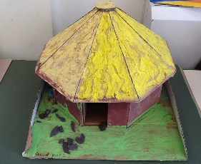
Please research and make a Stone Age necklace (try to make it look as authentic as possible) or design and make an Iron Age roundhouse. The choice is yours. Please hand in your project during the week beginning 6th October 2025. This will be put on our display for all to see
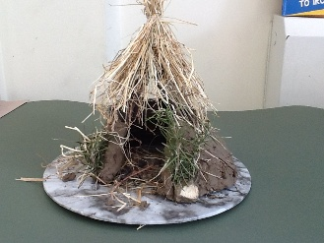 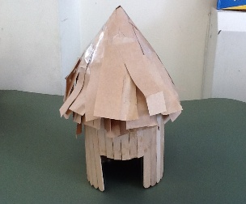 Reminders
Please remember to name your uniform, especially jumpers and cardigans.
We have PE every Wednesday and Thursday so please remember to bring your PE kit into school and keep it in your locker. Please remember to have trainers for PE.
Thank you for your continued support. Mrs Howard, Miss Cicero and Mrs Mills

