Y3 Maths Homework (Autumn 18.9.25)

Number and Place Value – please stick these two sheets into your Homework Book.

1). What number is represented below? _________

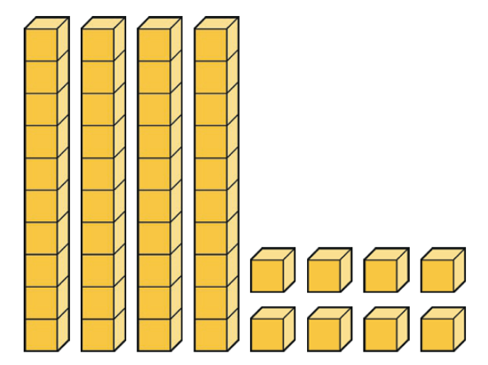

2). Match the representation to the correct number.
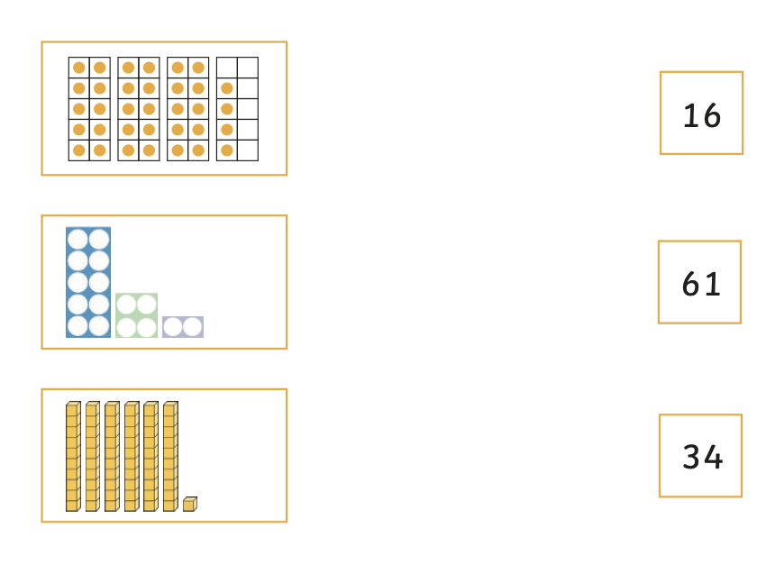

3). Draw arrows to show the position of each number on the number line.
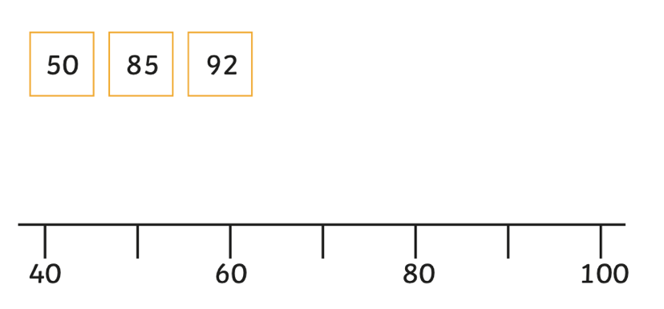

4). Complete the table using the correct numbers and words.

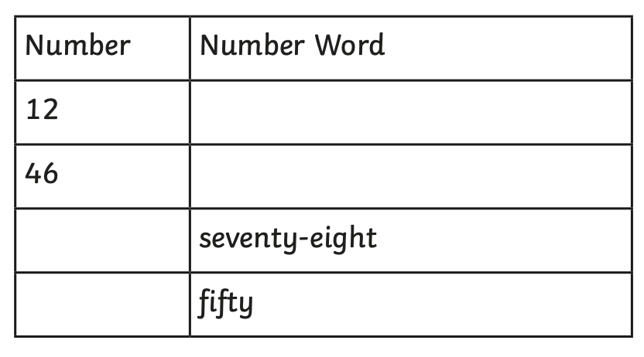
5). Match the numbers to the correct speech bubbles.
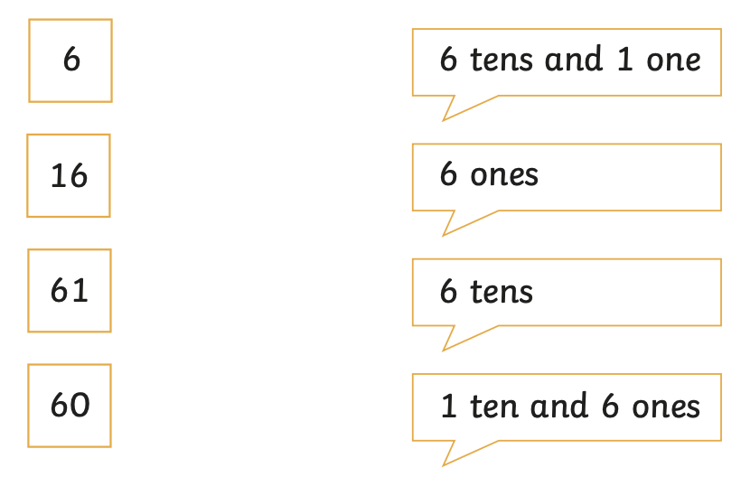

6).

a). Complete the part-whole diagrams.
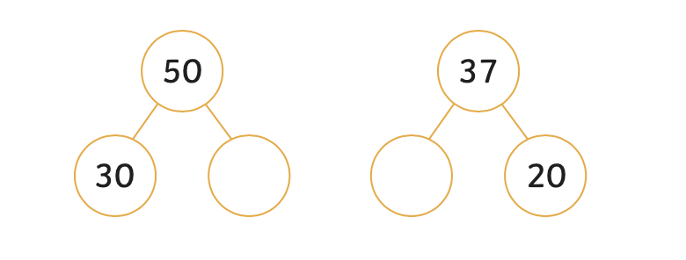

b). Find two different ways to complete these part-whole diagrams.

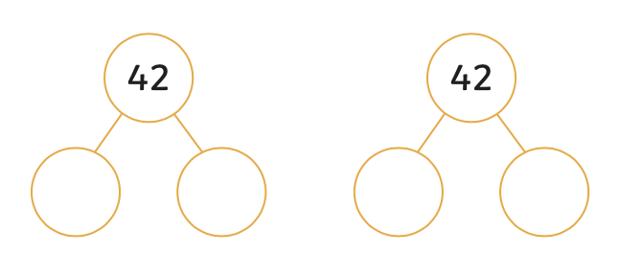

Y3 Maths Homework (Autumn 18.9.25)

Number and Place Value - ANSWERS

1). 48

2).
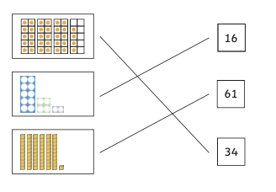
3).
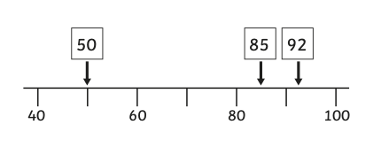
4).
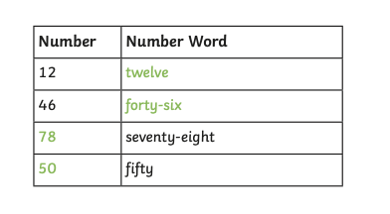
5).
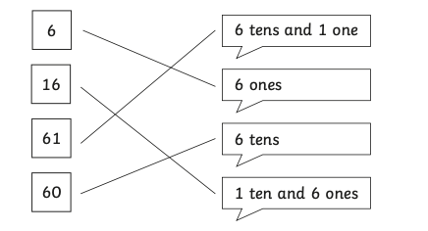

6).


