Y3 English Homework week 7 (16.10.25)
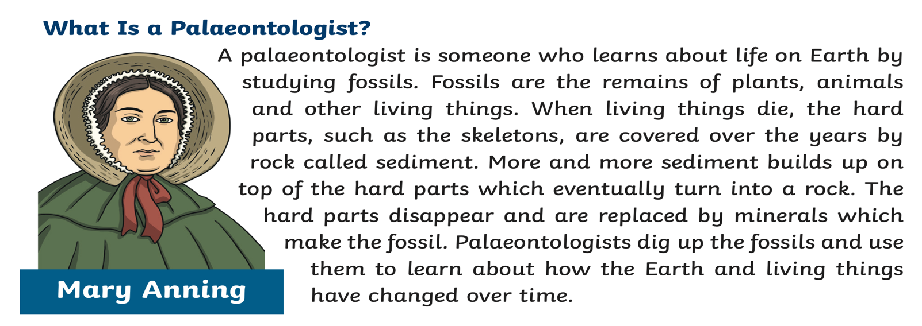
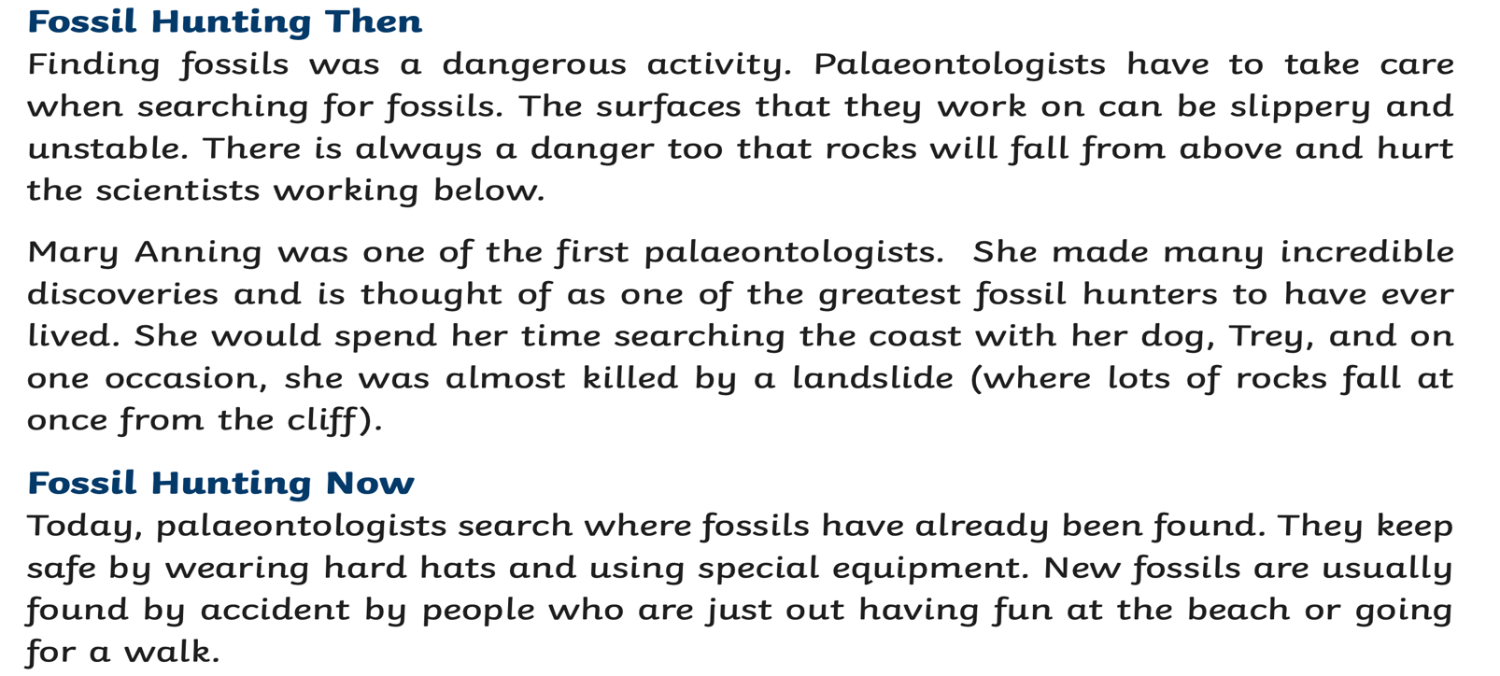
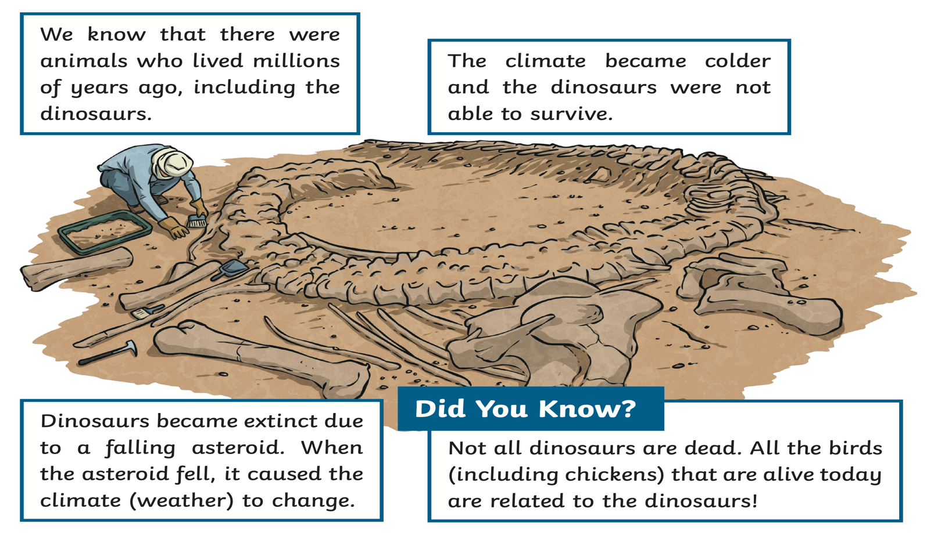
Y3 English Homework week 7 (16.10.25) Fossil Hunting Comprehension.

Please just stick this answer sheet into your Homework book.

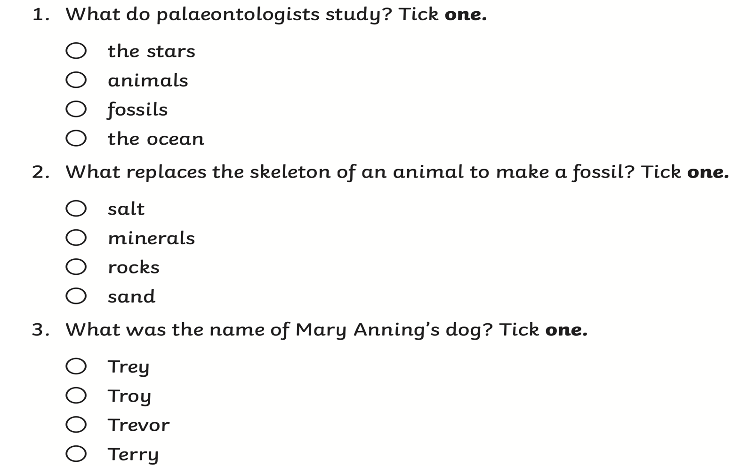

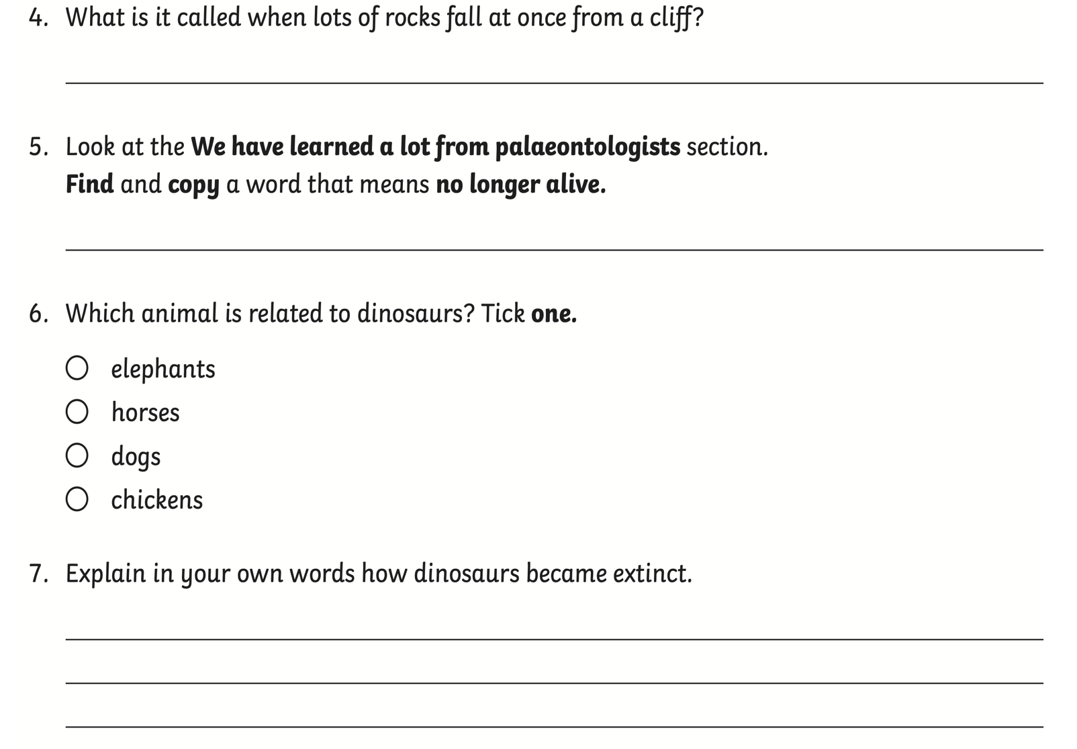

Y3 English Homework Fossil Hunting week 7 (16.10.25)Comprehension.

ANSWERS



