Y3 Maths Homework week 7 (16.10.25) Rounding to the nearest ten or hundred
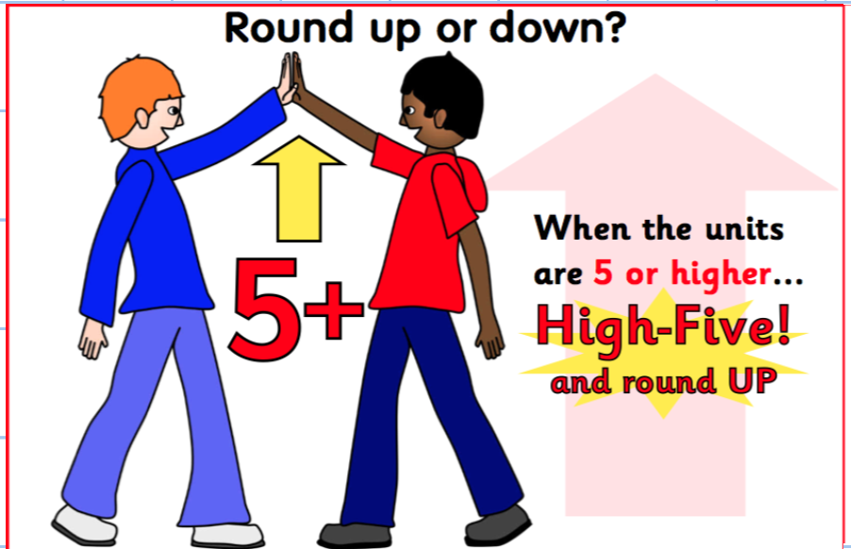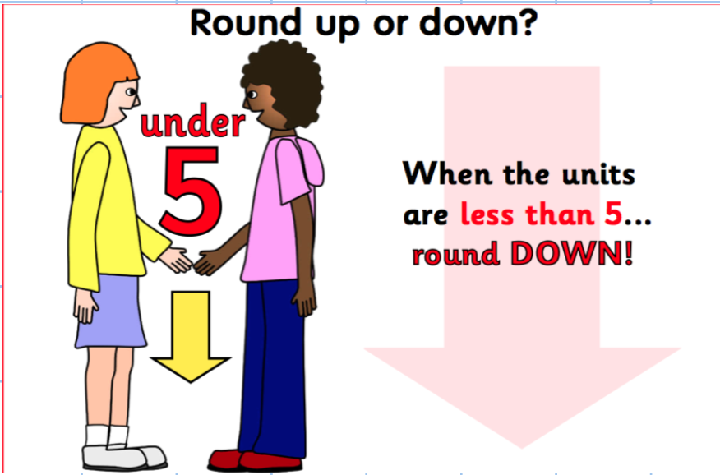
Challenge 1:
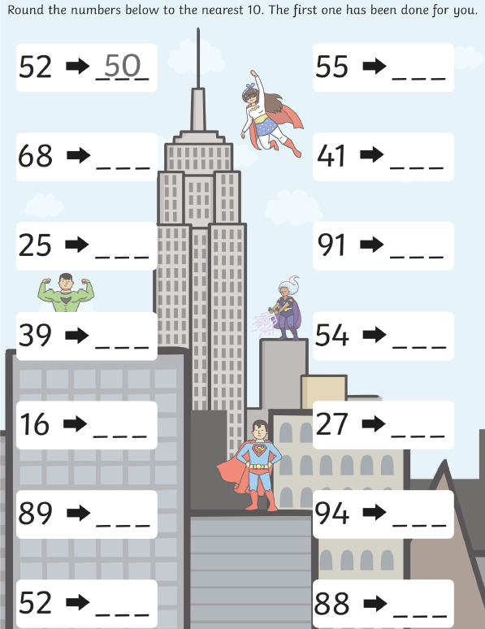
Y3 Maths Homework week 7 (16.10.25) Rounding to the nearest ten or hundred.
Challenge 1: ANSWERS:
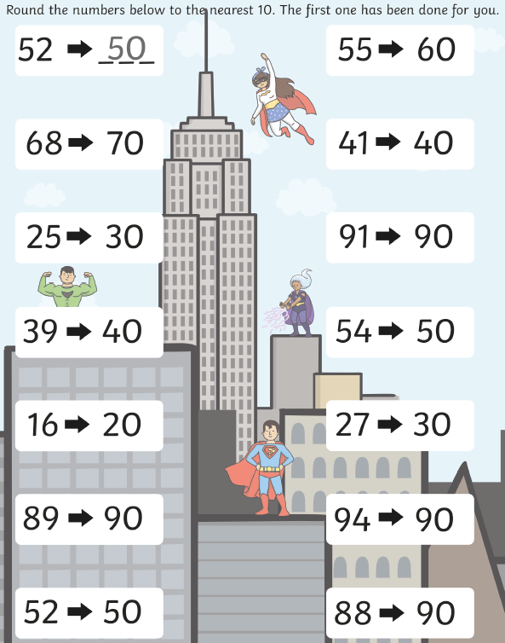

Y3 Maths Homework week 7 (16.10.25) Rounding to the nearest ten or hundred.
Challenge 2:

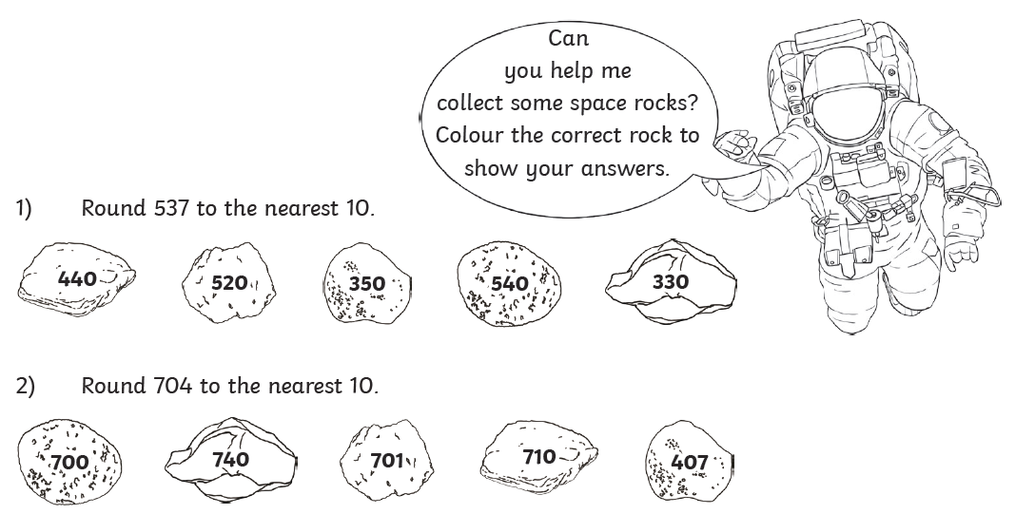
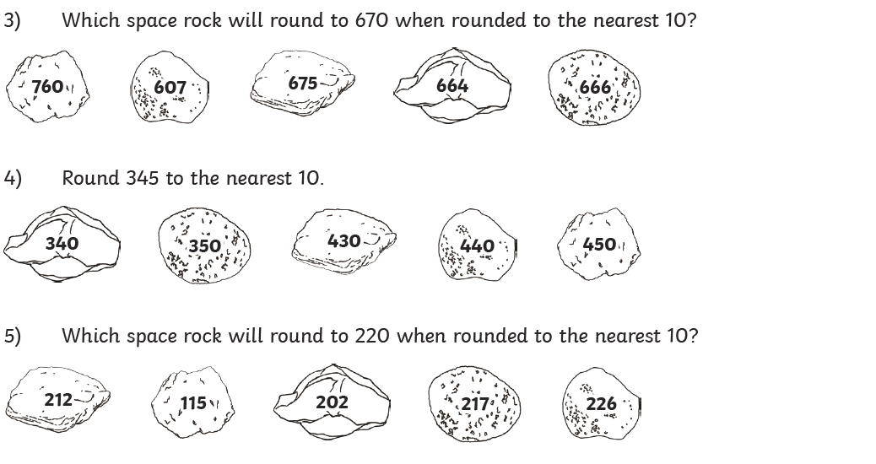

Y3 Maths Homework week 7 (16.10.25) Rounding to the nearest ten or hundred.
Challenge 2: ANSWERS



