Y3 English Homework Autumn 2 week 9
Comprehension page 1

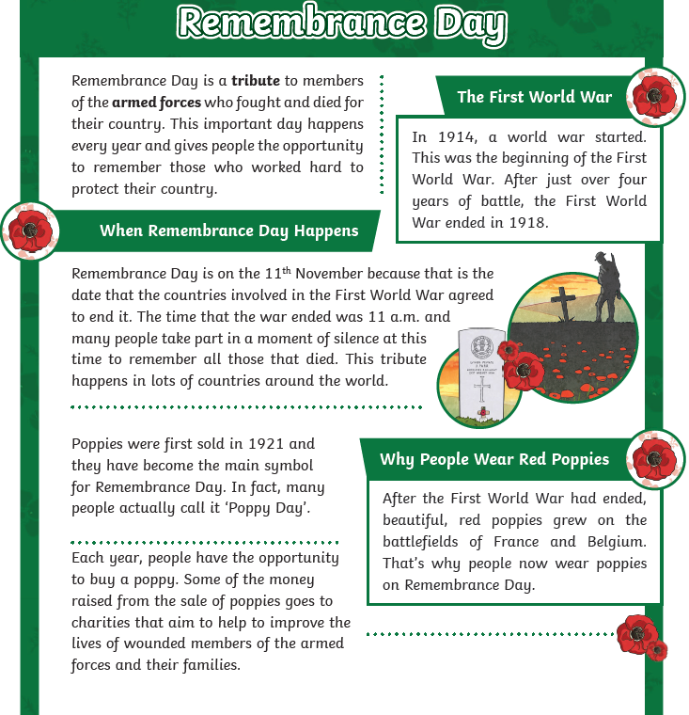

Comprehension page 2

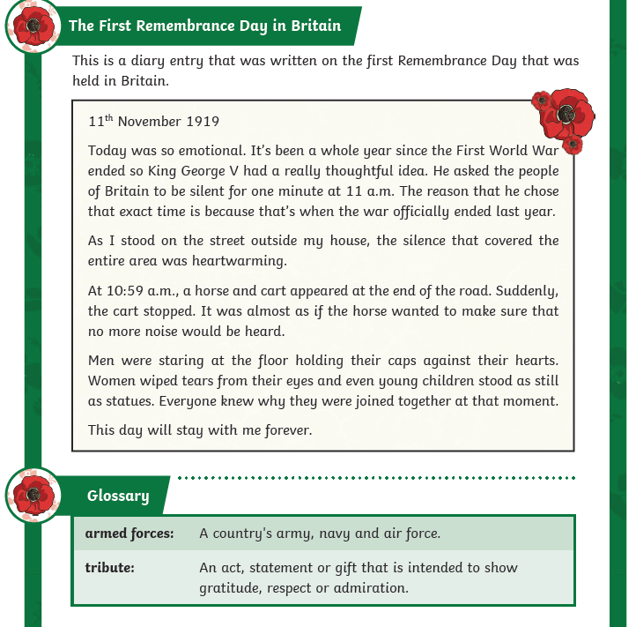

Y3 English Homework Autumn 2 week 9 Questions (Only stick this sheet in your Homework book).
REMEMBRANCE DAY
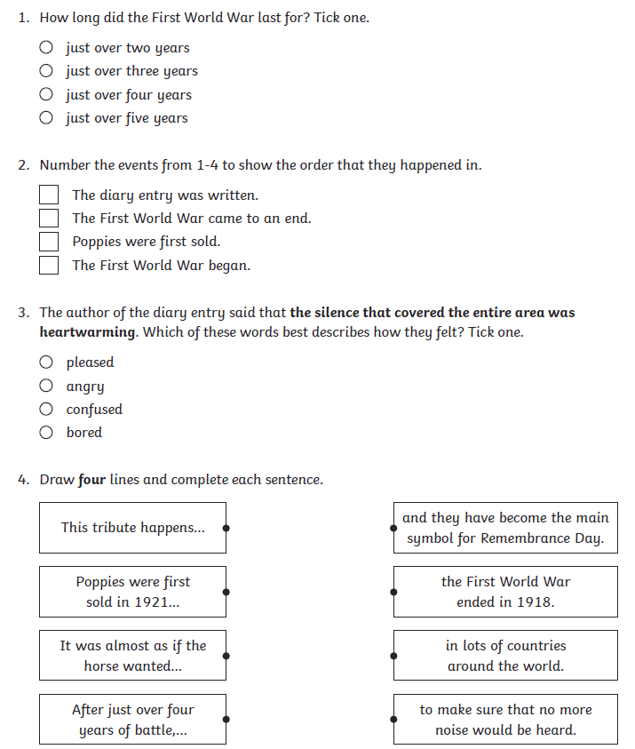

Y3 English Homework Autumn 2 week 9 Questions (Only stick this sheet in your Homework book).
REMEMBRANCE DAY
Page 2

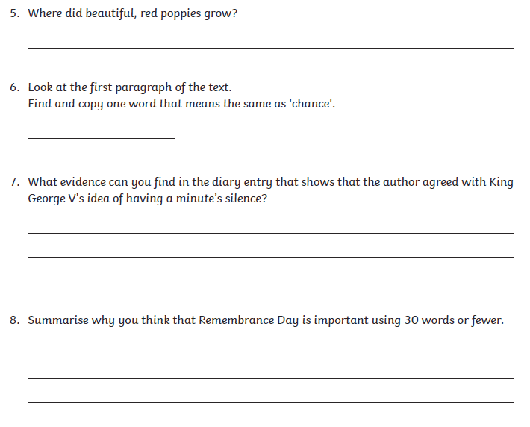

Y3 English Homework Autumn 2 week 9 ANSWERS
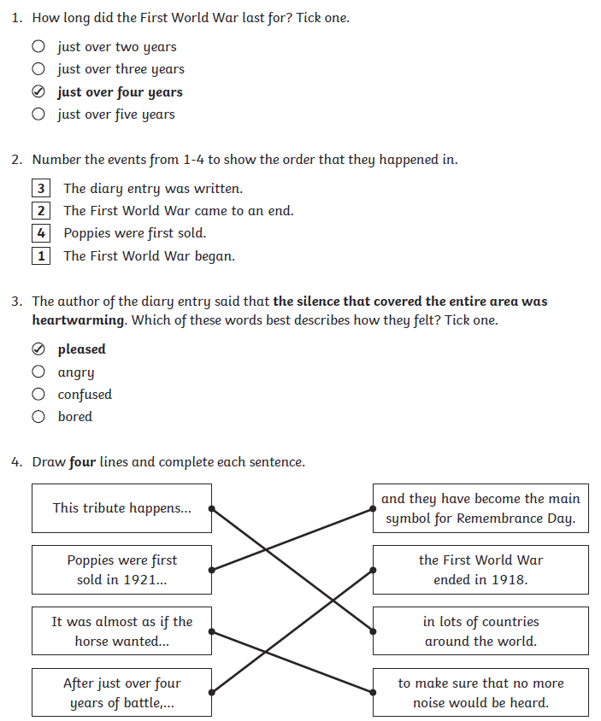

Y3 English Homework Autumn 2 week 9 ANSWERS
Page 2



