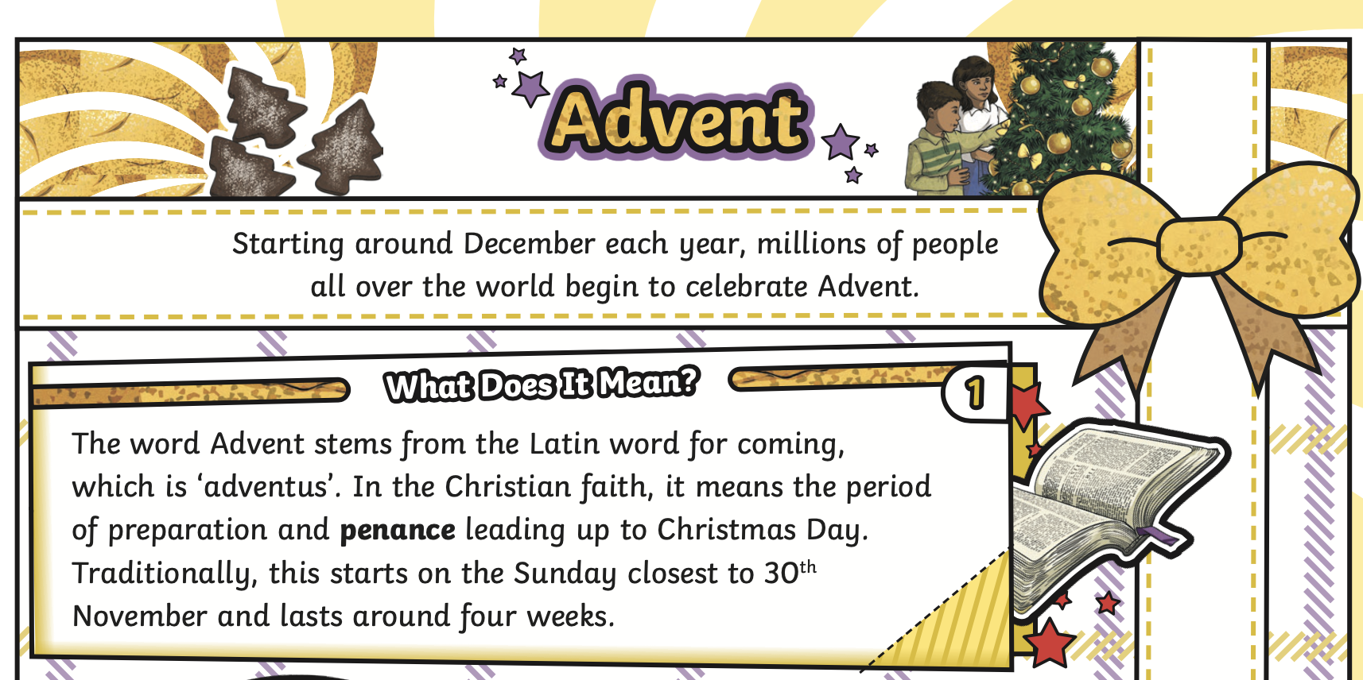
Y3 English Homework week 14 (11.12.25)
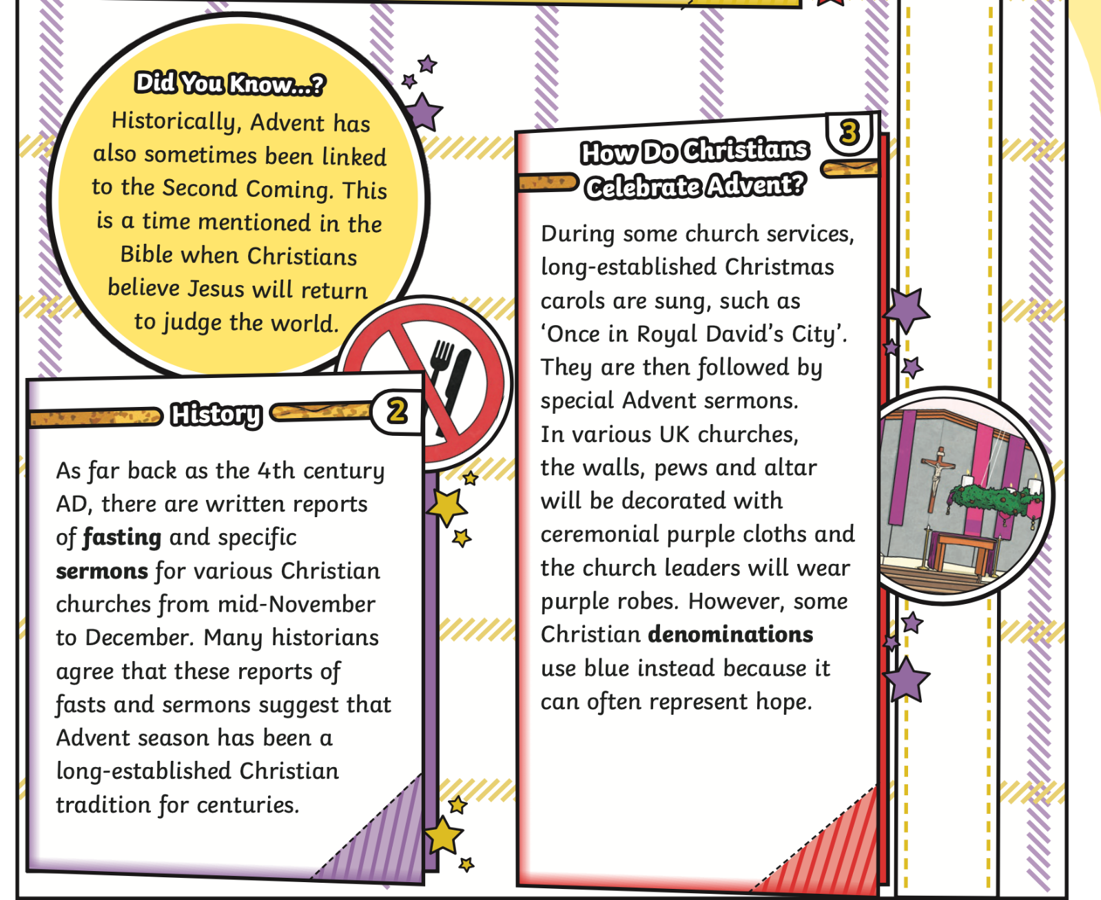

Page 2
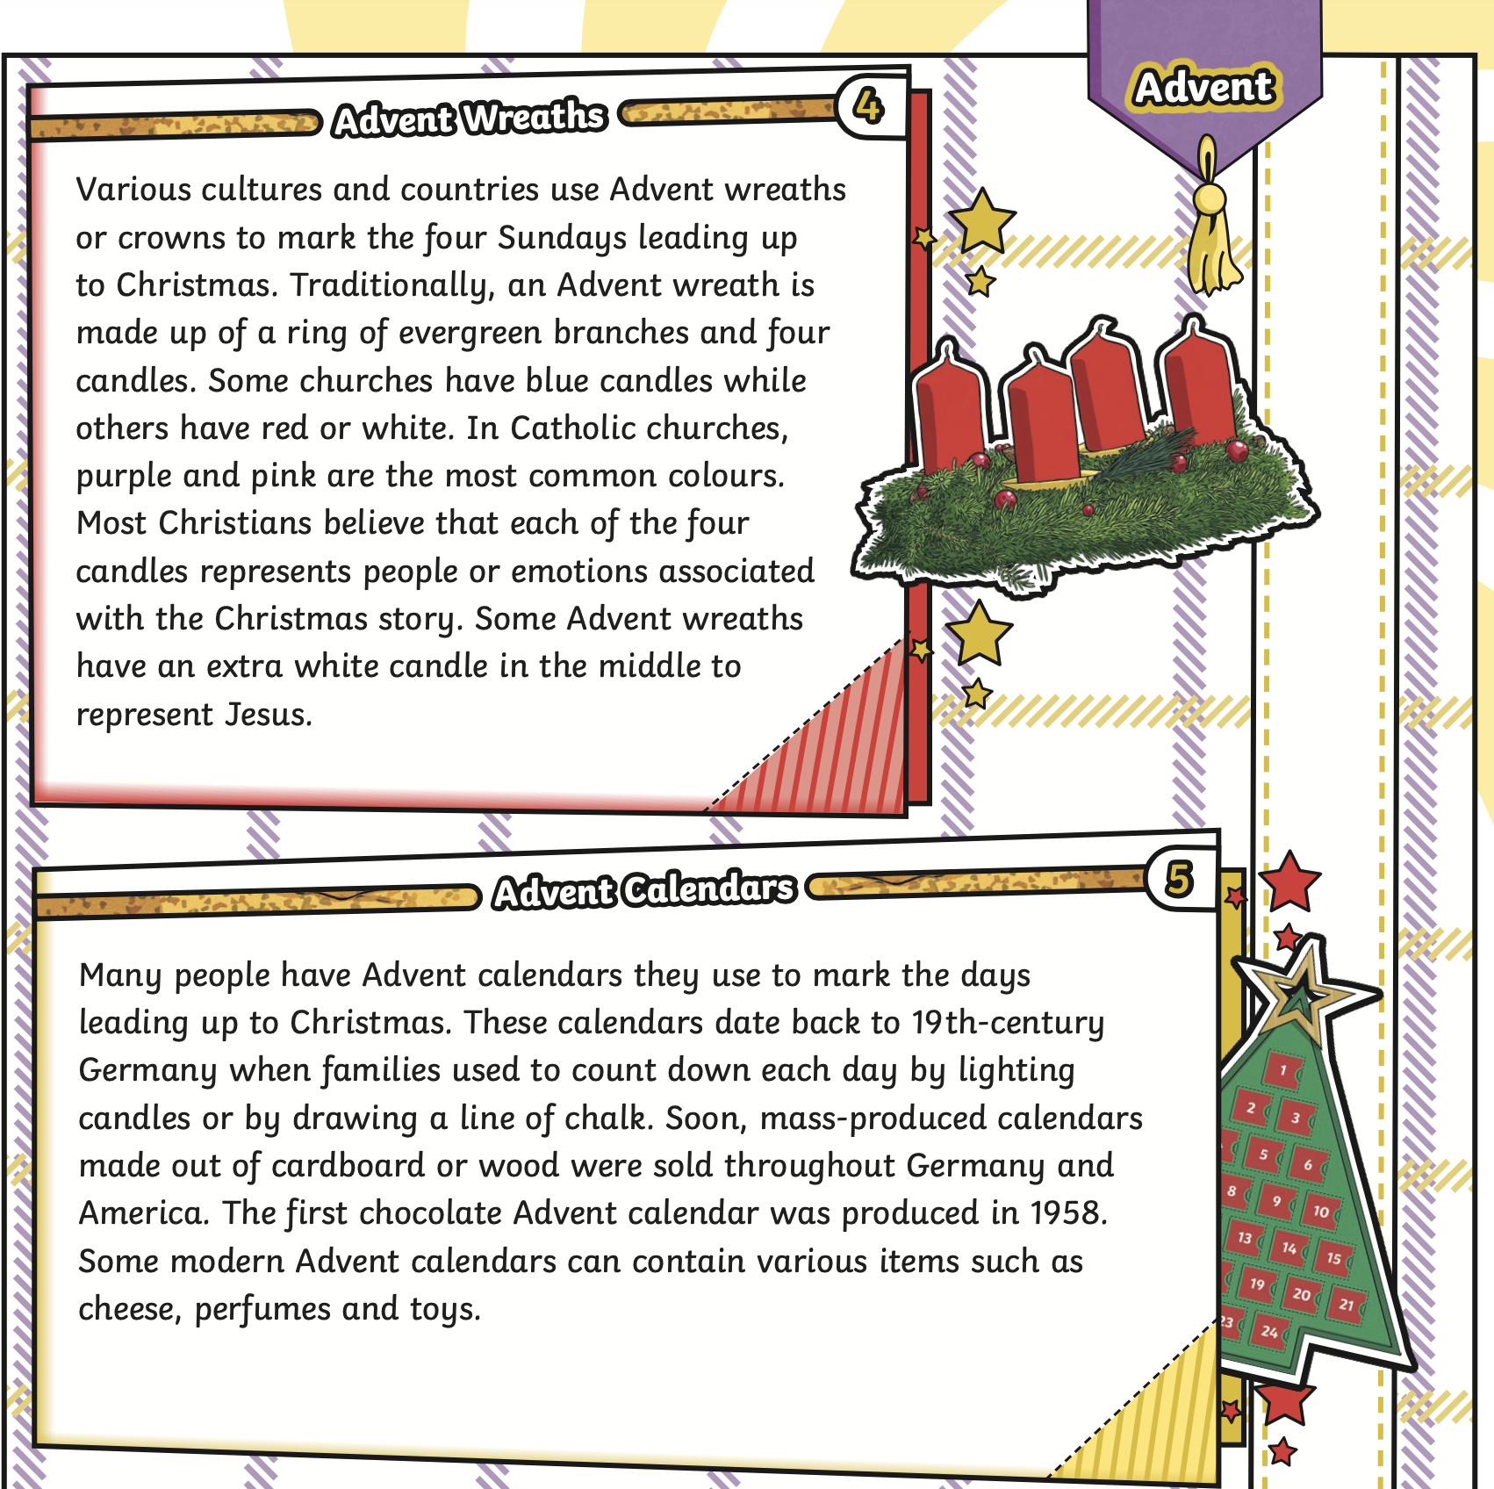

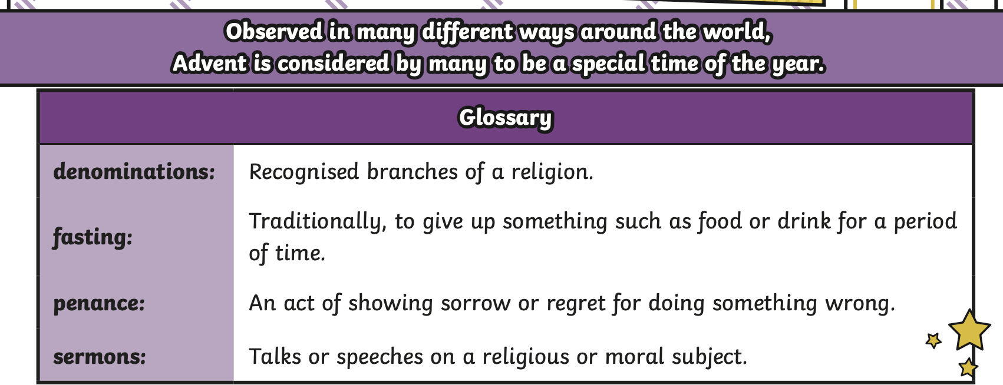

Y3 English Homework week 14 (11.12.25)
Just stick the answer sheet into your Homework book please.
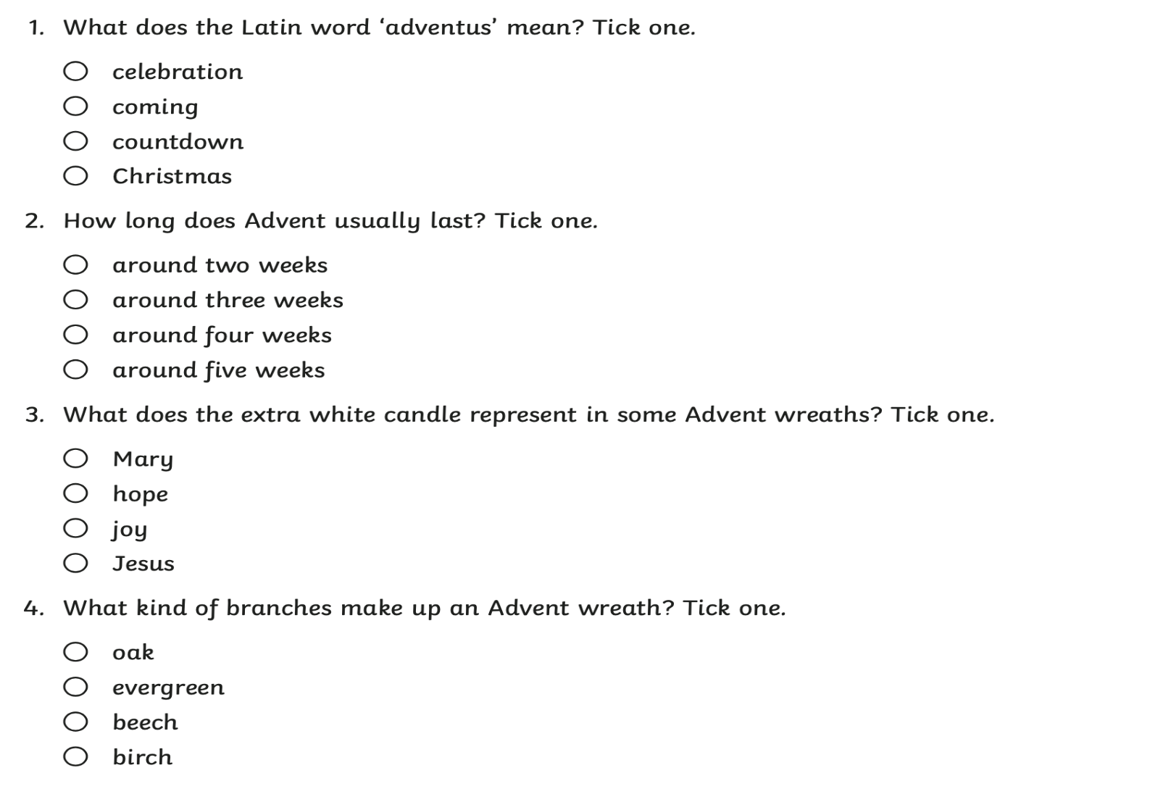
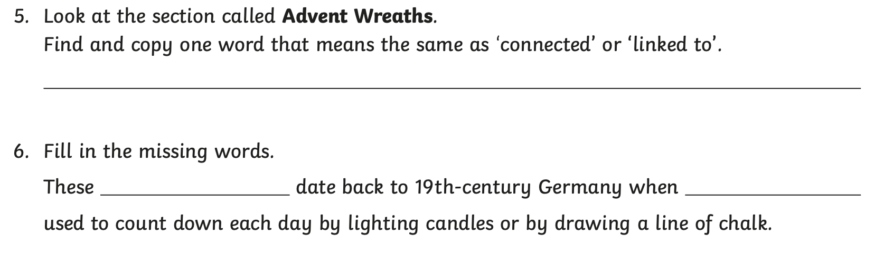
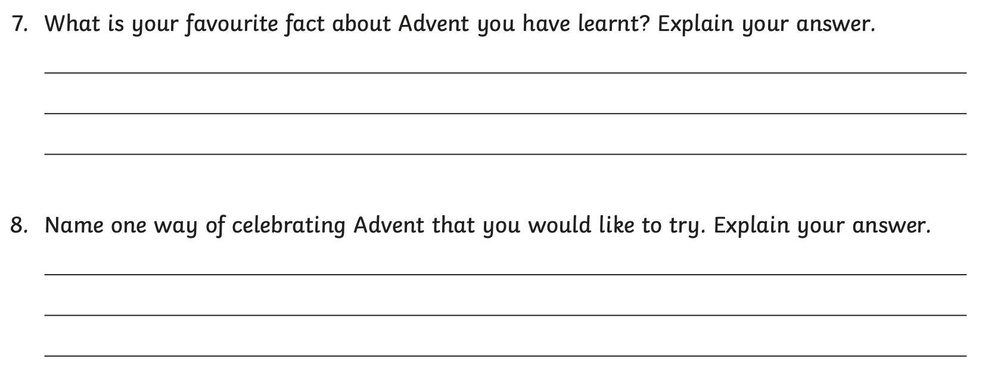
Mark your answers using the Answer Sheet on the Y3 Class News (Homework section week 13) on the school website.

Y3 English Homework week 14 (11.12.25) ANSWERS



