Y3 English Homework week 5 (2.10.25) Malorie Blackman
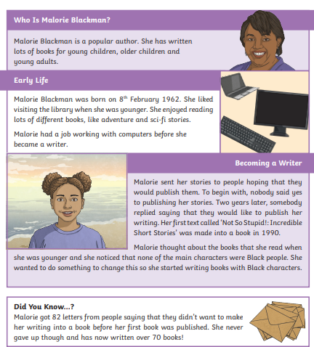

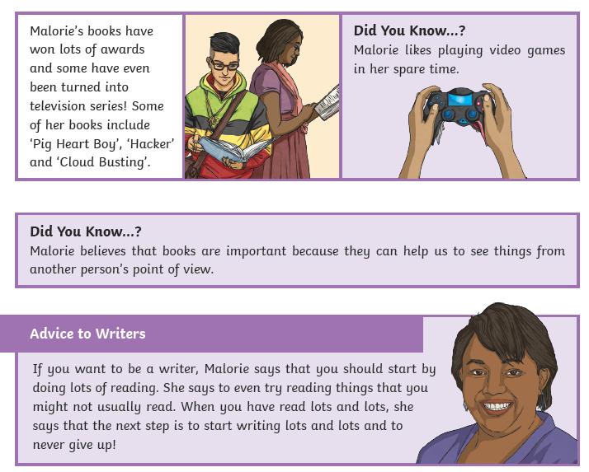

Y3 English Homework week 5 (2.10.25) Malorie Blackman Comprehension.

Please stick this answer sheet into your Homework book.
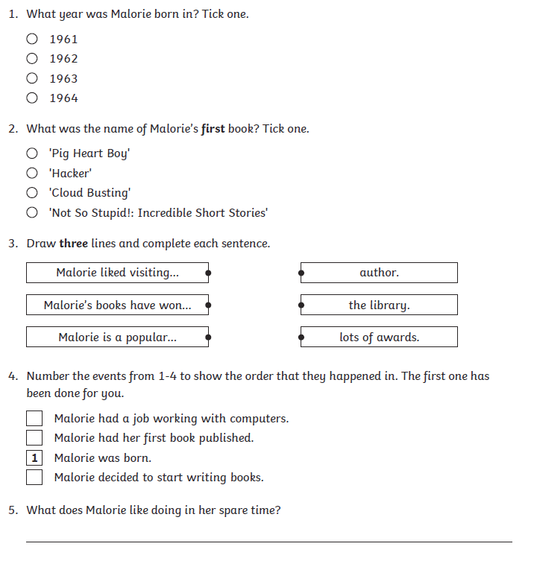


Y3 English Homework week 5 (2.10.25) Malorie Blackman Comprehension.
ANSWERS



