Y3. Maths Homework week 5 (2.10.25)

Lost in the Maze: finding 10 more or less than a given number. (Challenge 1).

Cody needs to find his way to the golden cup. Choose a starting number from the top of the grid.
Counting 10 less from that number each time, find the path to the cup. You can colour in each square of your path. You can travel in any direction apart from diagonally.
E.g.
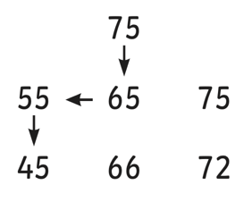

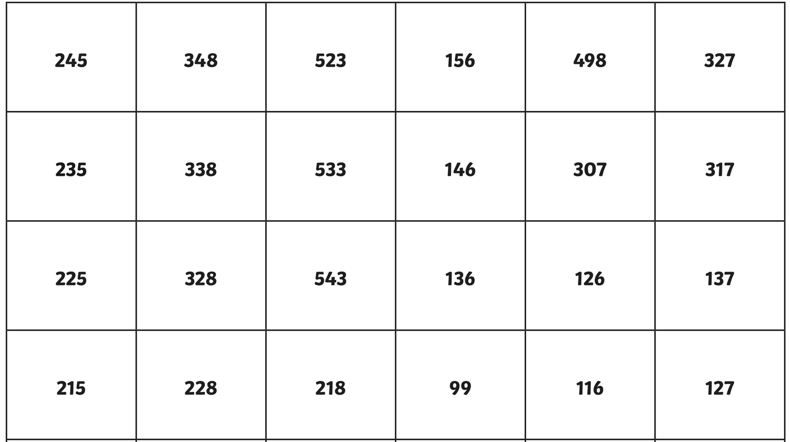
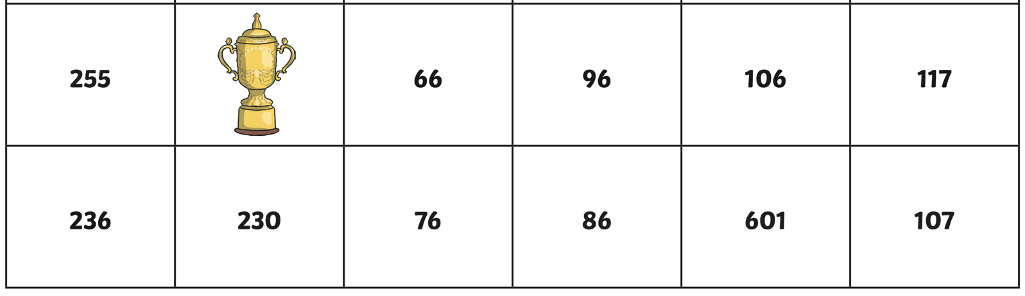

Y3. Maths Homework week 5 (2.10.25)

Lost in the Maze: finding 100 more or less than a given number. (Challenge 2).

Cody needs to find his way to the golden cup. Choose a starting number from the top of the grid.
Counting 100 more from that number each time, find the path to the cup. You can colour in each square of your path. You can travel in any direction apart from diagonally.
E.g.

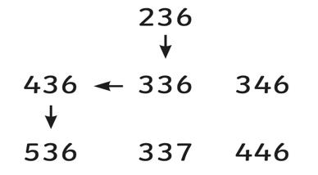

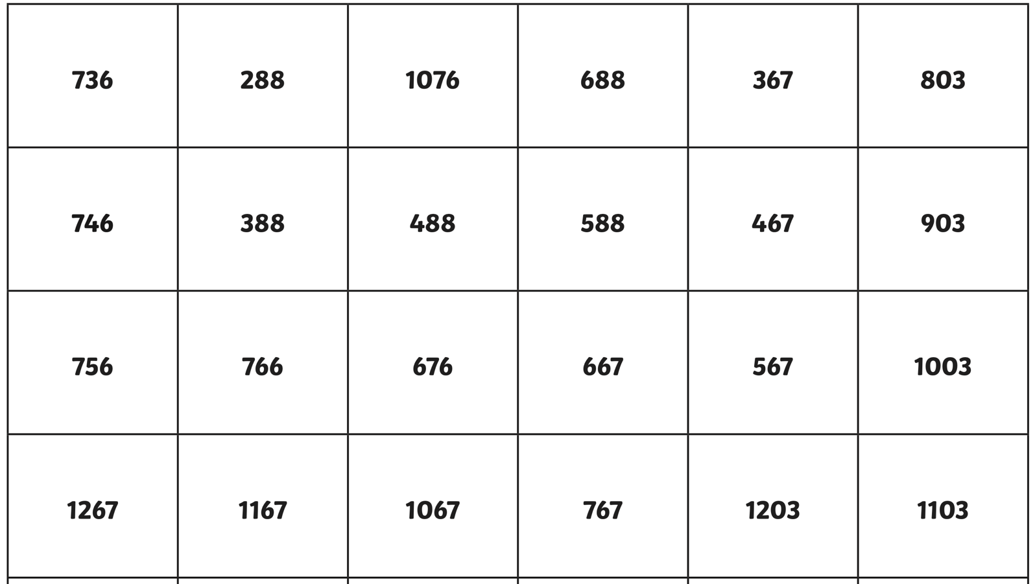
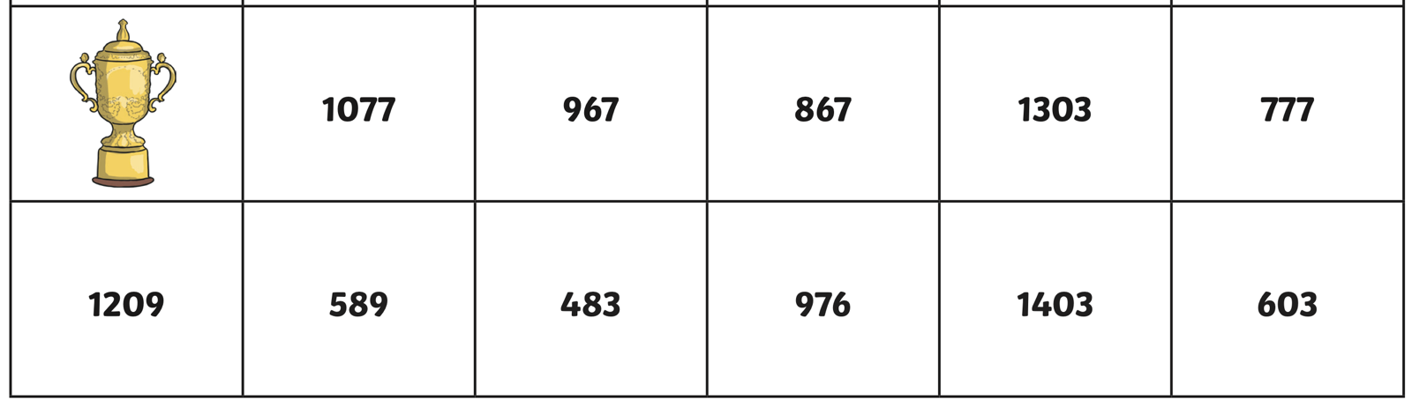

Y3. Maths Homework week 5 (2.10.25)

Lost in the Maze: finding 10 more or less than a given number. (Challenge 1). ANSWERS.

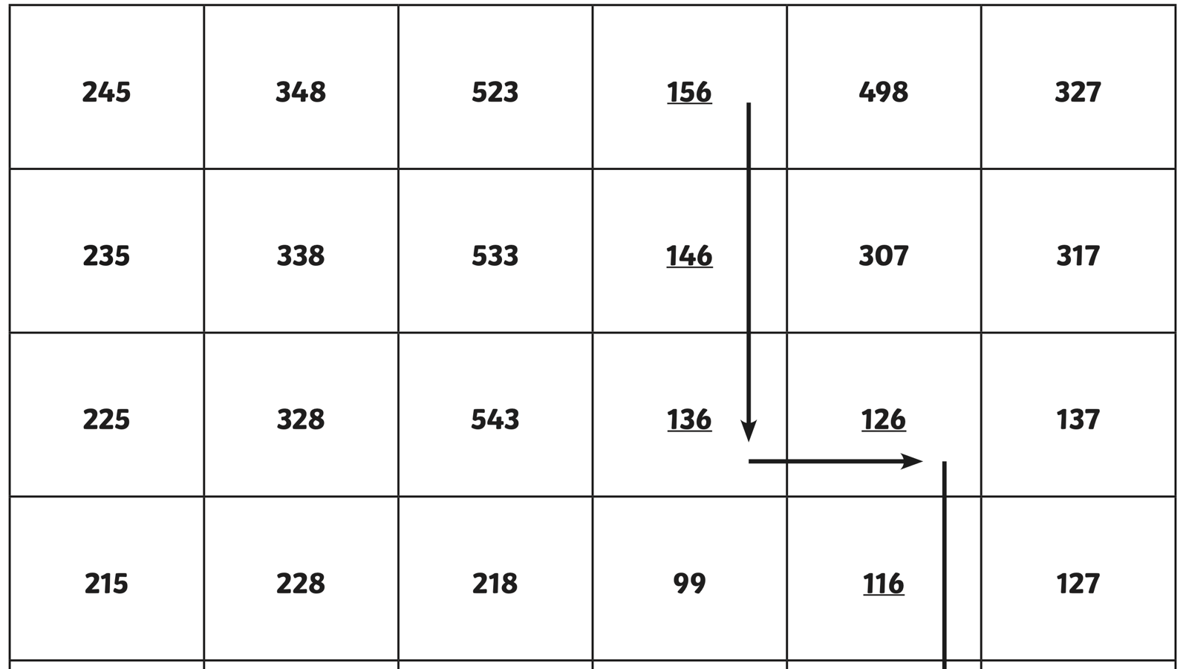
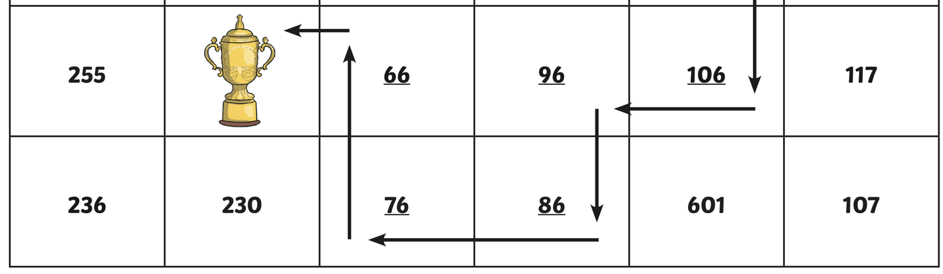

Lost in the Maze: finding 100 more or less than a given number. (Challenge 2). ANSWERS.



