Y3 Maths Homework week 6 (9.10.25)

Greater Than and Less than – Challenge 1

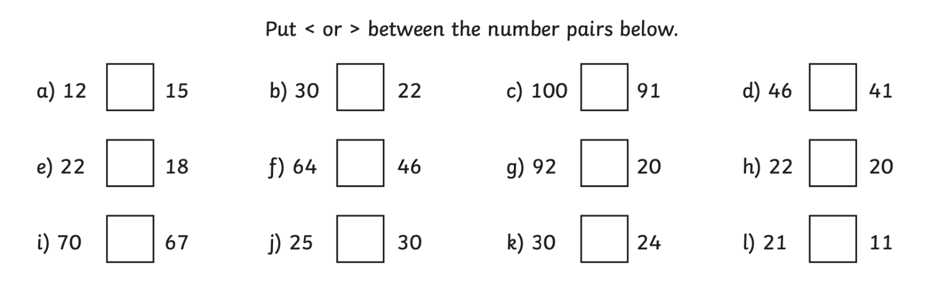
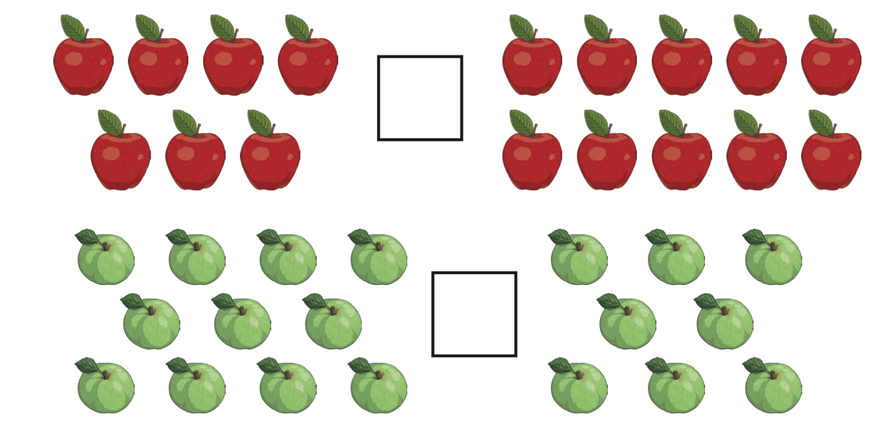___________

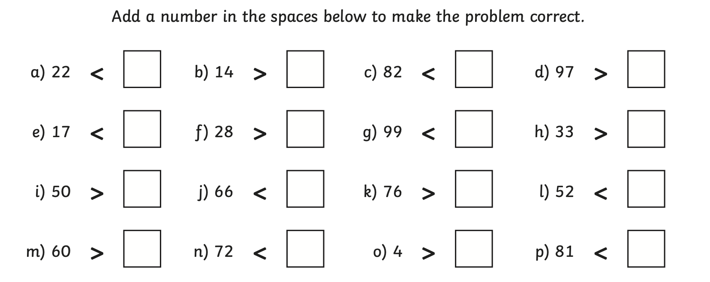

Greater Than and Less than – Challenge 1

ANSWERS

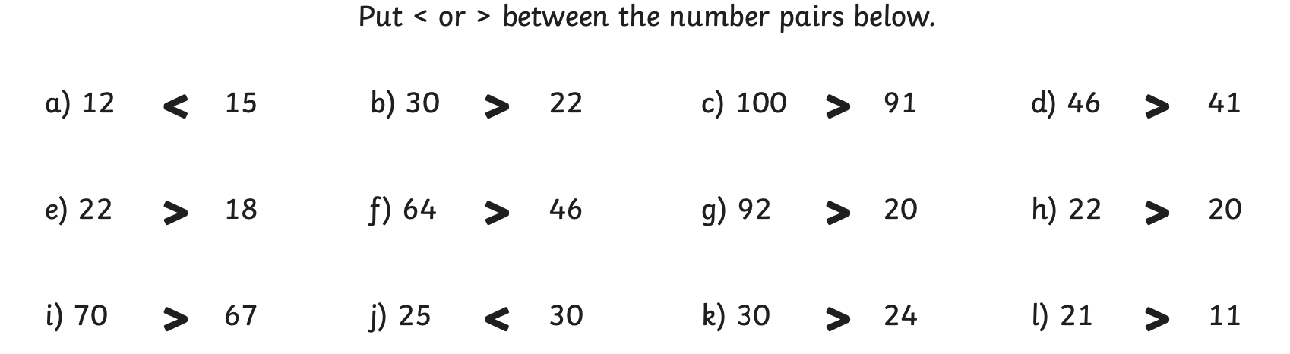
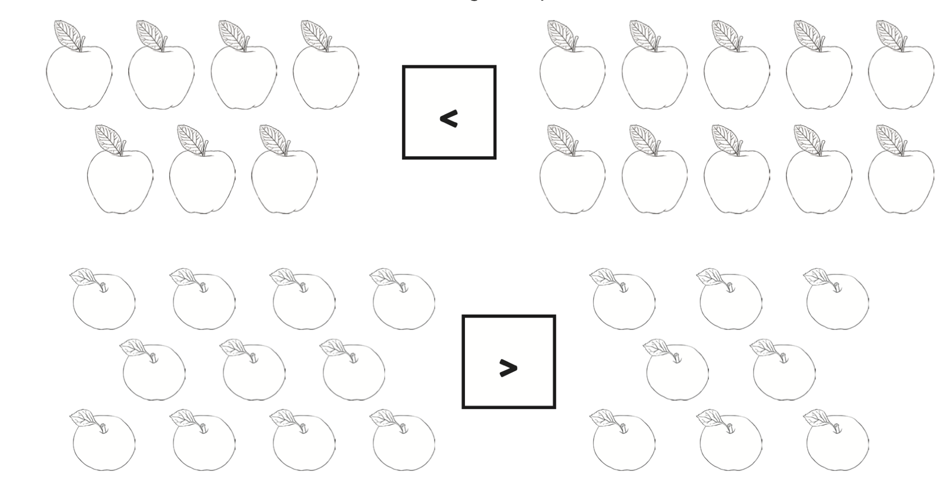

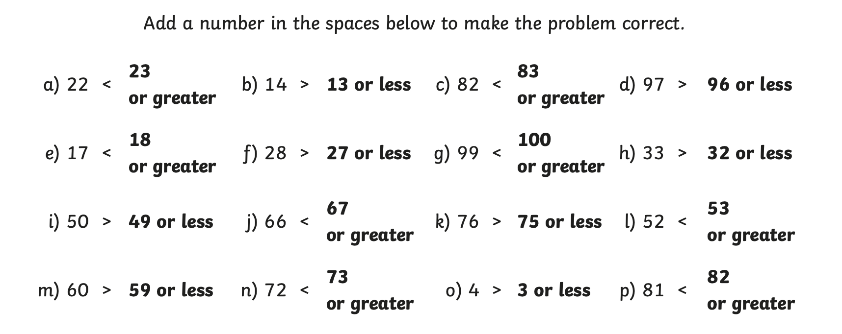

Y3 Maths Homework week 6 (9.10.25)

Greater Than and Less than – Challenge 2

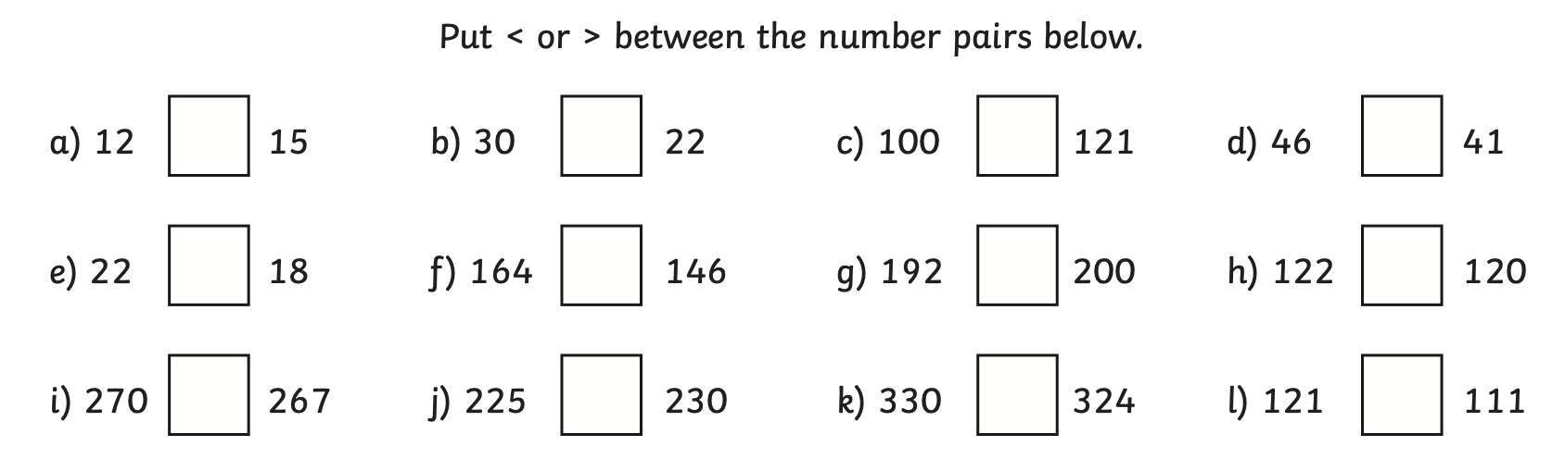

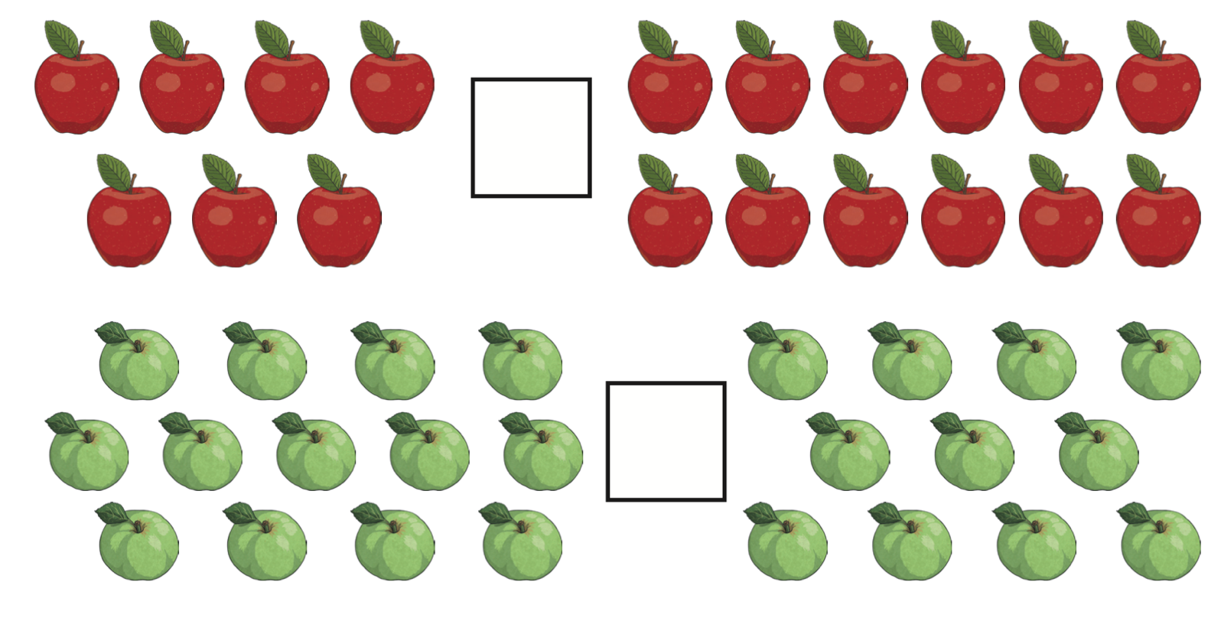

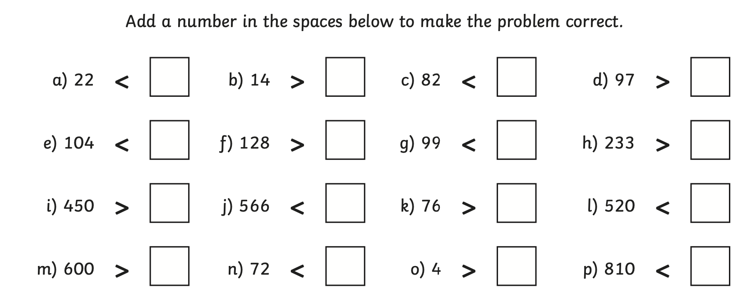

Greater Than and Less than – Challenge 2

ANSWERS



