Year 3 Science: Rocks
Famous scientists: Mary Anning.
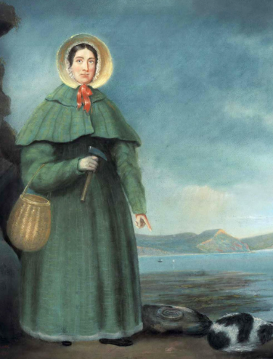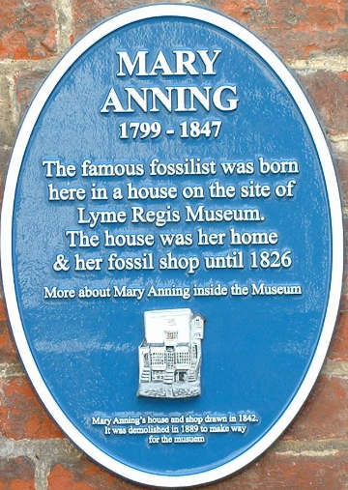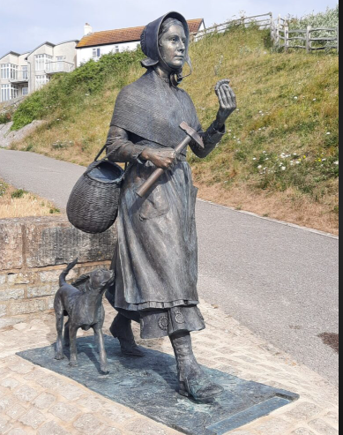
Mary Anning was born in the seaside town of Lyme Regis, Dorset, UK, in 1799. Although her parents had ten children, only Mary and her brother Joseph lived to adulthood. It’s said Mary had a lucky escape when she was a baby. The lady holding her was struck by lightning. Miraculously, little Mary survived.
Mary’s father didn’t earn much in his job as a cabinet maker, so he boosted the family’s earnings by looking for fossils (known as ‘curiosities‘ back then) at the beach and selling them to holidaymakers. Young Mary and Joseph would join him, and they developed a deep love of fossil-hunting.

After their father’s death in 1810, Mary and Joseph carried on fossil hunting, to support the family. In 1811, when Mary was 12, they uncovered a strange 5.2-metre-long skeleton! At the time, people believed that any unrecognisable creatures must have travelled from far-off lands, so scientists simply thought it belonged to a crocodile. Eventually, though, they realised it was an ancient species, and it was named Ichthyosaurus – meaning ‘fish lizard‘.

Mary continued to scour the beach and crumbling cliffs of Lyme Regis with her dog Trey, and in 1823 she made another important discovery – the first ever Plesiosaur skeleton! This long-necked sea creature looked so odd that many people thought it was fake at first!

Mary made many other exciting discoveries, such as a flying reptile, later named the Pterodactyl, and coprolites – fossilised poo – which helped her work out what dinosaurs ate! Having taught herself geology, anatomy and scientific illustration, Mary was so highly skilled that she took important scientists fossil hunting and discussed ideas and theories with them.

Mary died in 1847. Although she was well-known for her discoveries, Mary wasn’t taken seriously as a scientist in her lifetime because of her gender and poor background. Some of the male scientists she worked with claimed her findings as their own! But today, Mary is recognised as a pioneer in the field of palaeontology (the study of fossils) and is celebrated as the greatest fossil hunter of all time!

Information from National Geographic Kids https://www.natgeokids.com/uk/discover/history/general-history/mary-anning-facts/

