Y3 English Homework week 12 (27.11.25) Making singular nouns plural:
Task 1:
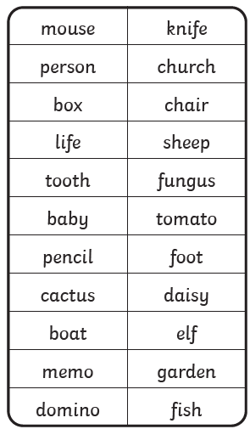
1). Make this set of singular nouns plural (write them in your Homework book)

2). Sort this set of singular nouns into the correct groups using the tables.

Task 2:
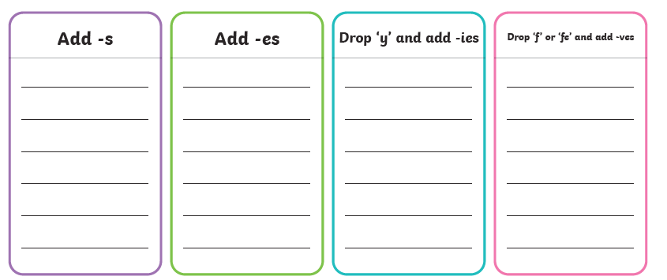
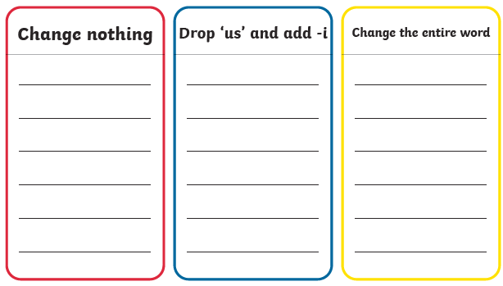

Y3 English Homework week 12 (27.11.25)
Answers

Task 1:

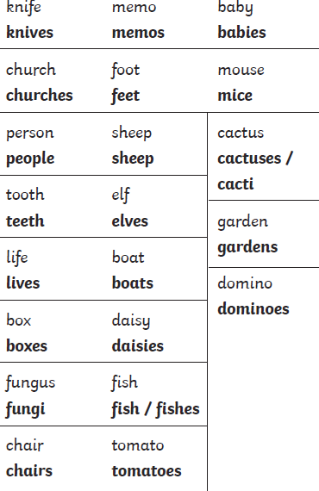

pencil
pencils

Y3 English Homework week 12 (27.11.25)
Answers

Task 2:
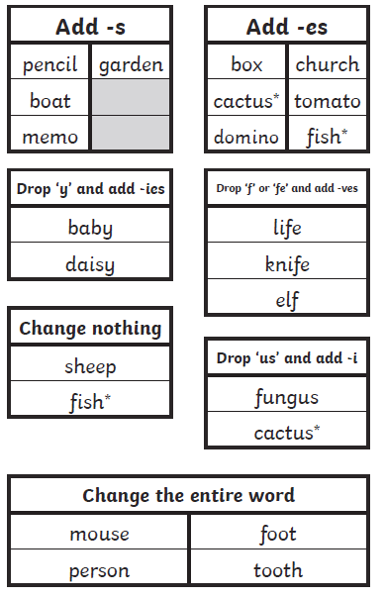

*The plural of cactus can be either cacti or cactuses.
*The plural of fish is fish but it can also be fishes.

