Y3 Maths Homework week 12 (27.11.25) Complete the Maths Mastery sheet on the 3 Times Table.
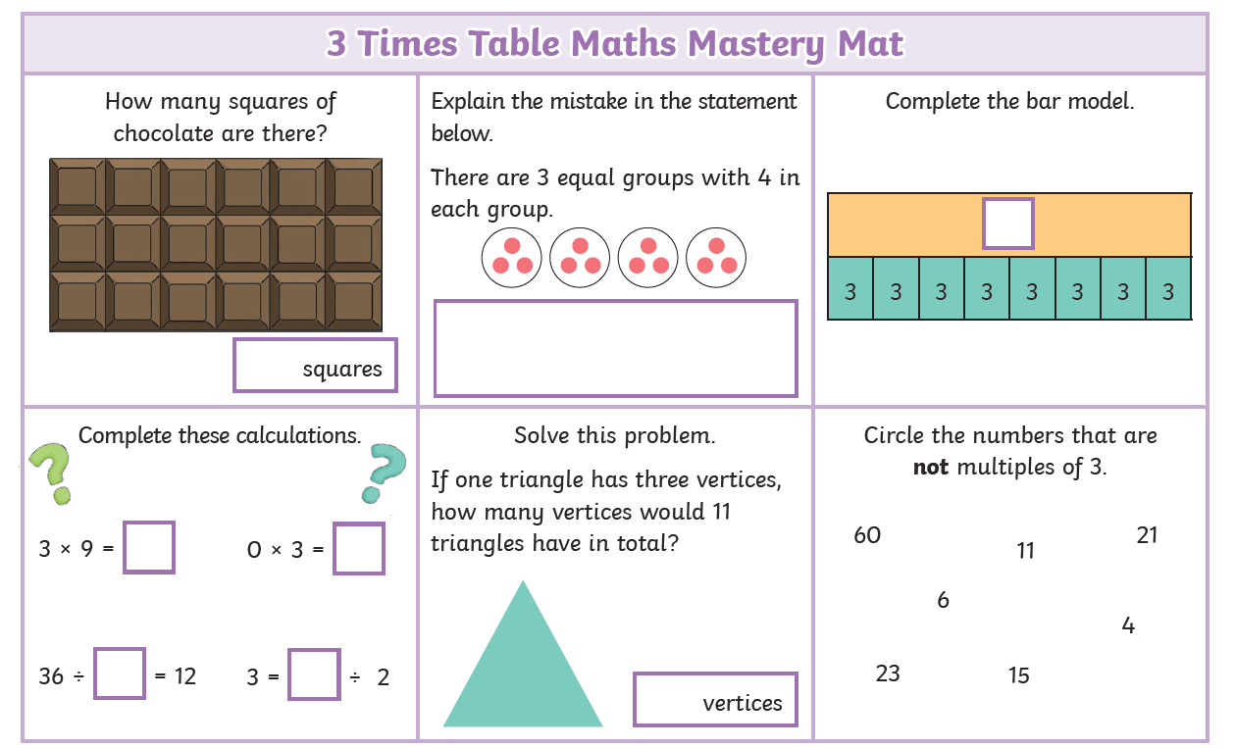

Y3 Maths Homework week 12 (27.11.25) ANSWERS



