Homework
Year 3
Thursday 29th January 2026
Homework Tasks:
1). Reading: Please remember to read daily with your child (about 20mins) and support their understanding through comprehension of the text and not just decoding the words.
Then send the signed Reading Record and book (if it needs changing) into school by Friday so that the Reading Record book can be checked and the book changed.
2). Spellings: Spellings are tested on Tuesdays and the new spelling pattern/rule introduced for that week. This week we’re revising ‘-al’ endings. Please note that Group 1 have 10 spellings to learn and Group 2 have 8 spellings this week.
The spellings are published on the Class Dojo to give you plenty of time to practise them and a list of the spellings are stuck into your Homework Book every week as well.
3). RE: Our RE task this week is based on the theme of Racial Justice. You need to research the life of St Charles Lwanga of Uganda and then on the lined paper provided write about his life and how you can be like him today.
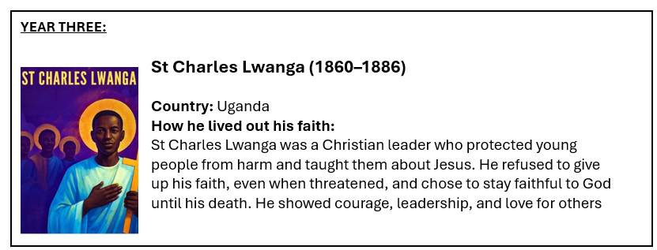
Then, on the hands and heart template, write the following words in the language you speak at home:
‘Whoever loves God, must also love his brother and sister’.

You can decorate the template afterwards. Make sure you write your name of the back of each sheet.
Our work will go on display in school.
Both pieces of work need to be handed in by Tuesday (3.2.26).

Reminders
Please remember to name your uniform, especially jumpers and cardigans.
We have PE every Tuesday (swimming kit) and Friday so please remember to bring your PE kit into school and keep it in your locker. Please remember to have trainers for PE.
Thank you for your continued support.
Mrs Howard, Miss Cicero and Mrs Mills.

