Y3 Maths Homework Spring week 2 (15.1.26)

Please complete all eight questions and then check and mark your answers on the school website (Class News – Year 3 – Homework – Spring Week 2 – Maths).

Then stick the sheet into your Homework book. Thank you.

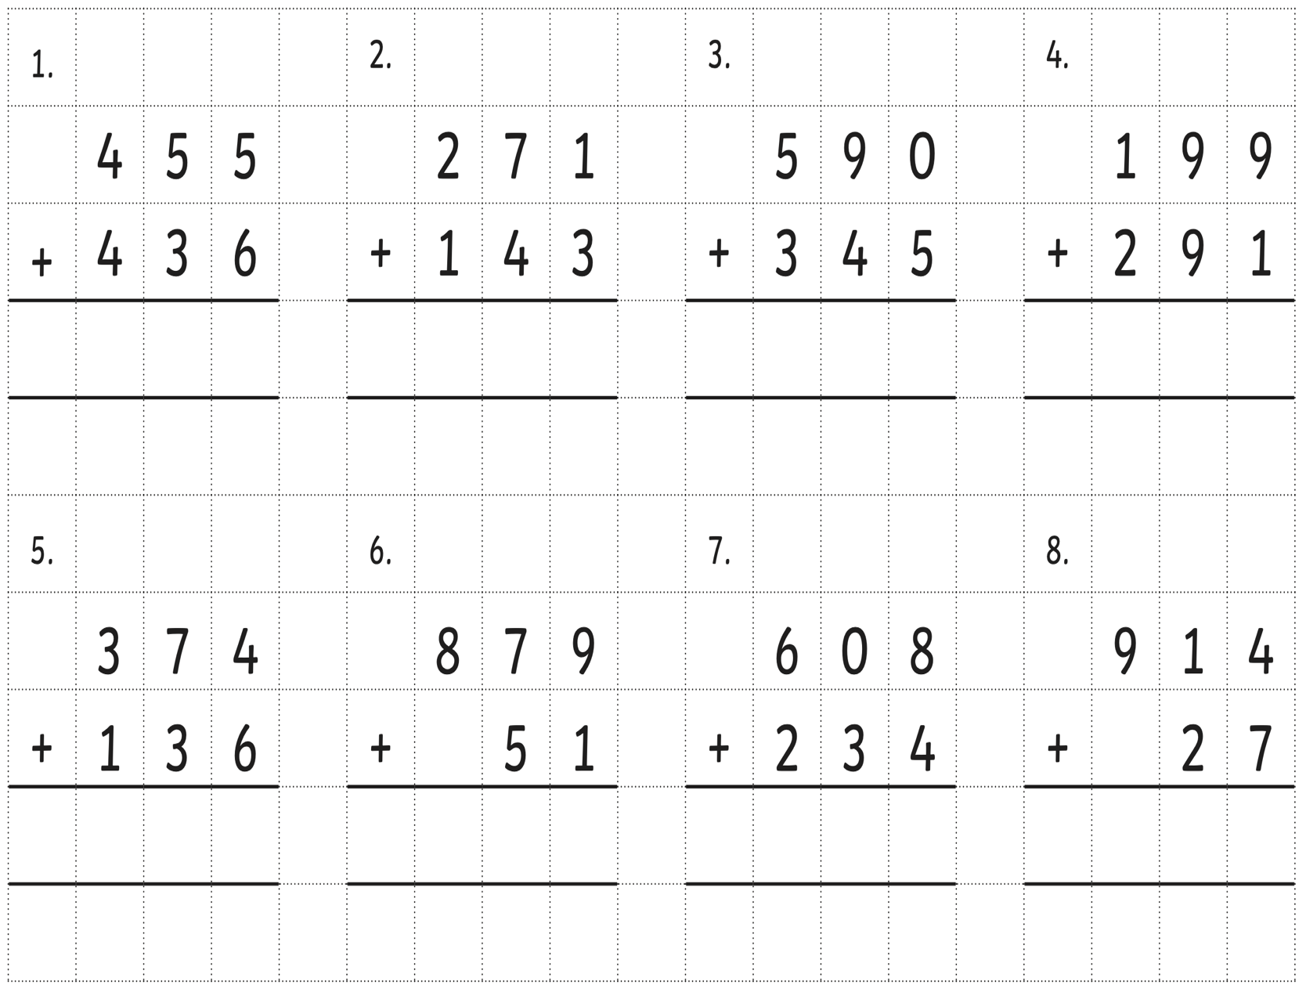

Have a go at the extra challenge too (optional)!
Explain the mistake that’s been made.

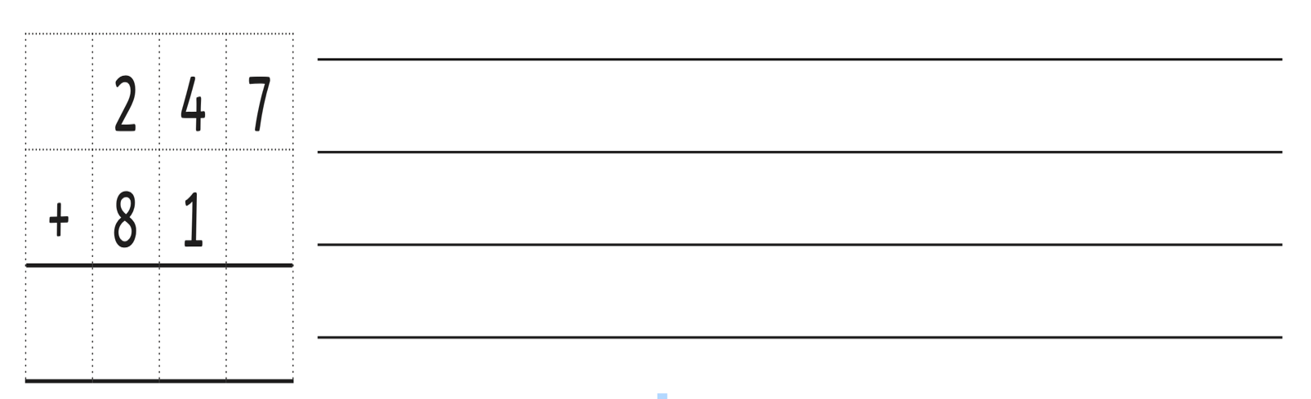

Y3 Maths Homework Spring week 2 (15.1.26)
ANSWERS

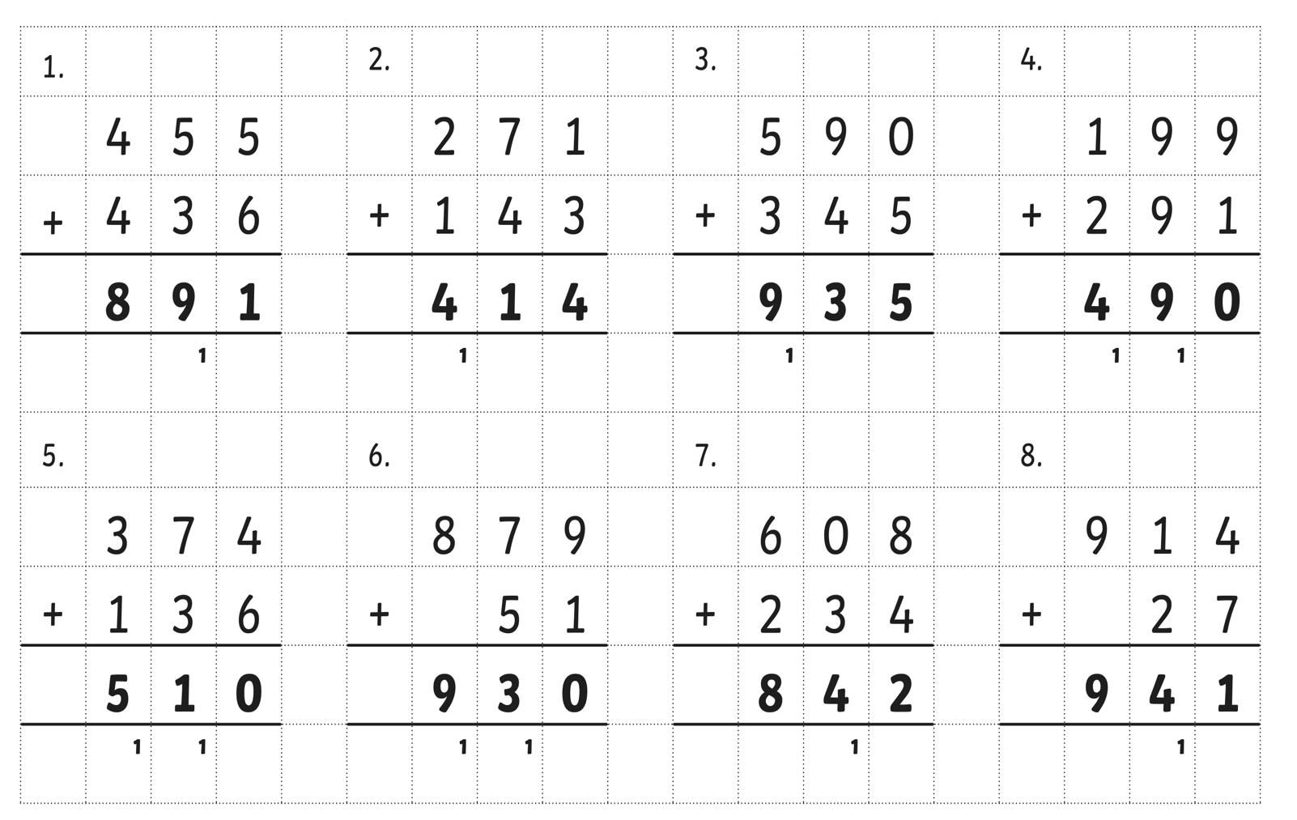

Extra Challenge:

The 8 tens and 1 one have been placed in the wrong place value columns. The 8 should be in the tens column and the 1 should be in the ones column.

The correct answer would then be 328.

