Y3 English Homework week 3 (22.1.26).
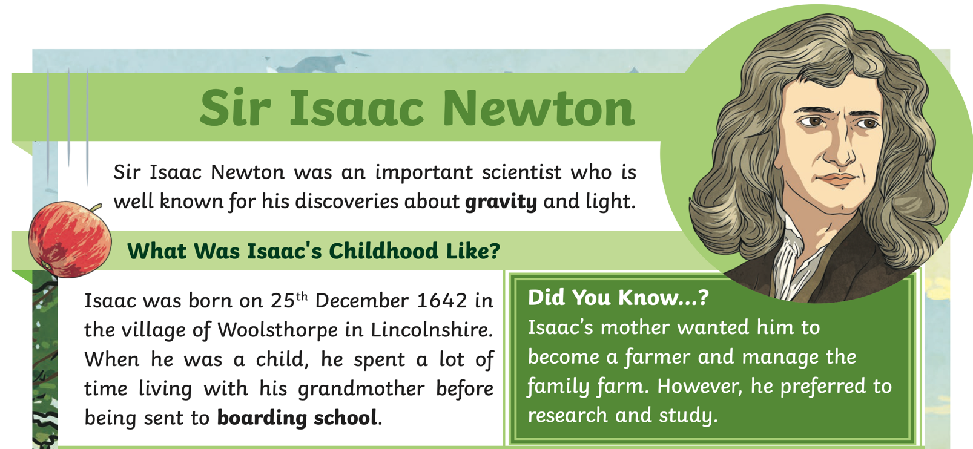
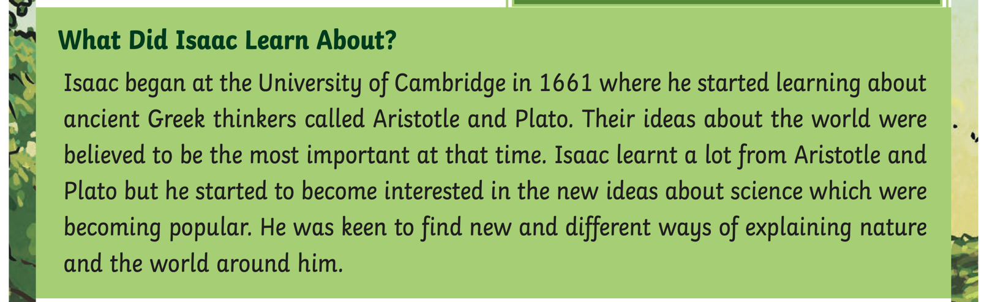
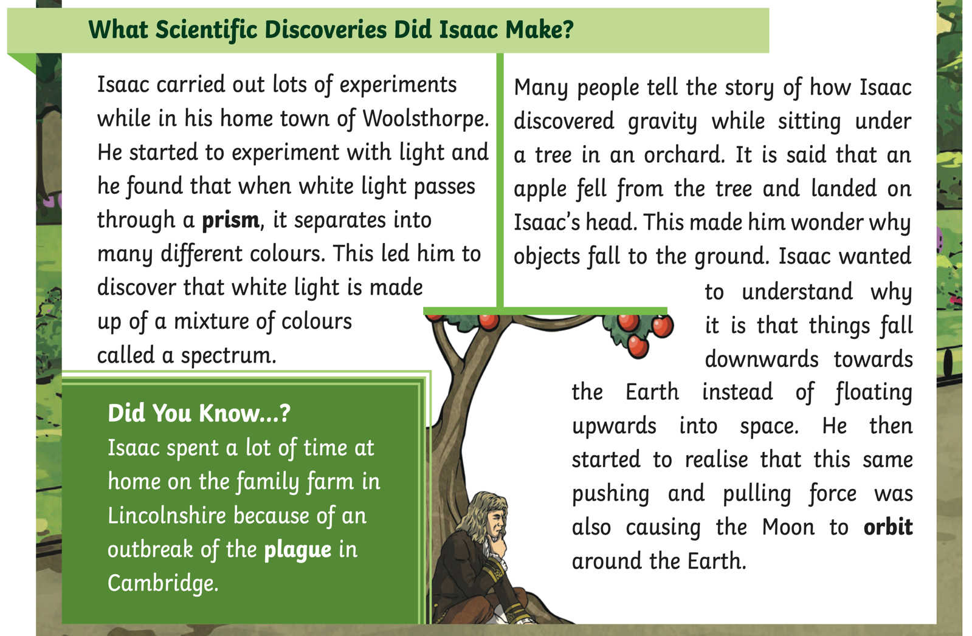

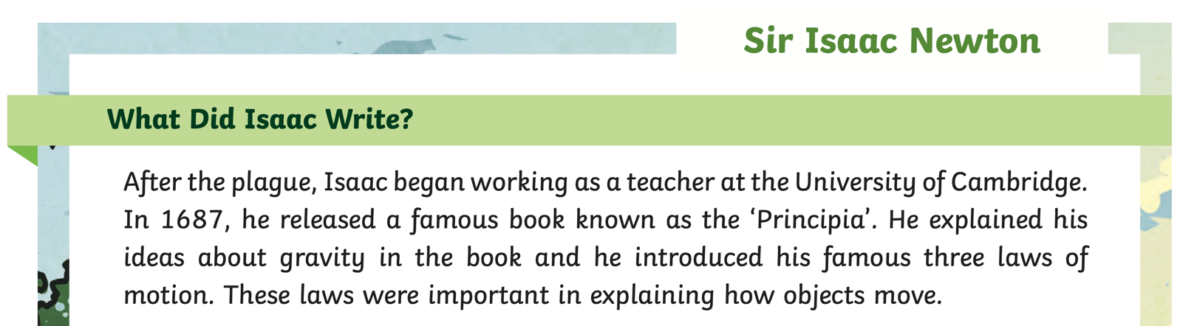
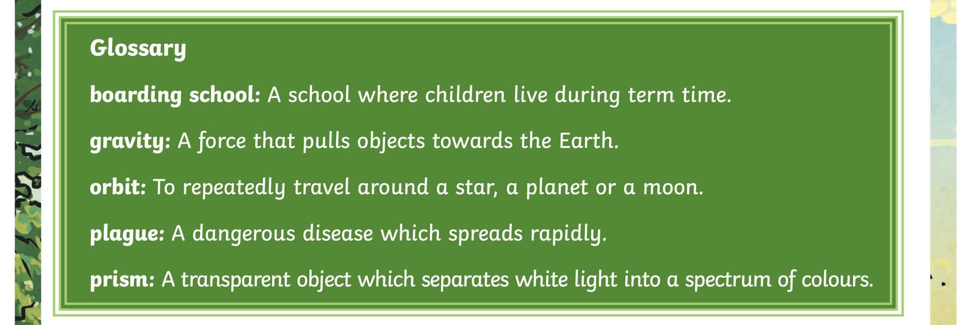

Y3 English Homework week 3 (22.1.26) Sir Isaac Newton Comprehension.

Please just stick this answer sheet into your Homework book.

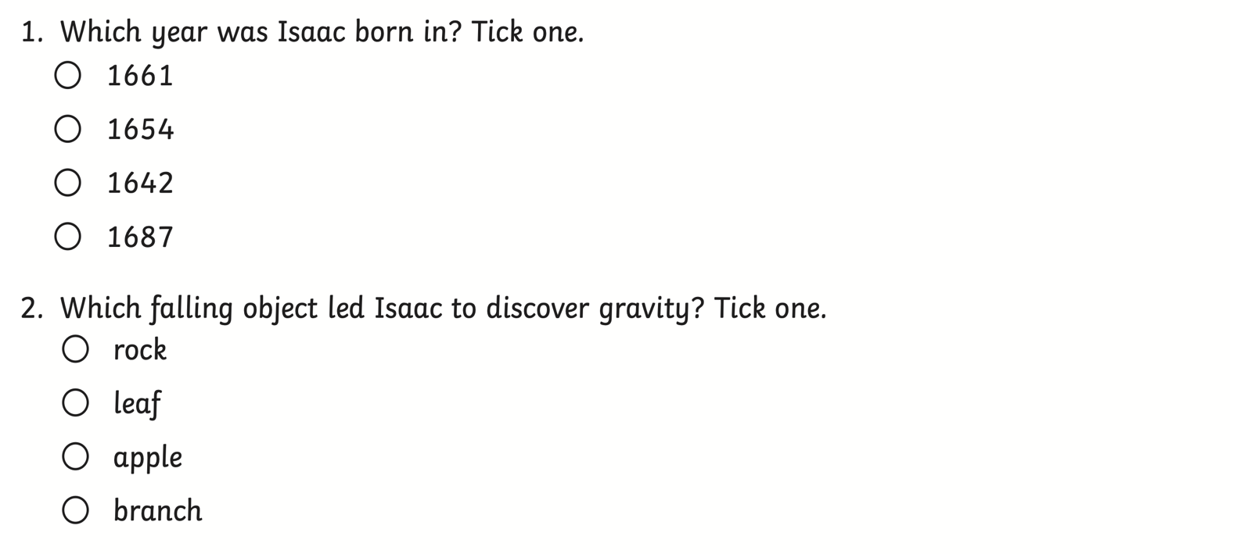
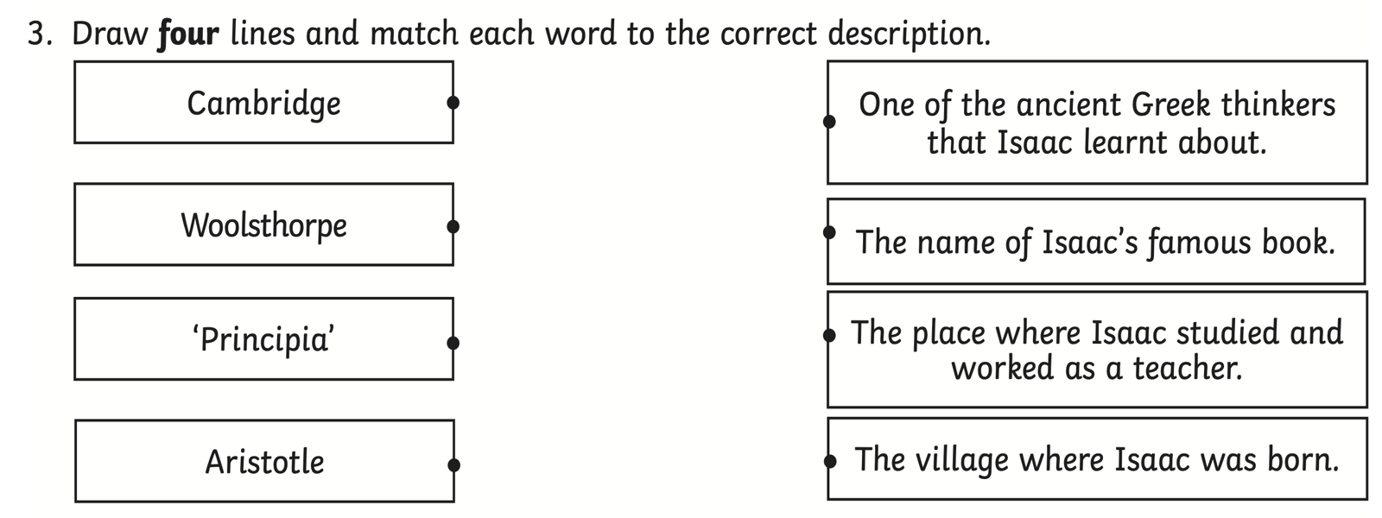

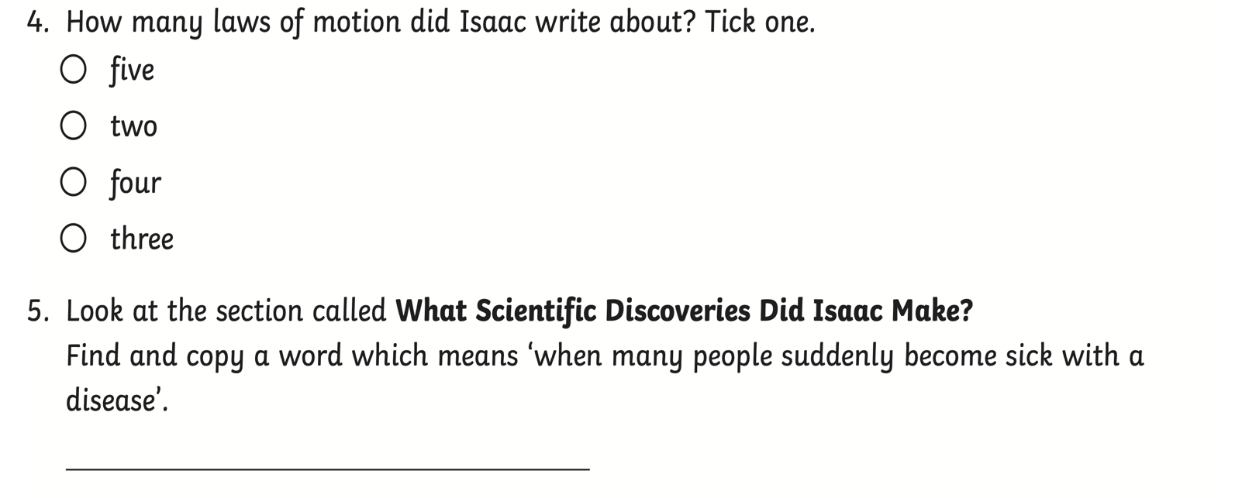

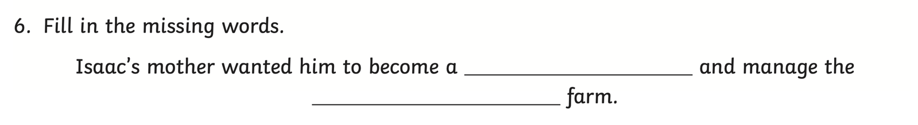
7.
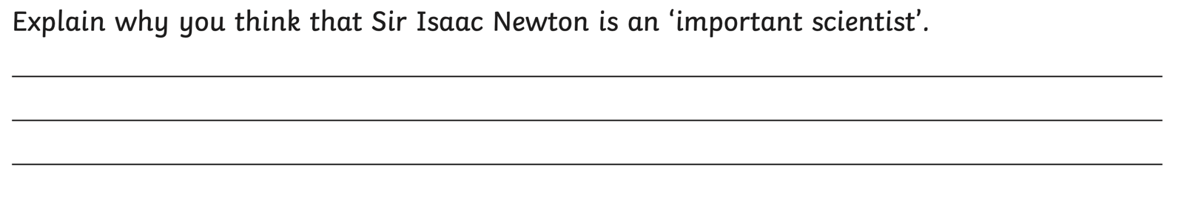

Y3 English Homework week 4 (25.1.24) Sir Isaac Newton Comprehension.

ANSWERS

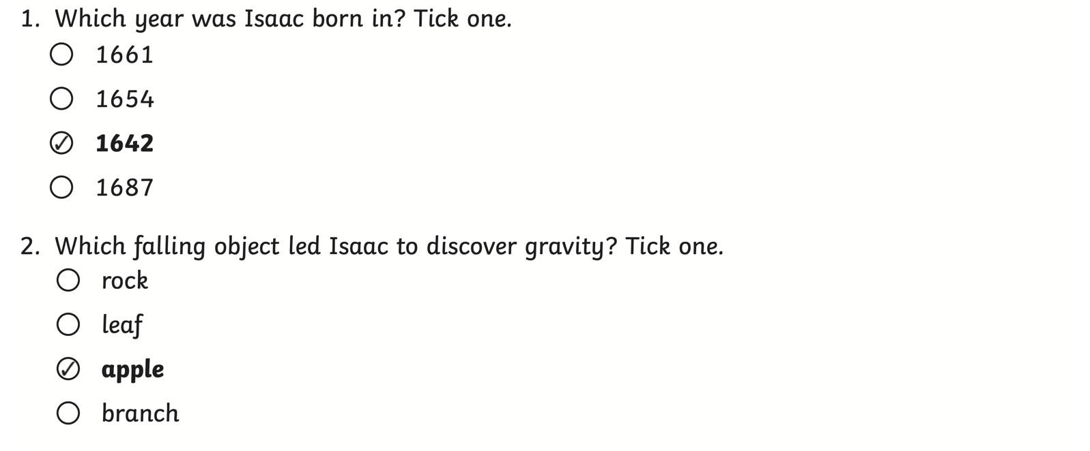
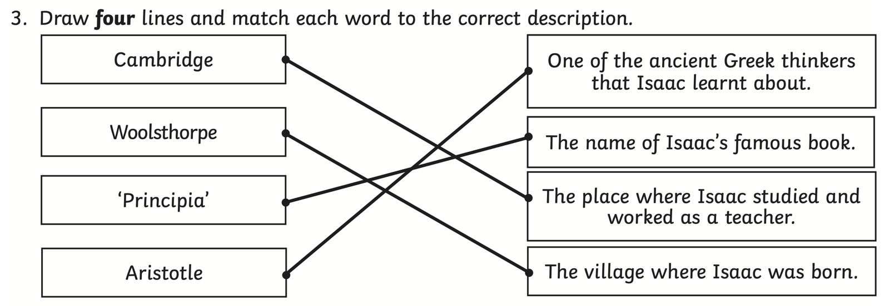
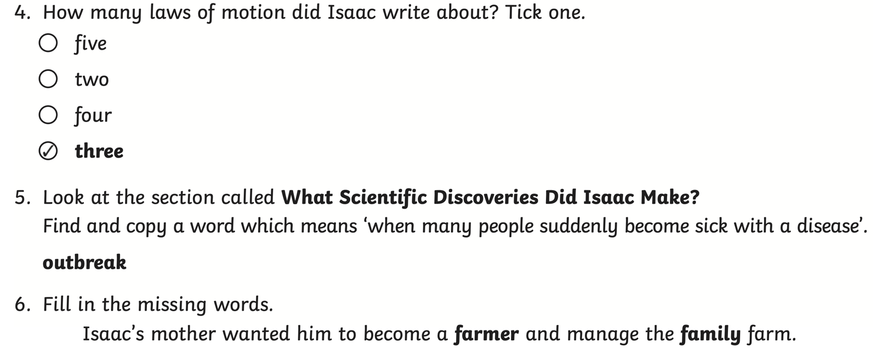
7.


