Y3 Maths Homework Spring week 3 (22.1.26)

Please complete all eight subtraction questions and then check your answers on the school website (Class News – Year 3 – Homework – Spring Week 3 – Maths). Remember to check whether you have to regroup and then show any exchanges you make.

Then stick the sheet into your Homework book. Thank you.

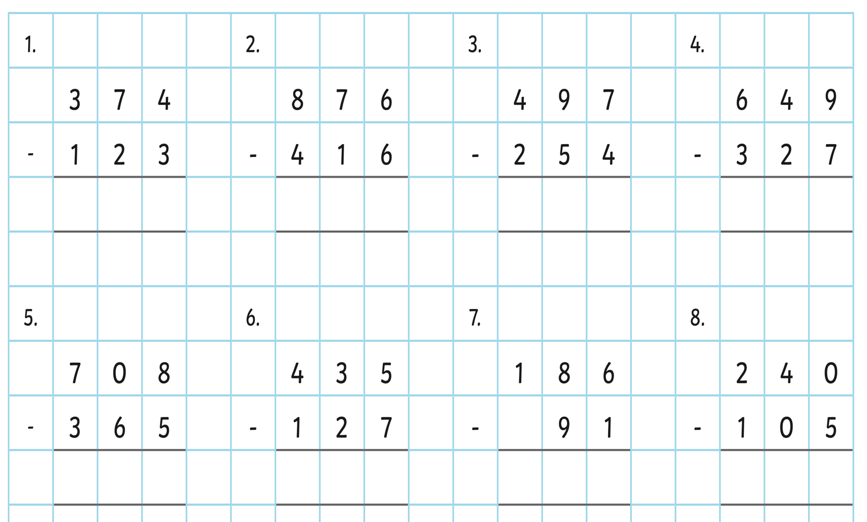

Have a go at the two extra challenge too (optional)!

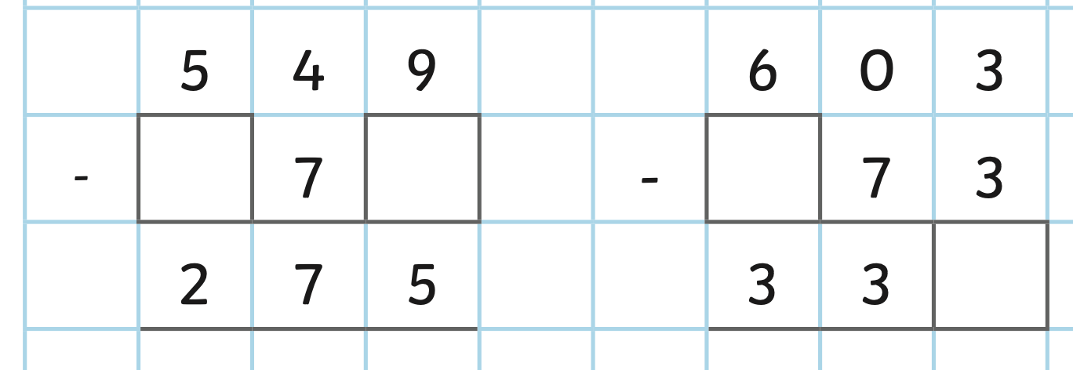

Y3 Maths Homework Spring week 3 (22.1.26)
ANSWERS

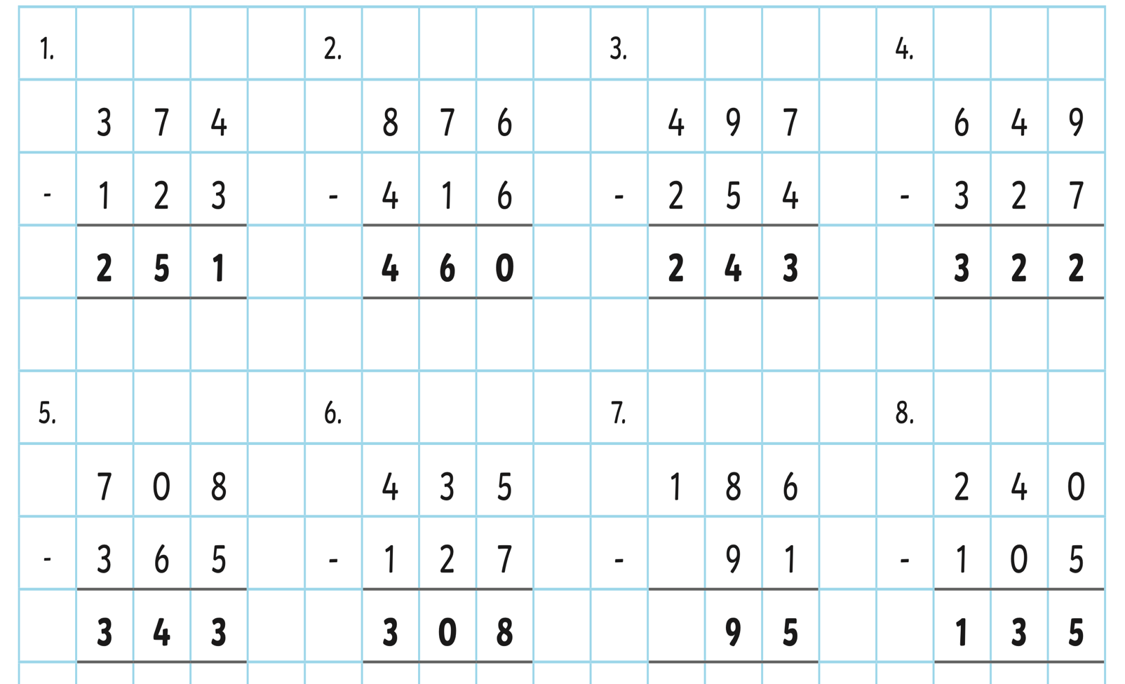

Extra Challenges:



