Year 3 Maths Homework week 1 (8.1.26) Please stick this sheet into your Homework book.
Task:
Complete the multiplication wheels for the 3 times table.
Tip: Remember the answer to the times table question is always on the outer ring.

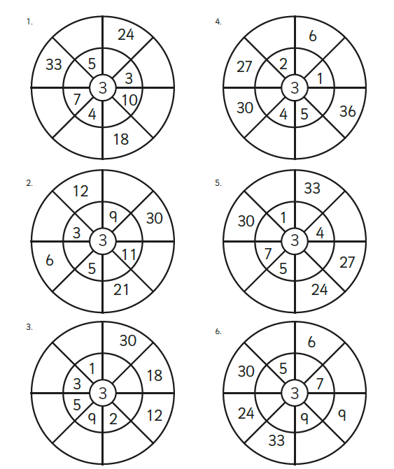

Now mark your work using the answer sheet on the Year 3 class page on the school website. Put in any corrections on this sheet.

Year 3 Maths Homework week 1 (8.1.26)
ANSWERS



