Year 3 English Homework week 8 (5.3.26)
Apostrophes for singular possession.

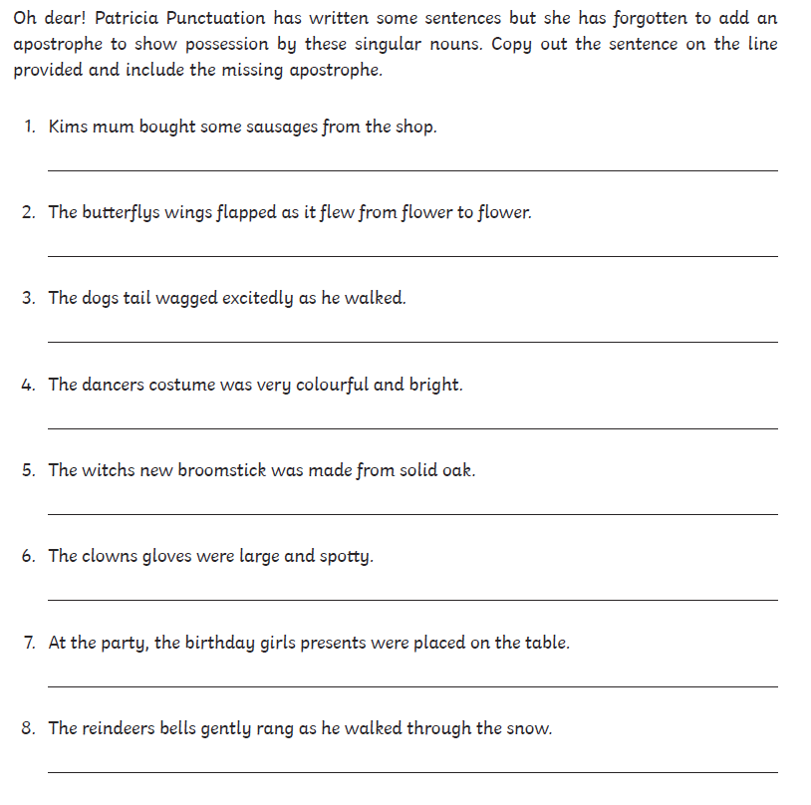

Year 3 English Homework week 8 (5.3.26) ANSWERS
Apostrophes for singular possession.



