Y3 Maths Homework (5.2.26)

Calculate the answers to the following questions. First of all, check whether you are doing addition or subtraction and then whether you’ll have to regroup and exchange.

Please try to complete all the questions then mark your work using the answer sheet on the Year 3 class page on the website. Stick this sheet into your Homework book too.

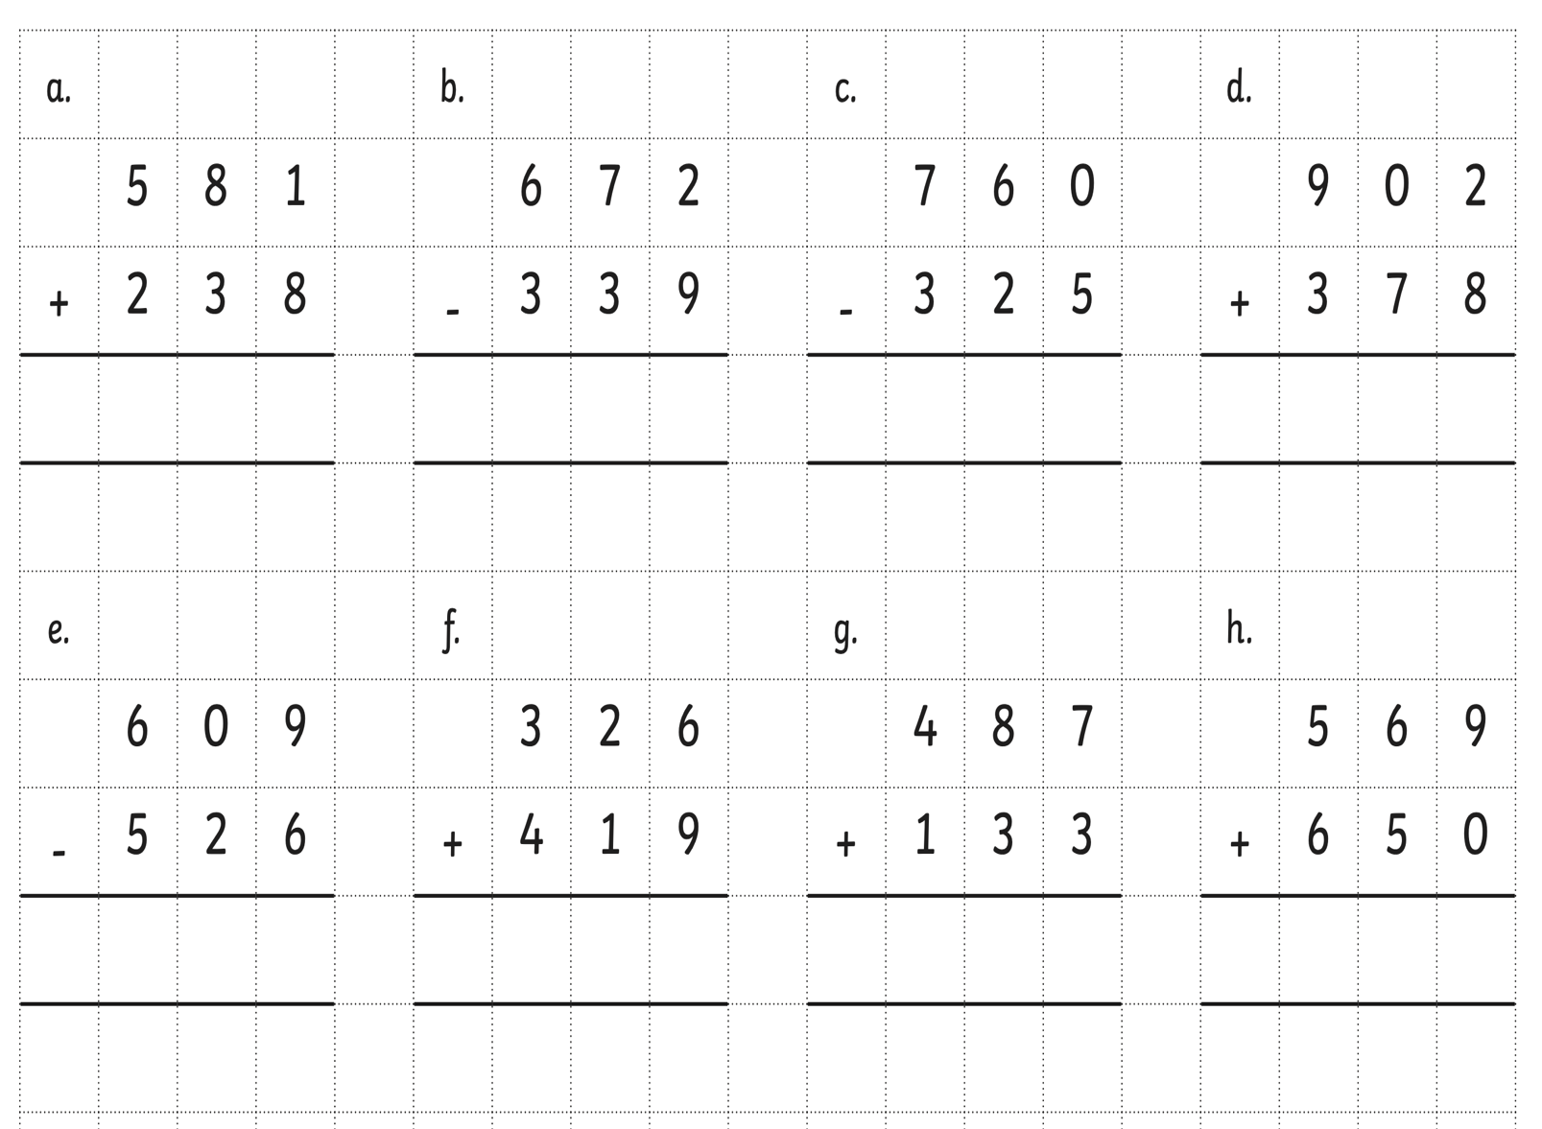

Y3 Maths Homework (5.2.26)
ANSWERS



