Year 3 Maths Homework week 7 (26.2.26). Please use the x4 tables sheet inside your Homework book as a support. Then stick this sheet in your Homework book.

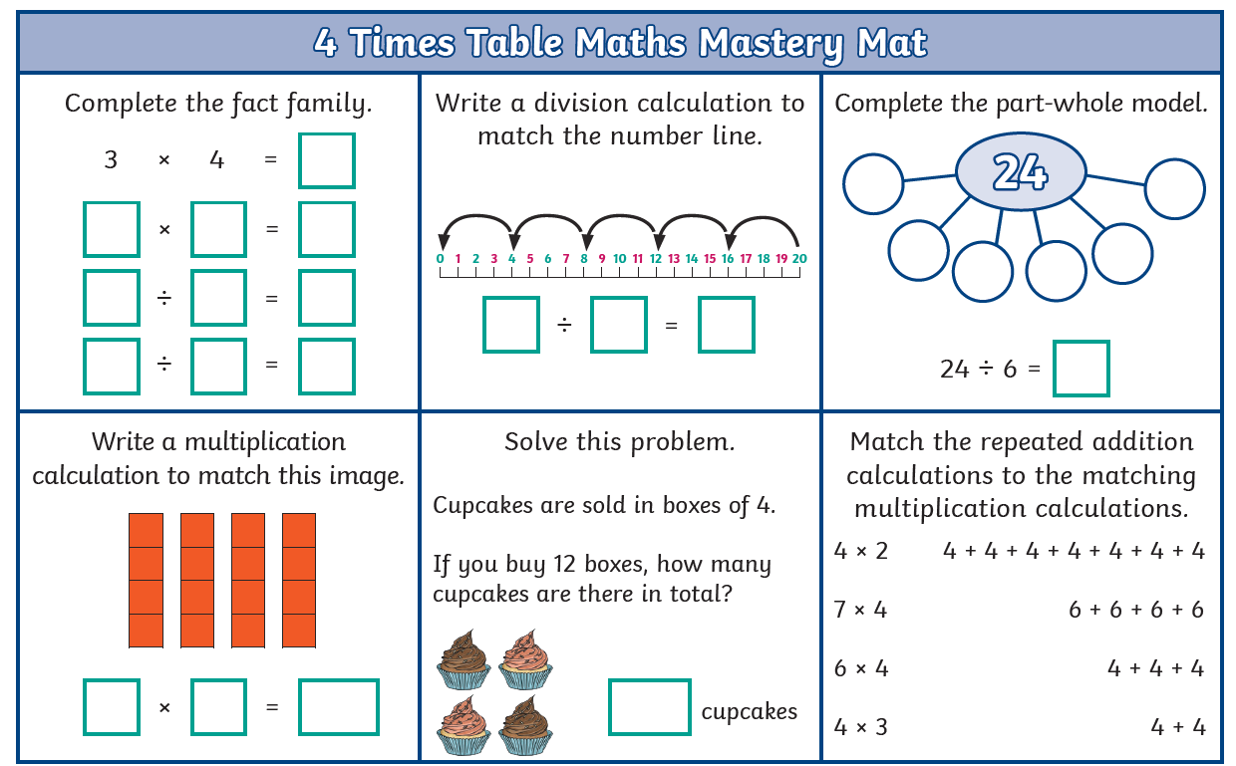

Year 3 Maths Homework week 7 (26.2.26). ANSWERS.


