Year 3 English Homework week 7 (26.2.26)
Apostrophes and Contractions.
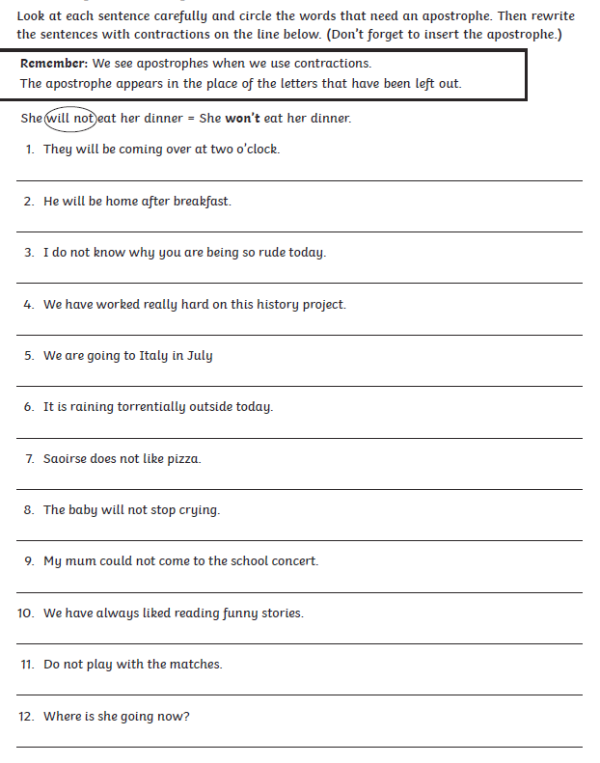

Year 3 English Homework week 7 (26.2.26) ANSWERS
Apostrophes and Contractions.



