Homework
Year 2
Thursday 17th October 2024
Please complete and return work completed in your homework book on Tuesday. Please ensure that you mark the homework
Dear Parents,
Please see below for homework this week.
Reading
Please remember to read with your child daily and support them with understanding through comprehension of the text and not just decoding. Please sign and date the reading record. If you have any comments you wish to write about your child’s reading please do so.
Spellings:
Our spellings this week are all from our year 2 spelling list;
Please choose 5 words and put them into sentences. For example: The door was blue and it was shut.

Maths:
In maths this week we have been looking addition and numbers on a number line. Please complete the addition number line sheet. (answers have also been uploaded on the website)

Subject of the Week: ART
Next week will be our termly art week in school. We are going to be studying lines, texture and creating these in images.
Use the key words below, and creating lines to represent these words. Label each word you have represented
I have added an example for support
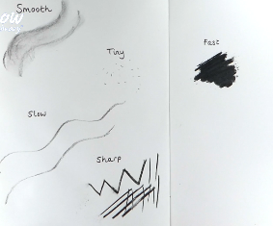
The key words are:
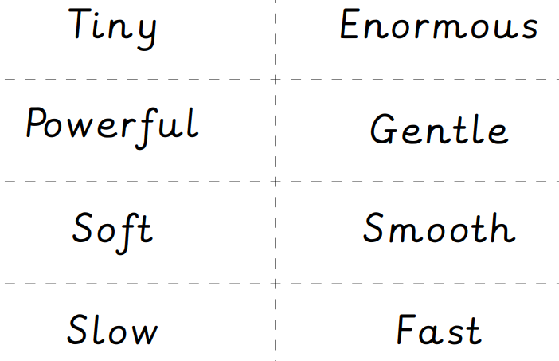
We look forward to seeing their lines and textures!

Thank you for your continued support.
Mrs Moseley and Miss Cicero

