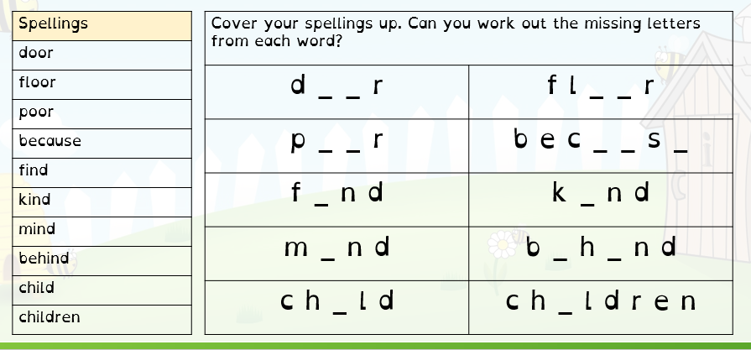
Spellings Thursday 17.10.24

Our spellings this week are all from our year 2 spelling list;
Please choose 5 words and put them into sentences. For example: The door was blue and it was shut.

