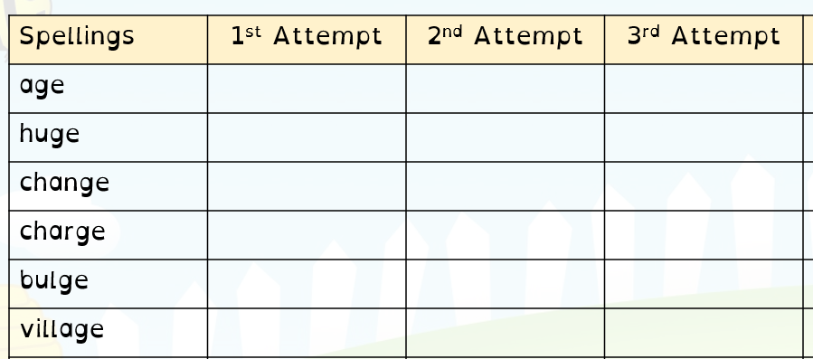
kind
find
mind
was
out
put

Task: choose 5 words and put them into sentences:

