SPELLINGS HOMEWORK
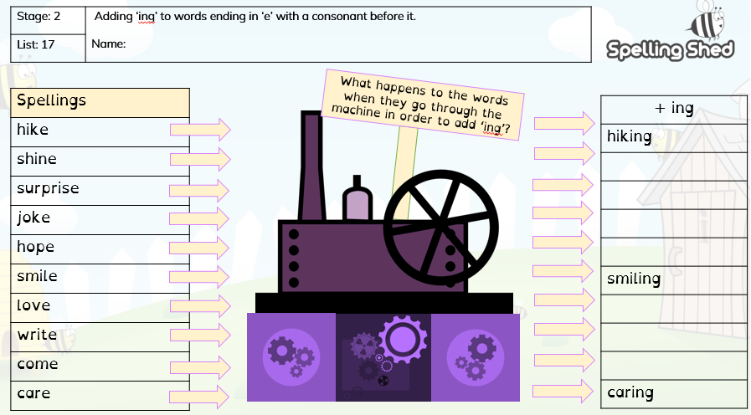
Choose 5 words and put them into sentences e.g: I was smiling at the boy

