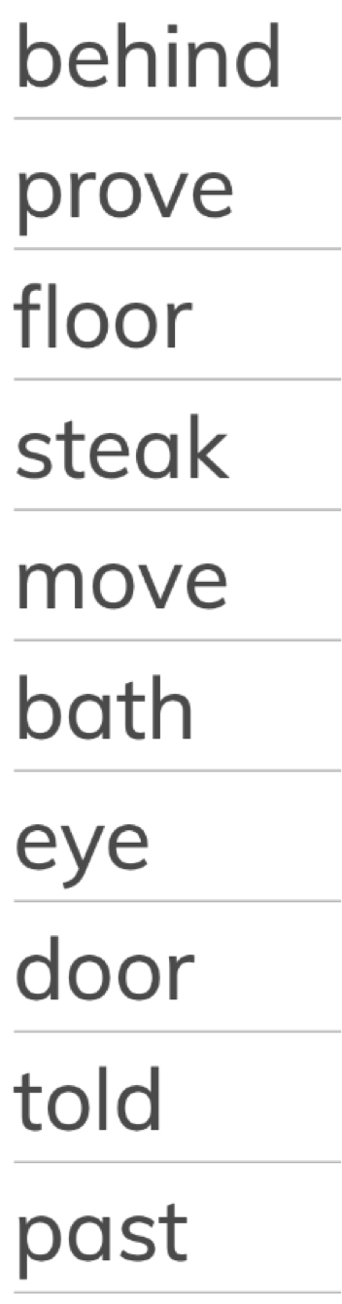
Please choose 5 of these words and write them in a sentence.

For example, I sat on the floor.

- ______________________________________________________________.

- ______________________________________________________________.

- ______________________________________________________________.

- ______________________________________________________________.

- ______________________________________________________________.

