Can you find the missing numbers and fill in the gaps?
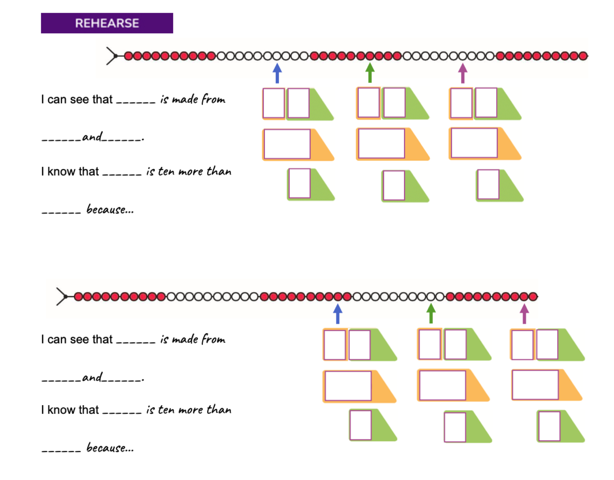

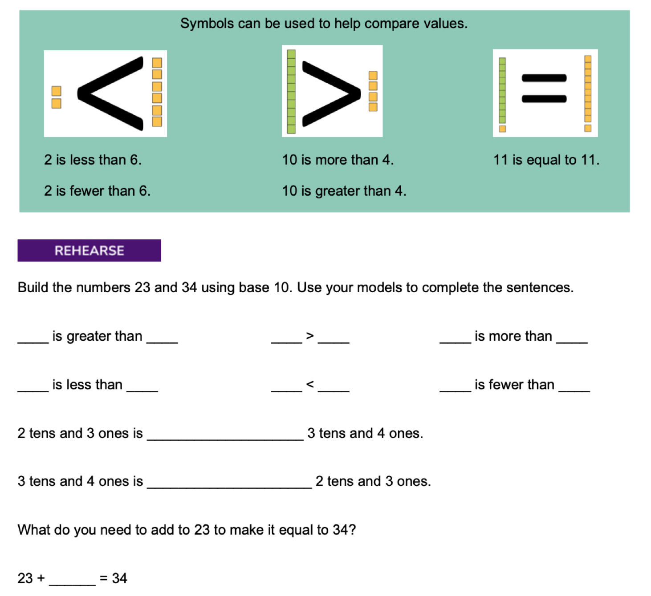
Fill in the missing gaps:

