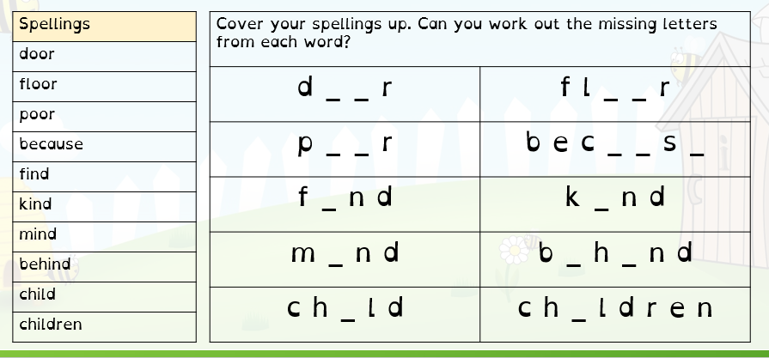
Spellings Thursday 09.10.25

Our spellings this week are all from our Year 2 spelling list.
Please choose 5 words and put them into sentences.

For example: The door was blue and it was shut.

