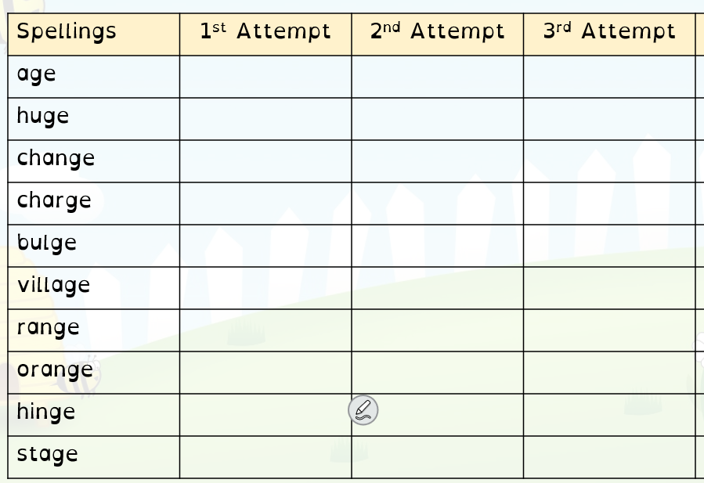
kind

kind
find
mind
Task: choose 5 words and put them into sentences:

