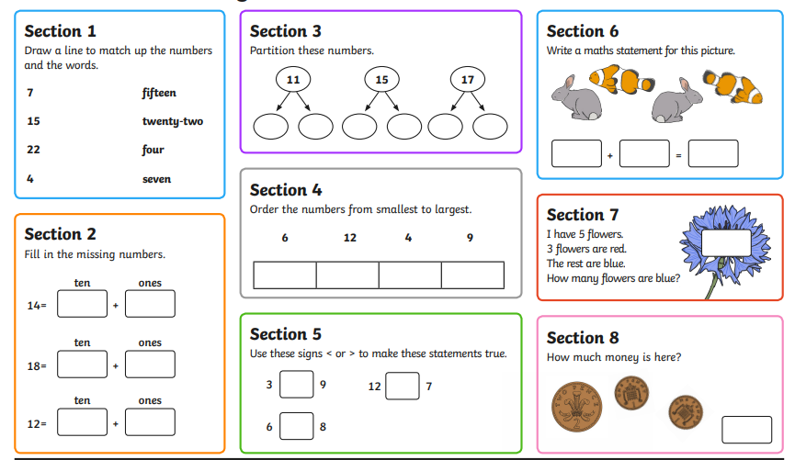
Maths Homework 25.09.2025

