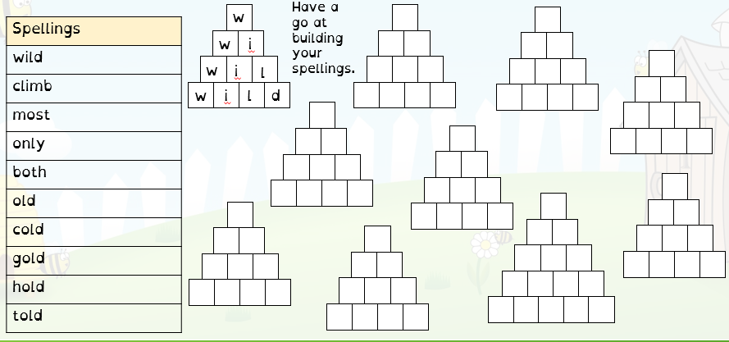
SPELLINGS: Thursday 16th January 2026
Choose 5 of your spellings words and put these into sentences:
Eg. I went into the wild woods.

