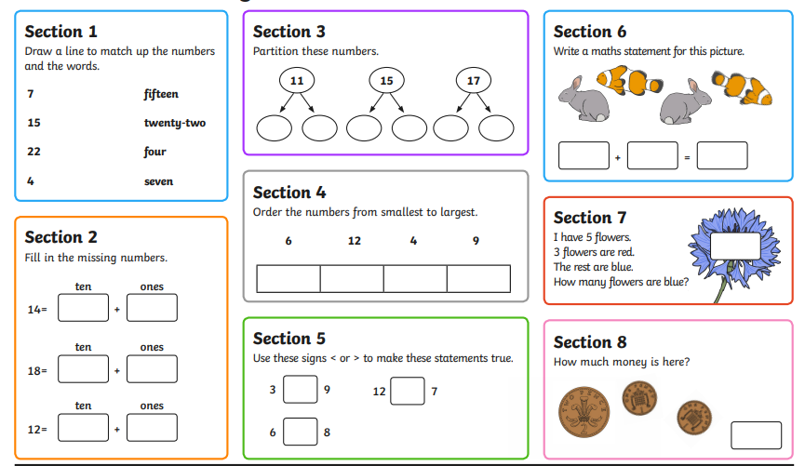
Maths Homework 19.09.2024

