Y5 English/PSHE Homework week 7 (12.6.25)
English/PSHE comprehension: Healthy Eating.

Page 1:
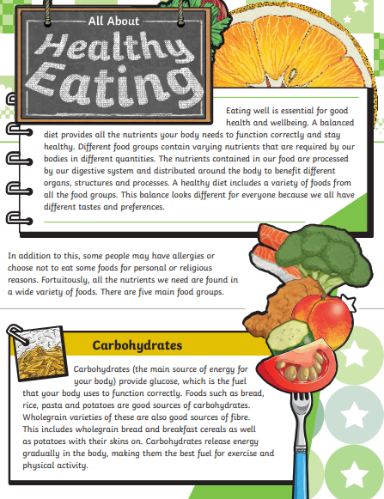

Page 2:
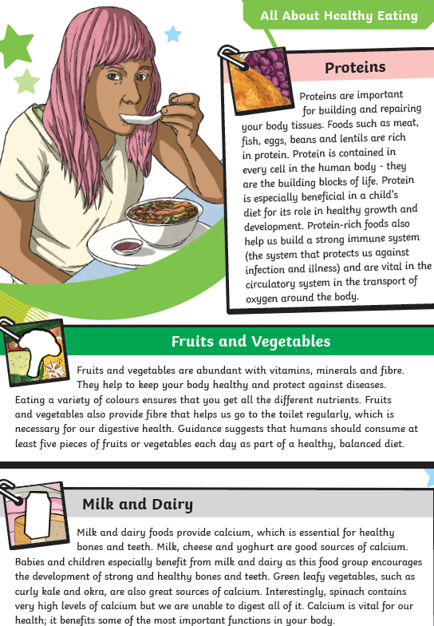
Page 3:

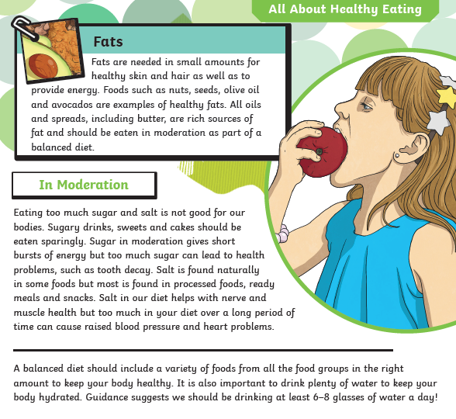

Page 4:
Y5 English Homework week 7 (12.6.25)
Question Sheet – only stick this sheet into your Homework book.

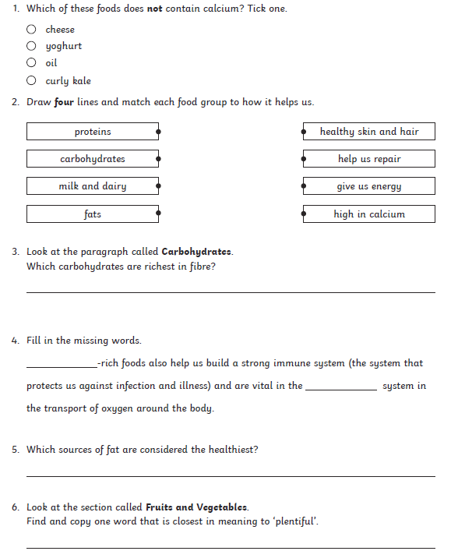
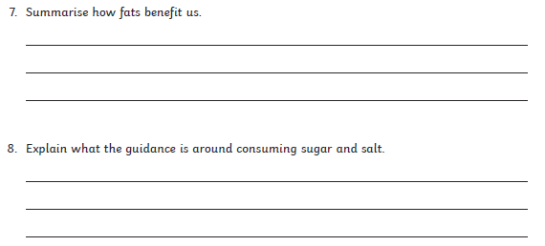
Page 5:
Y5 English Homework week 7 (12.6.25)
English/PSHE comprehension: ANSWERS



