Y5 English/RE Homework week 1 (24.4.25)

English/RE comprehension: The Prophet Muhammad (PBUH) and the Revelation of the Qur’an.

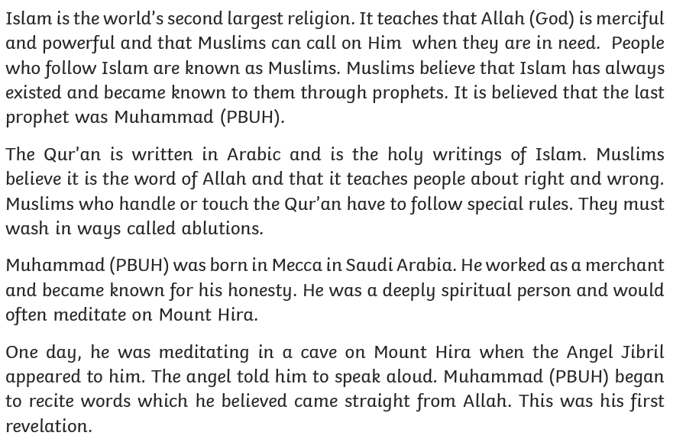
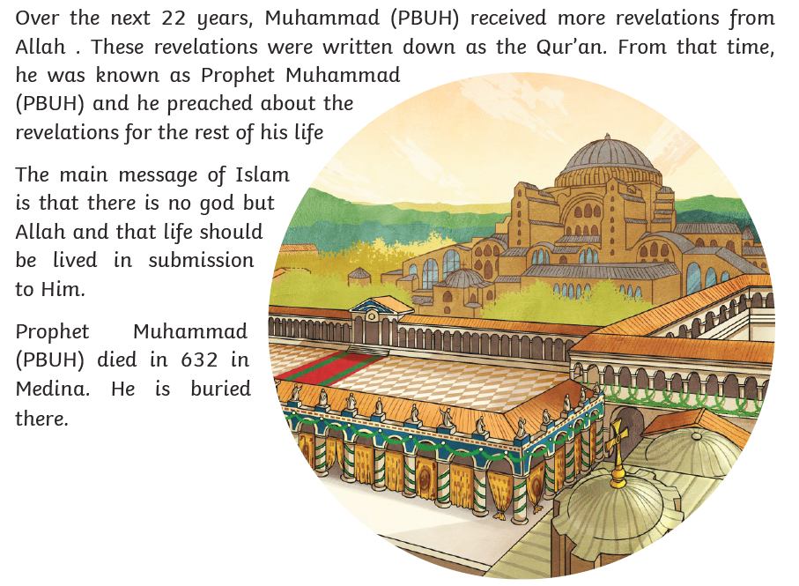

Y5 English Homework week 3 (24.4.25)
Question Sheet – only stick this sheet into your Homework book.

English/RE comprehension: The Prophet Muhammad (PBUH) and the Revelation of the Qur’an.

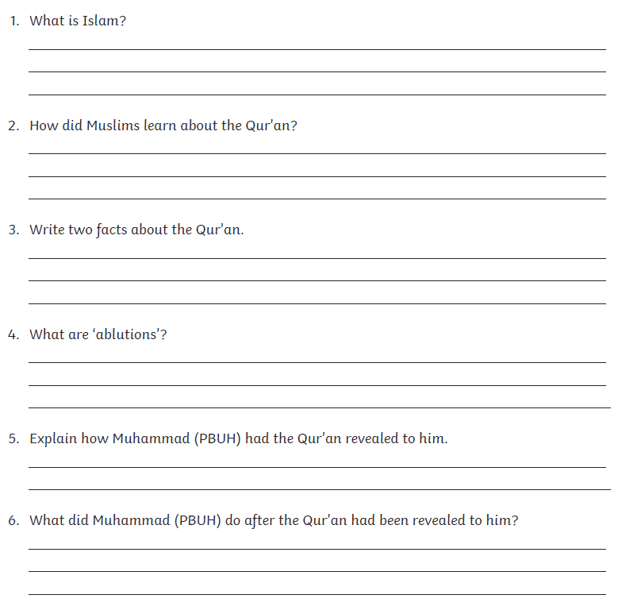

Y5 English Homework week 3 (24.4.25)
ANSWERS

English/RE comprehension: The Prophet Muhammad (PBUH) and the Revelation of the Qur’an.



