Y5 English Homework week 4 (15.5.25)
Comprehension.
Page 1.
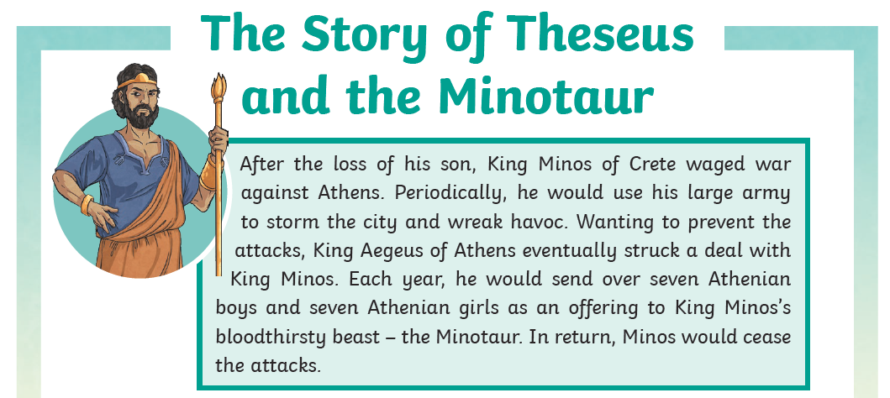
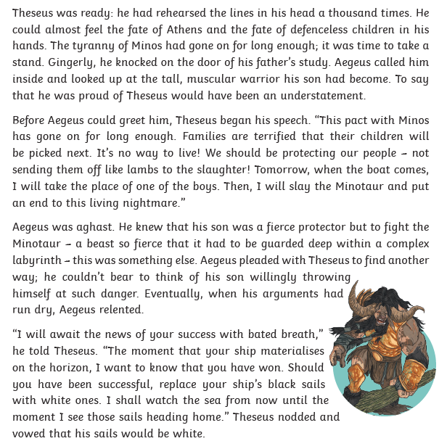

Y5 English Homework week 4 (15.5.25)
Comprehension.
Page 2.

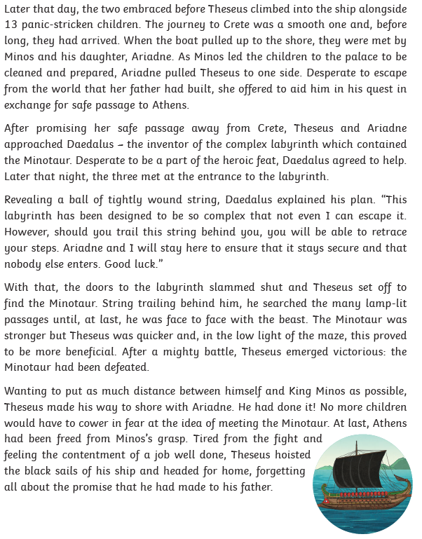

Y5 English Homework week 4 (15.5.25)
Comprehension.
Page 3 - Question sheet.



