Y5 Maths Homework week 4 (15.5.25)

Converting between metric units.

Please read the worked example below to support you with answering the question.
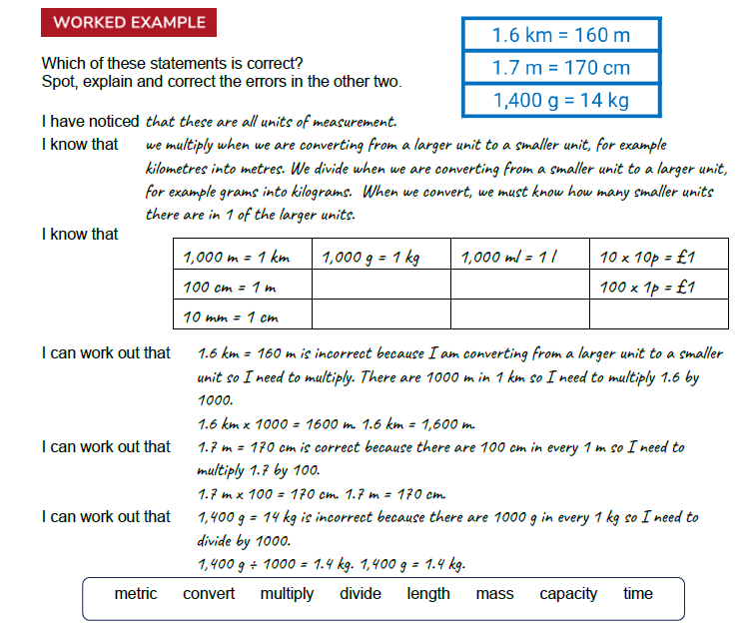

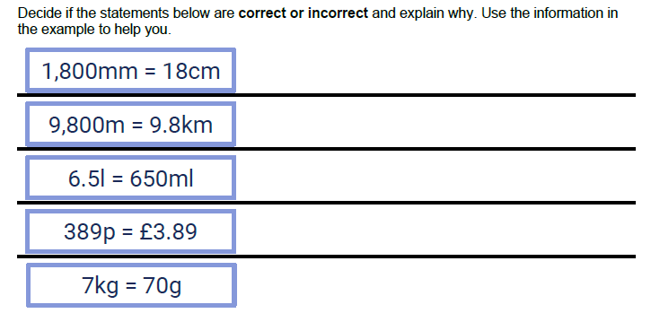
Stick this sheet in your Homework book then mark it by using the answer sheet in the Year 5 class page on the school website.

