Y5 Maths Homework 26.6.25

Revision of long multiplication: Please mark your answers and do any corrections you may have!

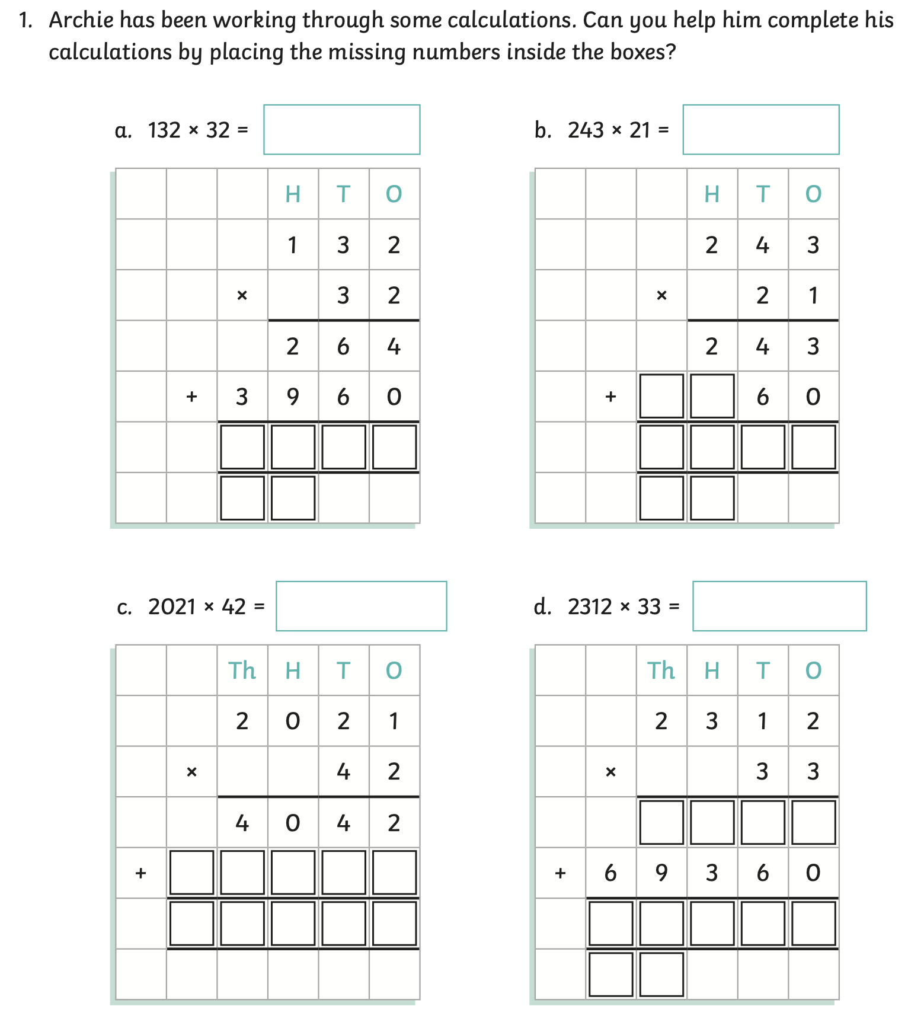

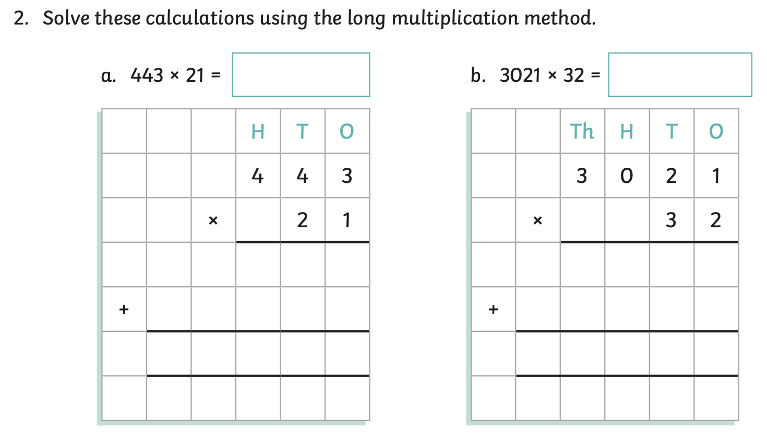

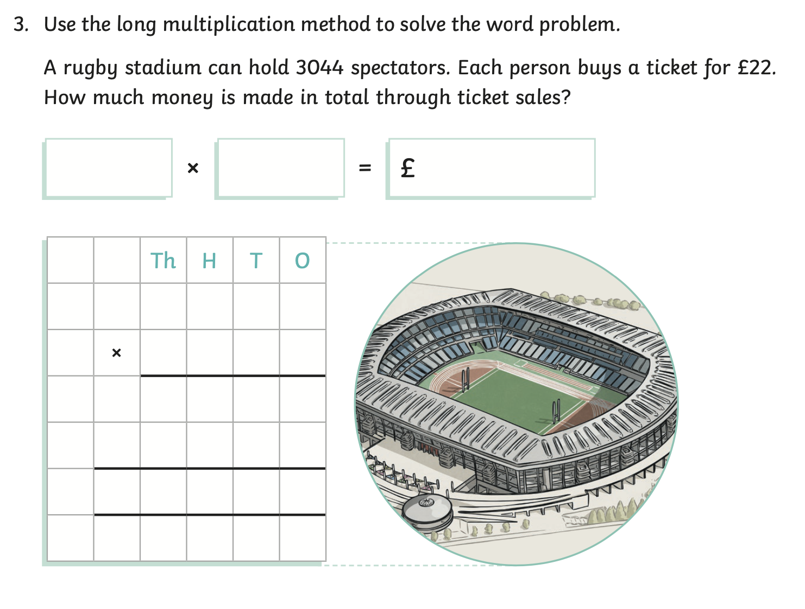

Y5 Maths Homework 26.6.25

Revision of long multiplication: Answers



