Y5 Spanish Homework
Imagine you are going to visit Spain for your holiday. Where would you like to go – to the coast or to a city (like the capital Madrid)?
Spain is a big place so mark on the map which part of the country you would like to visit, or if you’re moving around, you can mark each stop and map your route.
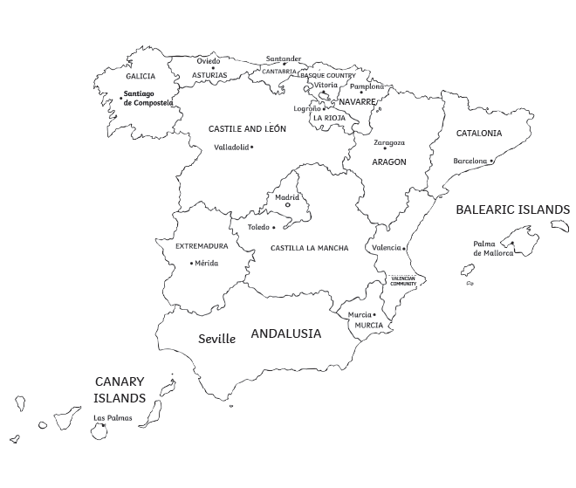

How will you get to Spain? Are you flying, driving, going by boat or walking? If you’re flying, how will you get to the airport?
Draw a list of pictures showing exactly what types of transportation you will use from the time you leave your front door till the time you arrive at your hotel, campsite or holiday home.

What are you going to do once you reach your destination? Depending on where you’re going in the country, there are lots of things to do. If you’re in Madrid, you may want to visit the Santiago Bernabéu Stadium, or if you’re visiting a beach resort, you could try a bit of snorkelling. Do some research and choose four new things you’d love to try while there. It doesn’t matter if you can’t do them all - you’ll just have something for next time!

Complete this sheet and stick it into your homework book and then write down the four new things you’d like to try in your book explaining why you’d like to do them.

