English Homework week 4 (30.1.25)

A relative clause is a specific type of subordinate clause that adapts, describes or modifies a noun. Relative clauses add information to sentences by using a relative pronoun such as who, that or which.

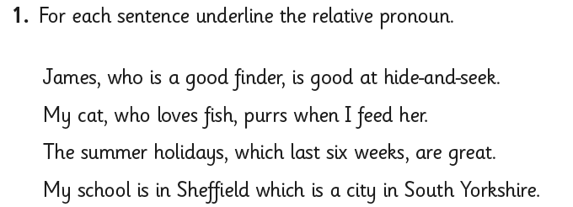

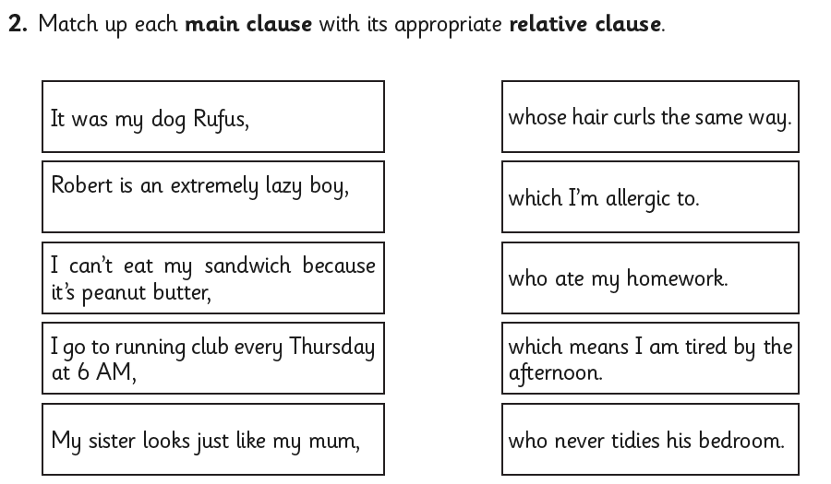

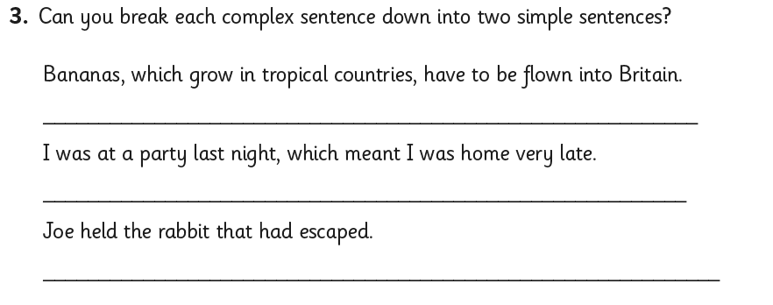

English Homework week 4 (30.1.25)
ANSWERS



