Y5 Maths Homework week 4 (30.1.25)

Choose the activity you would like to do (or you can do both). The remainders just need to be simple remainders, not fractions or decimals. There’s a power point to watch as a scaffold. Make sure that you stick the sheet into your homework book and check the answers on the Year 5 class page of the school website. Make any corrections too.

Activity 1: short division practise with remainders.

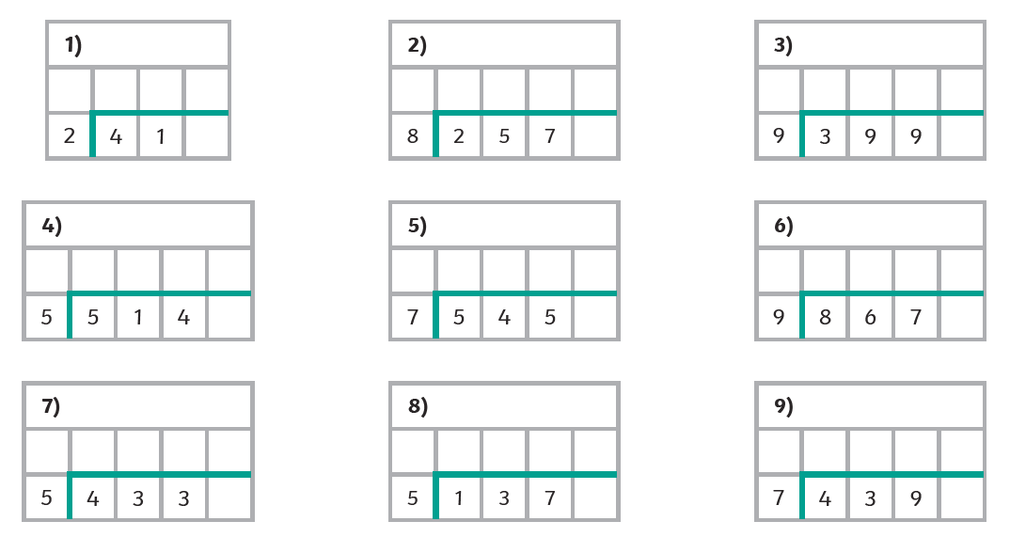

Activity 2: short division practise with remainders.

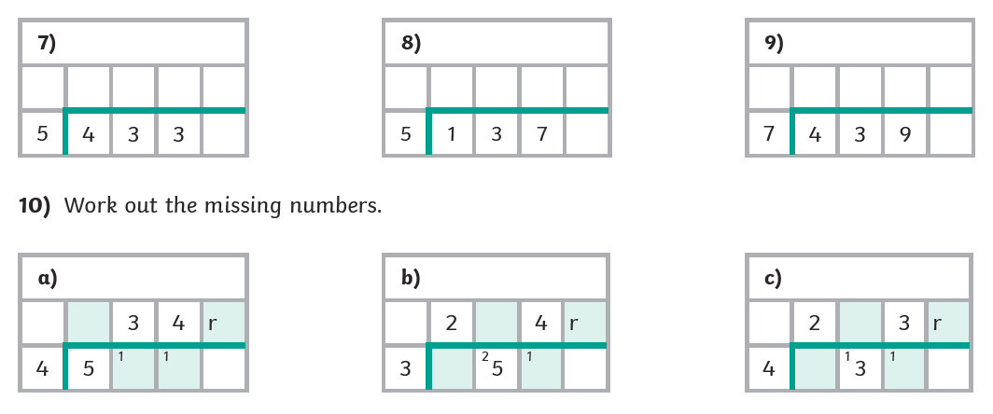

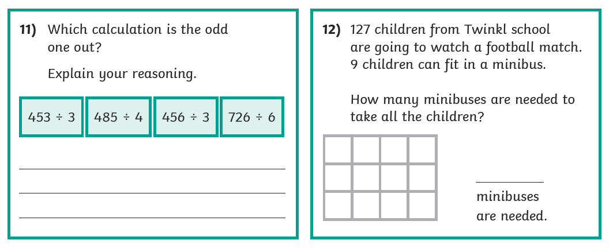

Year 5 Maths Homework (30.1.25) ANSWERS

Activity 1: Short division practise with remainders - Answers

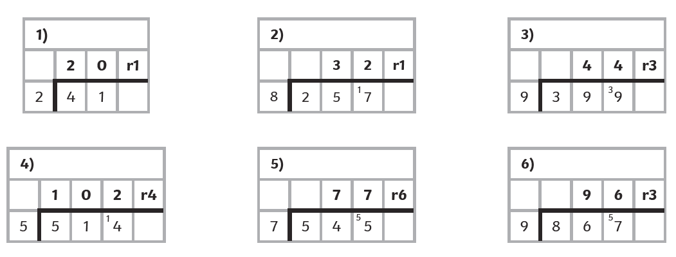

Activity 2: Short division practise with remainders – Answers



