Y5 Maths Homework week 10 (20.3.25)
Fractions: Converting between improper fractions and mixed number fractions.

There’s a revision power point on converting improper fractions into mixed number fractions for your information to support you.

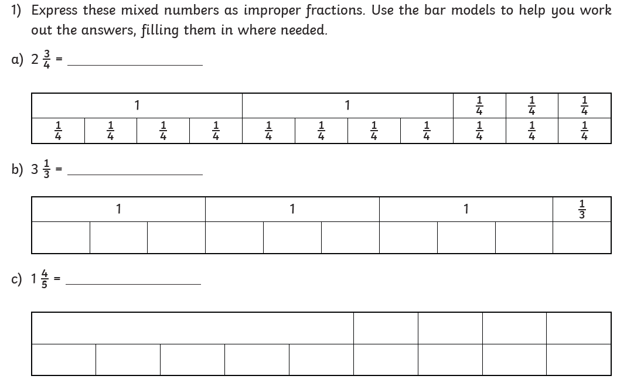
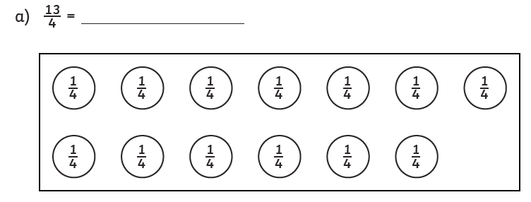

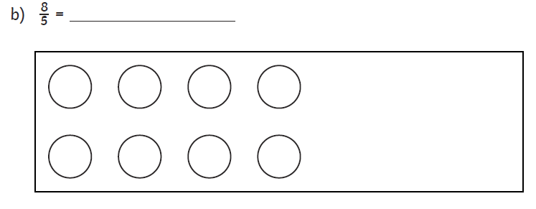

Y5 Maths Homework week 10 (20.3.25) ANSWERS
Fractions: Converting between improper fractions and mixed number fractions.



