Year 5 Maths Homework (16.1.25)

Choose the activity you would like to do (or you can do both). Make sure that you stick the sheet into your homework book and check the answers on the Year 5 class page of the school website. Make any corrections too.

Activity 1: 2-Digit x 2-Digit Multiplication

1). 2).
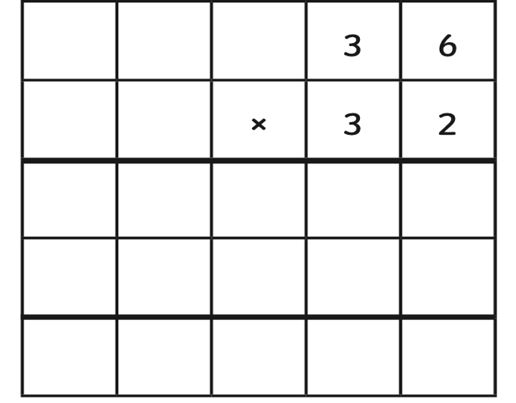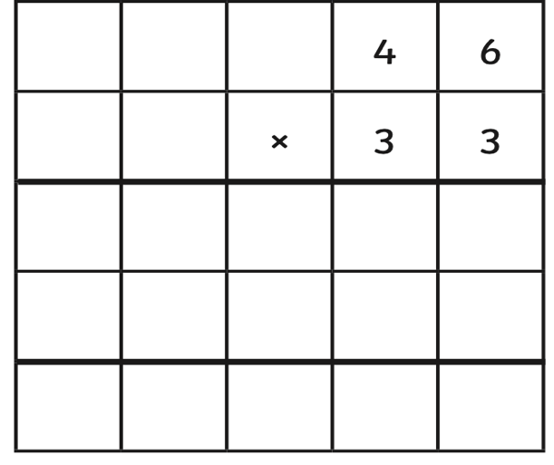

3). 4).
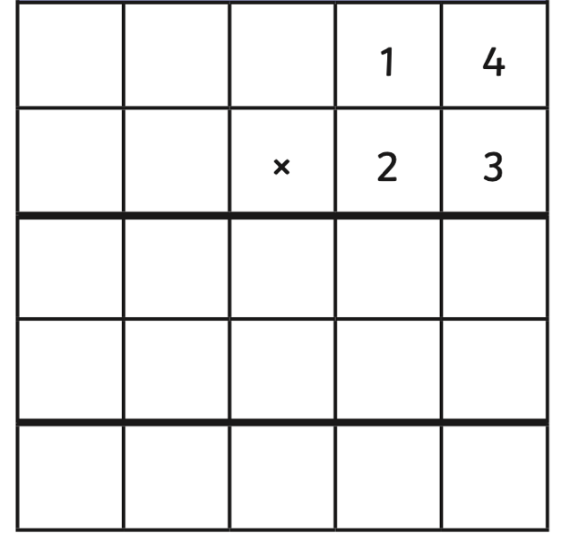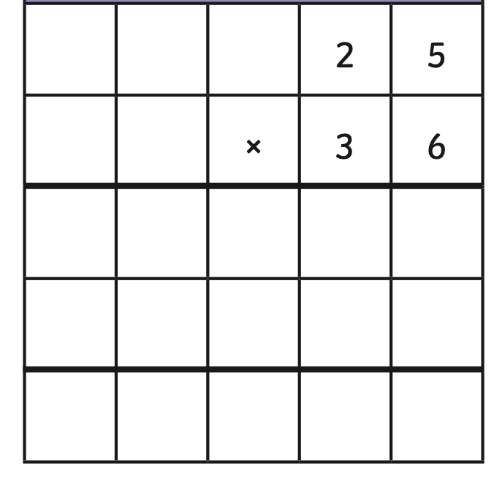

5). 6).

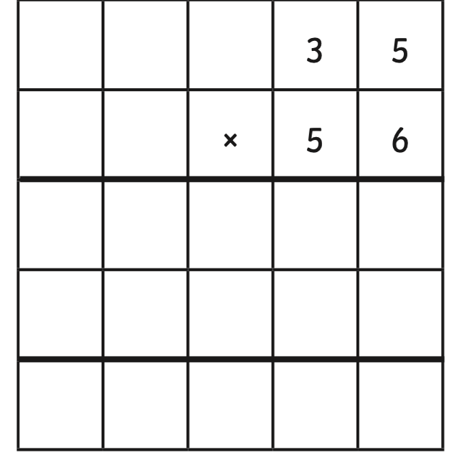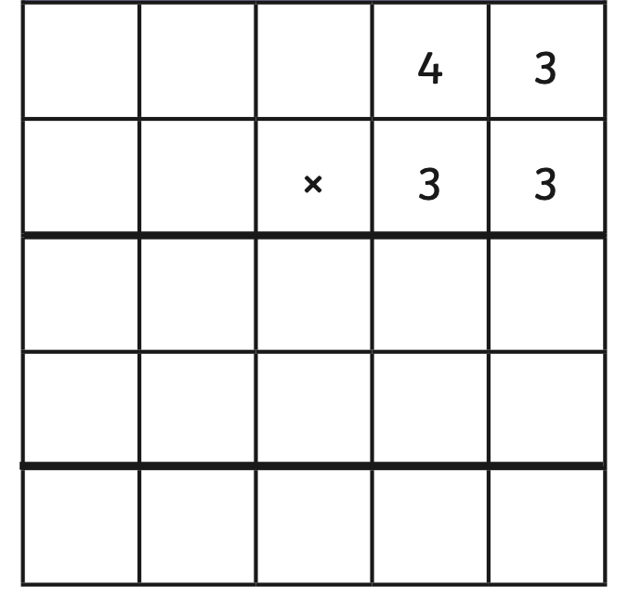
Activity 2: 3-Digit x 2-Digit Multiplication (16.1.25)

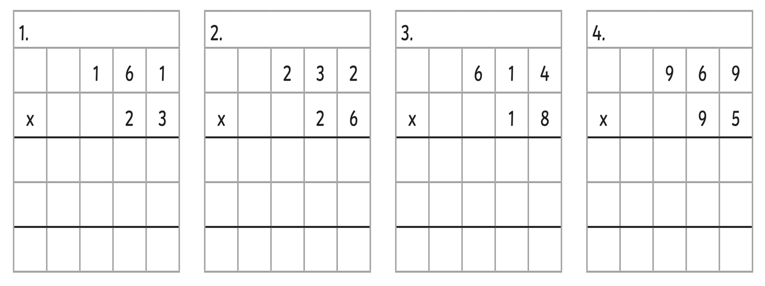

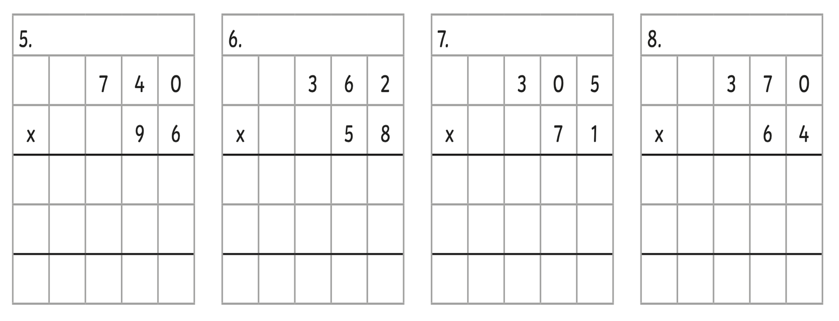

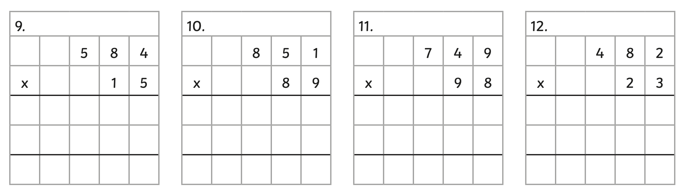

Year 5 Maths Homework (16.1.25) ANSWERS

Activity 1: 2-Digit x 2-Digit Multiplication - Answers

1). 2).
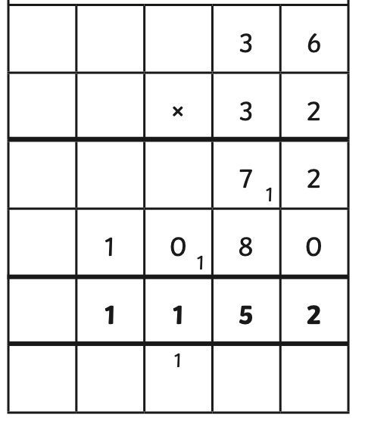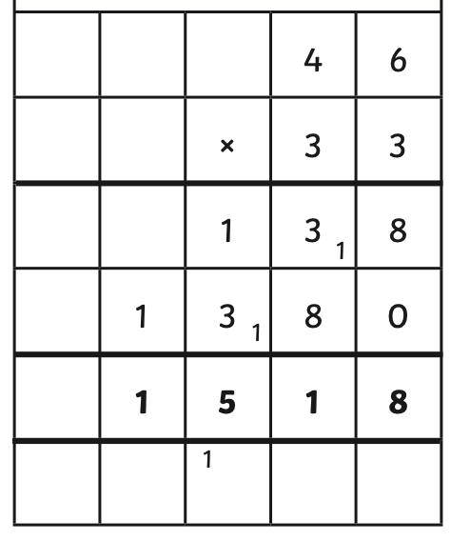
3). 4).
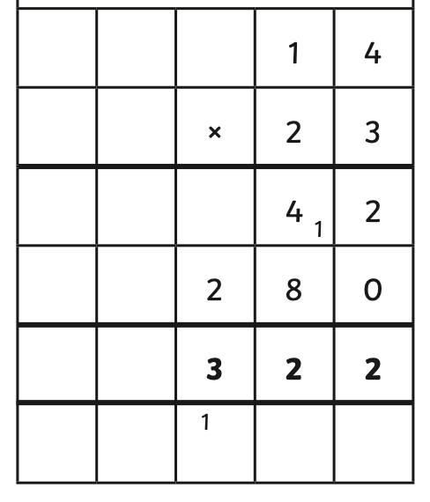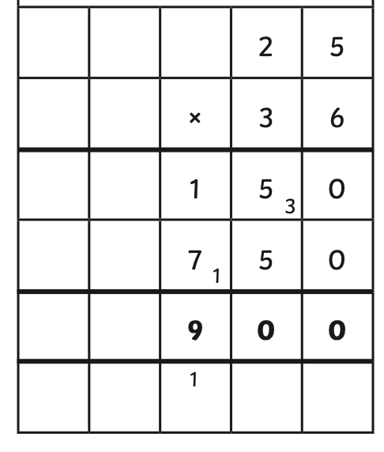

5). 6).
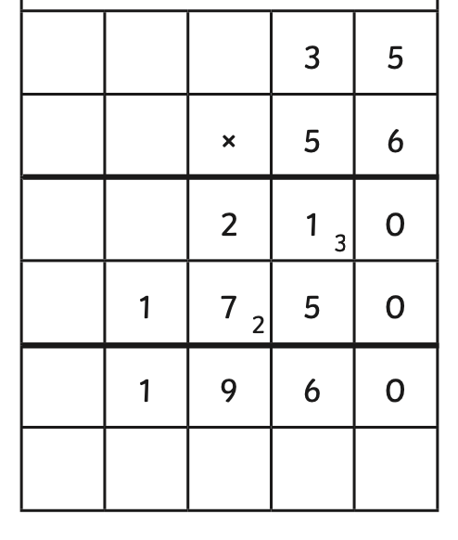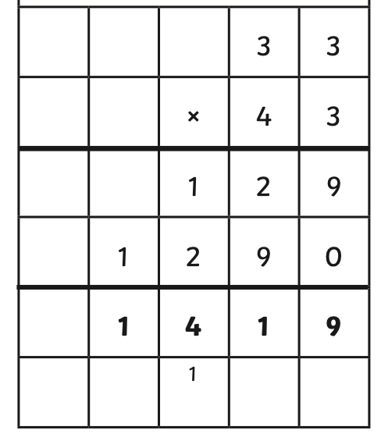

Activity 2: 3-Digit x 2-Digit Multiplication (16.1.25) Answers



